NWWG 2004 Working Document nr. XX

Information on the shelf deep-sea redfish (Sebastes mentella) fishery in Division Va 2004.

Figures and Tables

Kristjan Kristinsson and Thorsteinn Sigurdsson
Marine Research Institute
Skulagata 4, 101 Reykjavik
Iceland

Table 1: Shelf deep-sea S. mentella catch (in tons) of the Icelandic fishing fleet in ICES division Va 2003 divided by gear type and month as reported by Fiskistofa.
 | Month
Gear type | Jan. | Feb. | March | April | May | June | July | Aug. | Sept. | Oct. | Nov. | Dec. | Total
Long line | 0 | 0 | 0 | 0 | 0 | 0 | 0 | 0 | 0 | 0 | 0 | 0 | 1
Gill net | 0 | 0 | 0 | 0 | 0 | 0 | 0 | 0 | 0 | 25 | 0 | 0 | 25
Bottom trawl | 878 | 1,406 | 1,948 | 1,926 | 426 | 228 | 5,030 | 2,841 | 863 | 1,327 | 1,233 | 1,105 | 19,211
Pelagic trawl | 0 | 0 | 0 | 295 | 10 | 767 | 418 | 0 | 730 | 0 | 0 | 0 | 2,219
Other | 0 | 0 | 0 | 0 | 0 | 0 | 0 | 0 | 0 | 24 | 0 | 0 | 24
Total S. mentella | 878 | 1,406 | 1,948 | 2,221 | 436 | 995 | 5,448 | 2,841 | 1,593 | 1,376 | 1,233 | 1,105 | 21,480

Table 2: Total catch in tons of S. marinus and S. mentella in ICES Division Va 2003, divided by nation and vessel type. The division between S. marinus and S. mentella is based on samples and reported catch from log-books.
 |  | Total |  | S. marinus |  | S. mentella
 |  | Catch (t) |  | % | Catch | % | Catch | Source of information
Freezing vessels |  | 31,401 |  | 42.1% | 13,220 | 57.9% | 18,181 | Landings reports
Fresh landings |  | 25,633 |  | 74.7% | 19,148 | 25.3% | 6,485 | split.catch
Landings in Germany, |  |  |  |  |  |  |  | Based on reports
UK, and containers |  | 5,722 |  | 71.6% | 4,097 | 28.4% | 1,625 | from Germany
Germany/UK |  | 2,321 |  | 1.0% | 23 | 99.0% | 2,298 | Information from
Faeroe Island |  | 76 |  | 50.0% | 38 | 50.0% | 38 | various laboratories
Total catch |  | 65,153 |  | 56.06% | 36,526 | 43.94% | 28,627
S. viviparus |  | 3
Total catch | 65,153
Icelandic catch | 62,756

Table 3: The catch (in tons) of Sebastes marinus and S. mentella in ICES Division Va 2003, divided by nations.
Nation | Total catch | Proportion S. mentella | Catch  S. marinus | Catch  S. mentella
Iceland | 62,756 | 41.9% | 36,465 | 26,291
UK and Germany | 2,321 | 99.0% | 23 | 2,298
Norway
Faroe Island | 76 | 50.0% | 38 | 38
TOTAL | 65,153 | 44% | 36,526 | 28,627

Table 4: Proportion of S. marinus and shelf deep-sea S. mentella of the total redfish catch in division Va 1992-2003.
Year | S. marinus | S. mentella
1991
1992 | 54% | 46%
1993 | 47% | 53%
1994 | 40% | 60%
1995 | 46% | 54%
1996 | 49% | 51%
1997 | 49% | 51%
1998 | 53% | 47%
1999 | 60% | 40%
2000 | 60% | 40%
2001 | 67% | 33%
2002 | 72% | 28%
2003 | 56% | 44%
Average | 52% | 48%

Table 5: Total catch in tonnes of shelf deep-sea S. mentella in Va 1978-2003 and total catch in all areas on the continental shelfes of East-Greenland, Iceland, and the Faroe Islands.

Year | Va | Total
1978 | 3,902 | 17,090
1979 | 7,694 | 21,513
1980 | 10,197 | 26,831
1981 | 19,689 | 44,695
1982 | 18,492 | 38,889
1983 | 37,115 | 58,708
1984 | 24,493 | 41,932
1985 | 24,768 | 44,951
1986 | 18,898 | 46,454
1987 | 19,293 | 37,573
1988 | 14,290 | 31,433
1989 | 40,269 | 53,905
1990 | 28,429 | 44,204
1991 | 47,651 | 67,879
1992 | 43,414 | 63,103
1993 | 51,221 | 74,196
1994 | 56,720 | 83,566
1995 | 48,708 | 55,733
1996 | 34,741 | 41,856
1997 | 37,876 | 43,051
1998 | 33,125 | 38,890
1999 | 28,590 | 34,992
2000 | 30,696 | 37,408
2001 | 17,313 | 22,567
2002 | 19,148 | 23,744
2003 | 28,627

Table 6: Sampling from the shelf deep-sea S. mentella by nation and gear type in 2003.
Area | Gear | Landings (t) | No. samples | No. fish measured
Va | Pelagic trawl | 2,219
Va | Bottom trawl | 26,408
Vb | Bottom trawl
XIVb | Bottom trawl

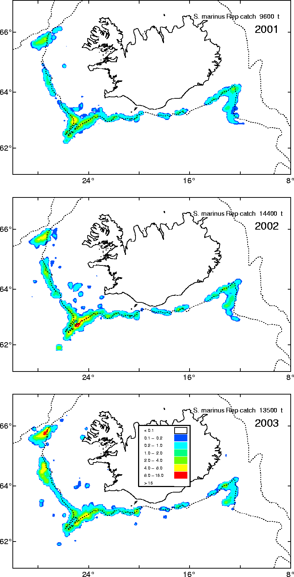
Figure 1: Geographical location of S. mentella fishery 2001-2003 in ICES Division Va as reported in Icelandic log-books.
Figure 2: Total S. mentella catch in Icelandic waters 2001-2003 (all years combined).

Figure 2: Catch in tonnes of shelf deep-sea S. mentella 1998-2004 in Division Va divided by month.

Figure 2: Standardized CPUE (upper) and fishing effort (lower) of the Icelandic bottom trawl fleet fishing for shelf deep-sea S. mentella in Icelandic waters 1986-2003. CPUE is standardazed using GLM-models. The two horizontal broken lines in the upper figure give the Upa (upper line) and Ulim (lower line).
Figure 2: Un-standardized CPUE (upper) and fishing effort (lower) of the Icelandic bottom trawl fleet fishing for shelf deep-sea S. mentella in Icelandic waters 1986-2003. The data comes from log-books of the bottom trawl fleet. The two horizontal broken lines in the upper figure give the Upa (upper line) and Ulim (lower line).

Figure 2: Raw 50% CPUE for shelf deep-sea S. mentella from the Icelandic bottom trawl fleet in Division Va in October-December 1986-2003.

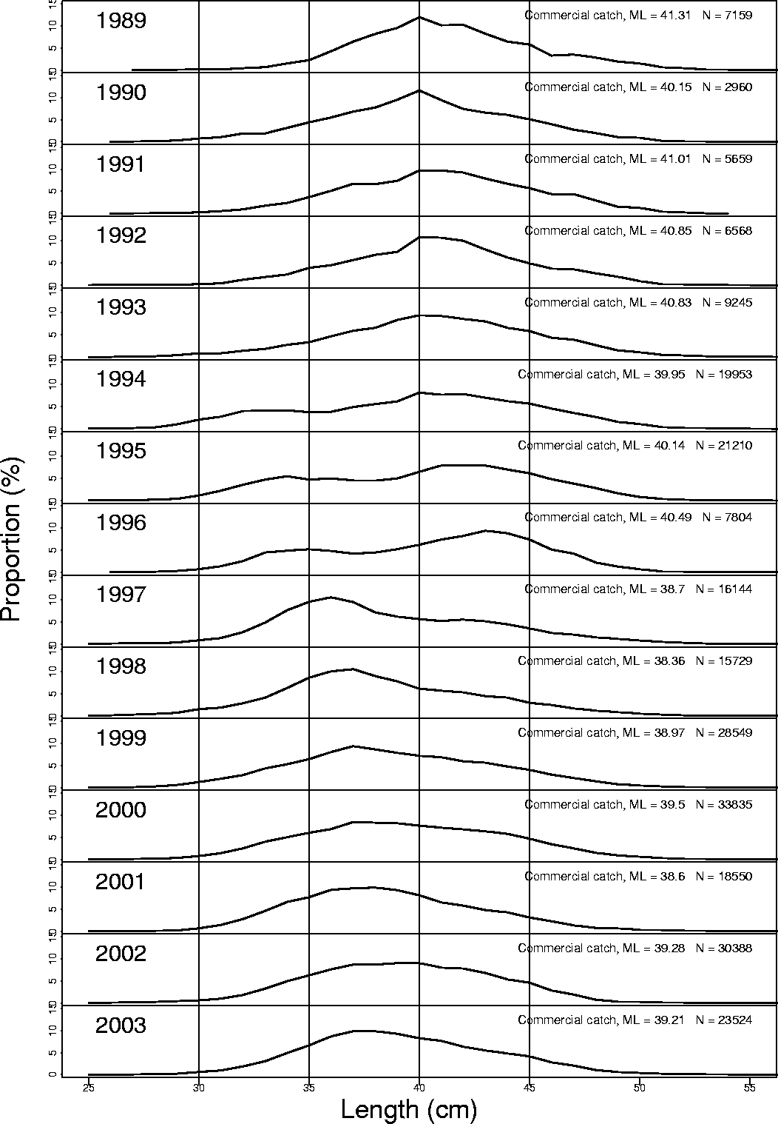
Figure 3: Length distribution of shelf deep-sea S. mentella from the bottom trawl fishery in ICES Division Vb 1989-2003.

Figure 8. Length distribution of shelf deep-sea S. mentella caught by a German vessel in Division Va. Numbers of individuals measured were 514 and mean length was 40.5 cm.

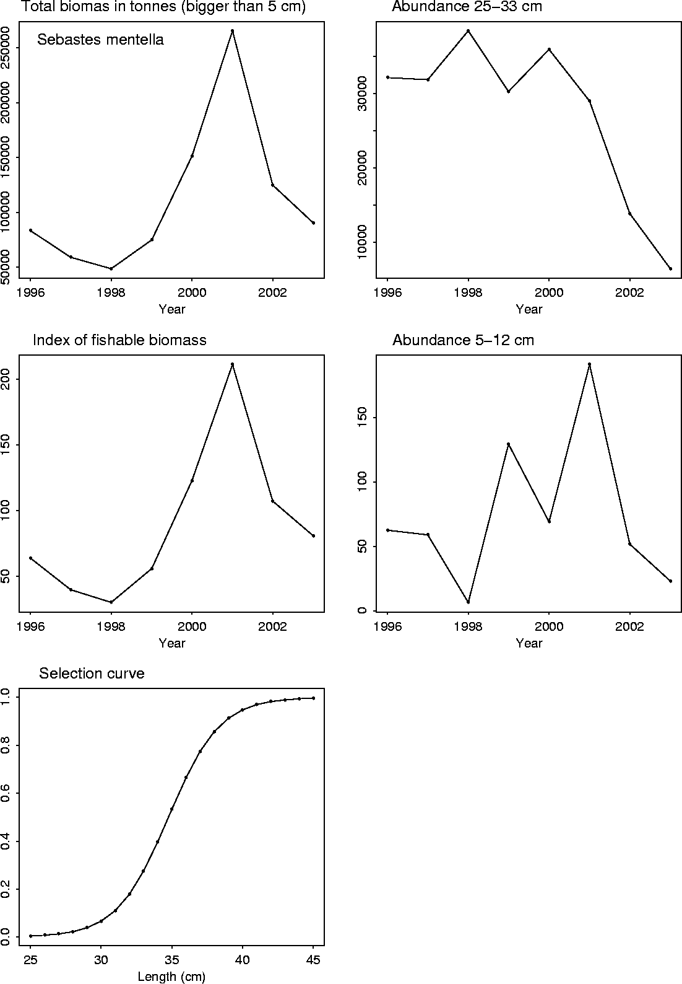
Figure 4: Abundance and biomass of shelf deep-sea S. mentella in the autumn survey conducted in Division Va 1996-2003. The time period 2000-2003 is not comparable to 1996-1999 time period as the number of sations in the 2000-2003 period were increased to cover the main distribution of S. mentella on the shelf.

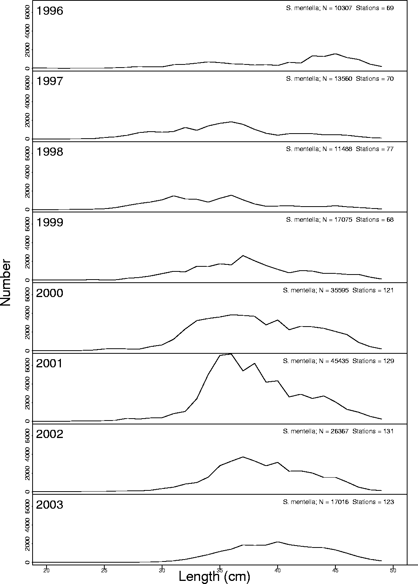
Figure 5: Lenght distribution of shelf deep-sea S. mentella in Division Vb 1996-2003 from the research survey conducted annually in October.

Table 7: Catch projection.
 |  | GLM - 10% |  | GLM - 50% |  | GLM - 70% |  | Raw - 10% |  | Raw - 50% |  | Raw - 70%
Year | Landings | CPUE | Effort | CPUE | Effort | CPUE | Effort | CPUE | Effort | CPUE | Effort | CPUE | Effort
1986 | 18,898 | 1000 | 18.9 | 1000 | 18.9 | 1000 | 18.9 | 943 | 20.0 | 966 | 19.6 | 969 | 19.5
1987 | 19,293 | 1062 | 18.2 | 1096 | 17.6 | 1094 | 17.6 | 977 | 19.7 | 1000 | 19.3 | 996 | 19.4
1988 | 14,290 | 920 | 15.5 | 988 | 14.5 | 1006 | 14.2 | 877 | 16.3 | 919 | 15.5 | 924 | 15.5
1989 | 40,269 | 881 | 45.7 | 949 | 42.4 | 959 | 42.0 | 974 | 41.3 | 1006 | 40.0 | 1009 | 39.9
1990 | 28,429 | 809 | 35.1 | 907 | 31.3 | 919 | 31.0 | 806 | 35.3 | 856 | 33.2 | 861 | 33.0
1991 | 47,651 | 784 | 60.8 | 924 | 51.5 | 948 | 50.3 | 771 | 61.8 | 863 | 55.2 | 873 | 54.6
1992 | 43,414 | 637 | 68.2 | 720 | 60.3 | 743 | 58.5 | 611 | 71.0 | 673 | 64.5 | 682 | 63.7
1993 | 51,221 | 556 | 92.1 | 652 | 78.6 | 669 | 76.5 | 549 | 93.4 | 629 | 81.5 | 635 | 80.7
1994 | 56,720 | 529 | 107.2 | 581 | 97.6 | 600 | 94.6 | 488 | 116.1 | 543 | 104.4 | 553 | 102.6
1995 | 48,708 | 499 | 97.6 | 596 | 81.7 | 628 | 77.5 | 515 | 94.7 | 589 | 82.7 | 602 | 81.0
1996 | 34,741 | 459 | 75.7 | 601 | 57.8 | 636 | 54.6 | 489 | 71.0 | 583 | 59.6 | 597 | 58.2
1997 | 37,876 | 517 | 73.2 | 631 | 60.0 | 657 | 57.7 | 565 | 67.1 | 654 | 57.9 | 666 | 56.8
1998 | 33,125 | 497 | 66.7 | 635 | 52.2 | 664 | 49.9 | 545 | 60.7 | 651 | 50.9 | 663 | 50.0
1999 | 28,590 | 545 | 52.4 | 675 | 42.4 | 707 | 40.4 | 620 | 46.1 | 706 | 40.5 | 724 | 39.5
2000 | 30,696 | 601 | 51.1 | 715 | 42.9 | 751 | 40.9 | 636 | 48.2 | 732 | 41.9 | 753 | 40.8
2001 | 17,313 | 543 | 31.9 | 699 | 24.8 | 742 | 23.3 | 571 | 30.3 | 659 | 26.3 | 671 | 25.8
2002 | 19,148 | 531 | 36.0 | 689 | 27.8 | 724 | 26.4 | 560 | 34.2 | 656 | 29.2 | 666 | 28.7
2003 | 28,627 | 559 | 51.2 | 729 | 39.2 | 781 | 36.7 | 651 | 44.0 | 823 | 34.8 | 854 | 33.5
Av. 01-03 |  | 545 | 39.7 | 706 | 30.6 | 749 | 28.8 | 594 | 36.2 | 713 | 30.1 | 731 | 29.3

 | GLM - 10% |  | GLM - 50% |  | GLM - 70% |  | Raw - 10% |  | Raw - 50% |  | Raw - 70%
 | Catch | Effort | Catch | Effort | Catch | Effort | Catch | Effort | Catch | Effort | Catch | Effort
120% | 25,944 | 47.6 | 25,918 | 36.7 | 25,896 | 34.6 | 25,778 | 43.4 | 25,725 | 36.1 | 25,729 | 35.2
100% | 21,620 | 39.7 | 21,598 | 30.6 | 21,580 | 28.8 | 21,481 | 36.2 | 21,438 | 30.1 | 21,441 | 29.3
75% | 16,215 | 29.8 | 16,199 | 23.0 | 16,185 | 21.6 | 16,111 | 27.1 | 16,078 | 22.6 | 16,081 | 22.0
50% | 10,810 | 19.8 | 10,799 | 15.3 | 10,790 | 14.4 | 10,741 | 18.1 | 10,719 | 15.0 | 10,721 | 14.7

