ICES NWWG 2004 Working Document No. 20

Some information on redfish in Vb

by

Jákup Reinert

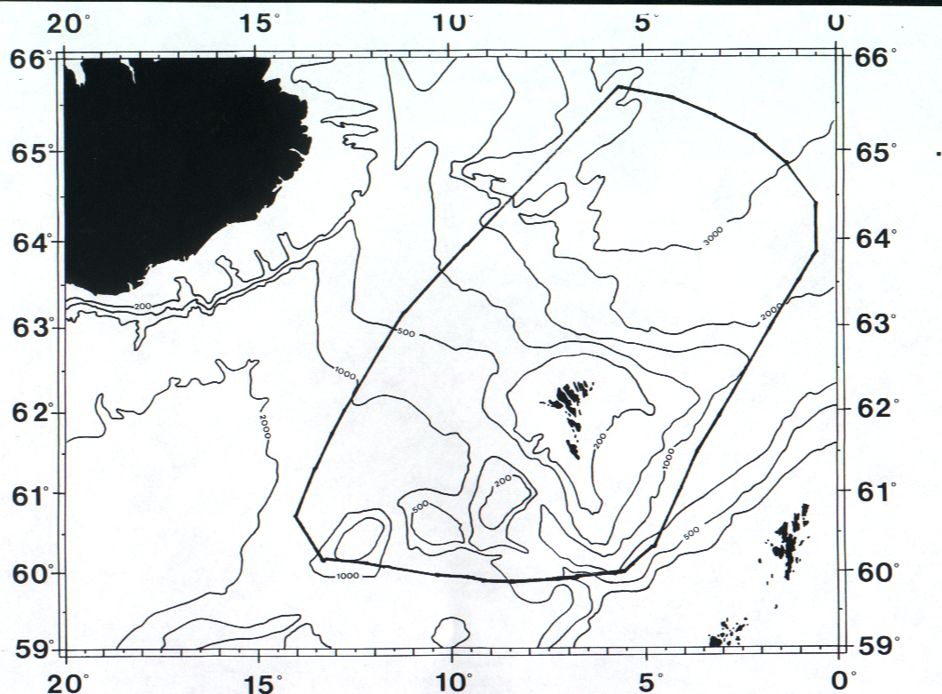

Figure 2.

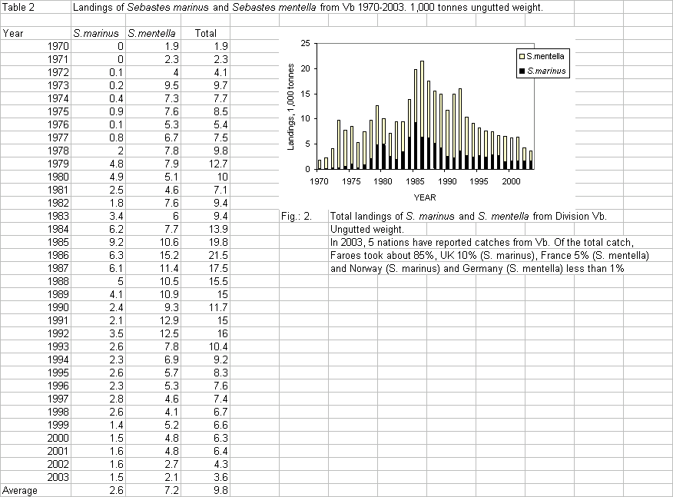

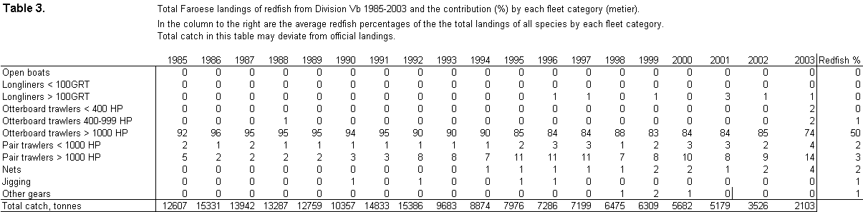

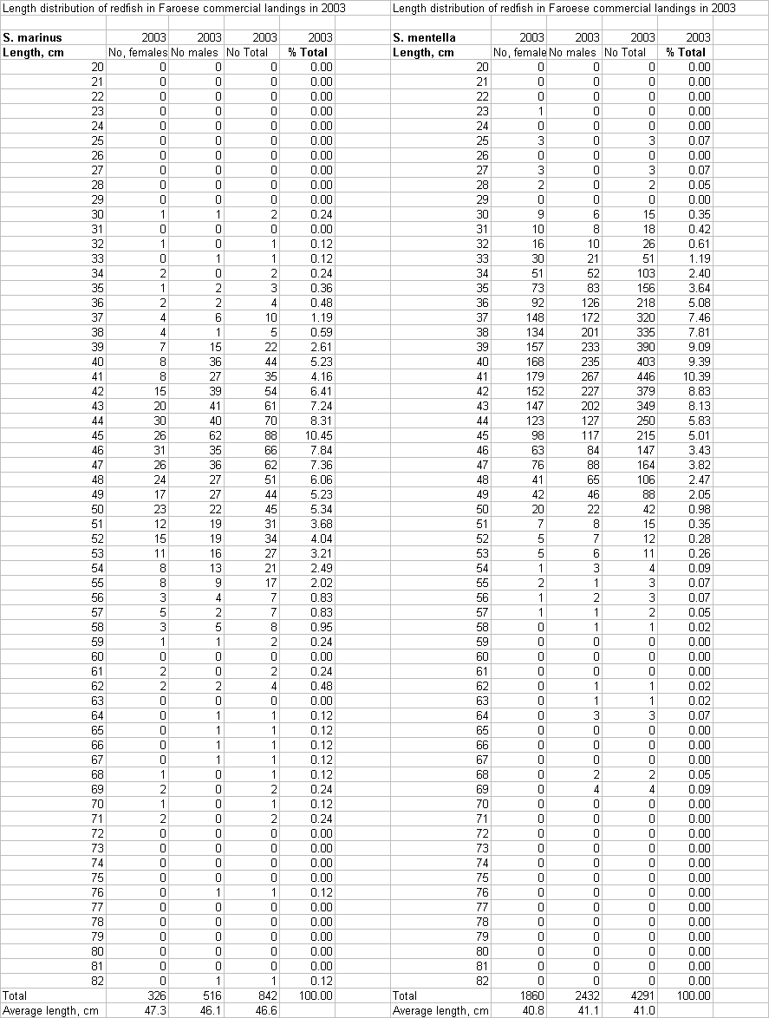

Figure 3. Length distribution of S. marinus in Faroese catches in Vb in 2003.

Figure 4. Length distribution S. mentella in Faroese catches in Vb in 2003

Faroese groundfish survey indices.

Faroese groundfish survey indices.
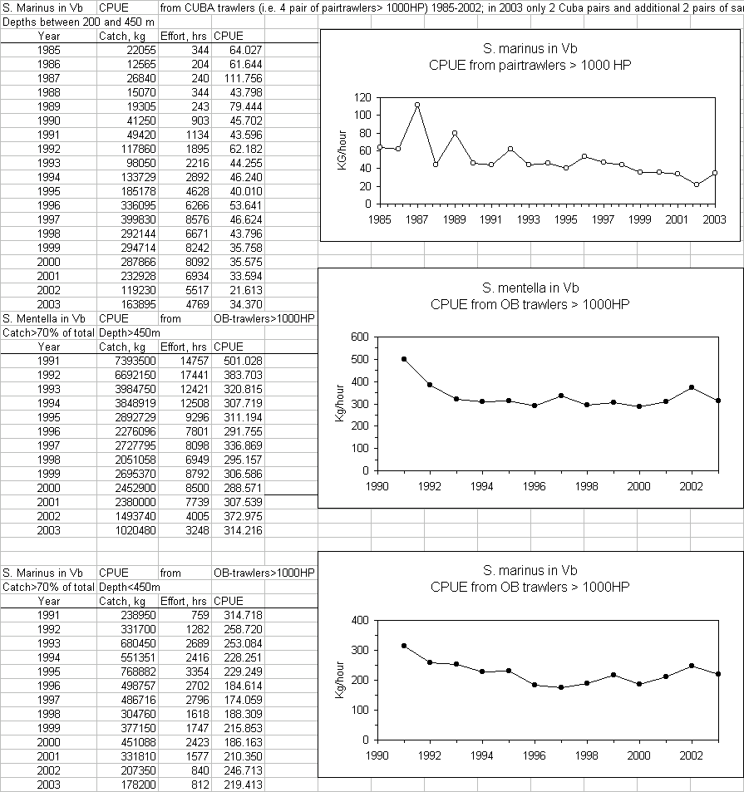

Commercial catch, effort and cpue series

.

