Working document NO 17 NWWG 2004

Restratification of the Faroese spring groundfish survey

Petur Steingrund, Faroese Fisheries Laboratory

The problem with large catches in the spring survey
Normally, the catch in a few hauls dominates the catch in the Faroese spring survey (Fig. 1). These large catches are normally got in hauls that are located around the 100 m isobath and may be allocated to different and sometimes large strata in different years according to the exact position of the haul. Thus the survey indices will be very much influenced by such hauls.

Restratification: Adding 5 new “spawning strata”
The large hauls are all located on traditional spawning areas for cod and may be grouped into five new strata (Fig. 2). By defining these areas - from the spring survey (Fig. 1) and tagging data (Fig. 3) - , more accurate indicies should be obtained. The new stratification is also shown in Fig. 4).

The justification for having two strata north of the Faroe Islands is that some years the spawning fish have a westerly distibution and sometimes a more easterly distribution. Cod spawning north of Faroe Islands come from all areas north and east of Faroe Islands.

The justification for having a spawning stratum far west of Faroe Islands is that tagging data support spawning (we investigate recaptured fish). Also a very large catch was observed there in spring survey in 1995, but the station was omitted (a large hole was in the cod-end). Cod spawning in this area originate from a limited area around the spawing area.

The justification for having two spawning strata (south) west of Faroe Islands is that tagging data support spawning (we investigate recaptured fish) as well as the spring survey. The southermost spawning area seems to be of minor importance, but is included anyway (since we now stratify by spawning areas). The southermost spawning area is not extending so far south as the tagging data indicate because these fish were tagged in the area and usually were immature (or did not have ripe eggs/sperm). Cod spawning in these areas come from the areas west and south of Faroe Islands.

Results
The biomass estimates (estimated catch in all 542 squares) are considerably lower with the new stratification (Table 1-2, Fig. 5). Also the estimates are varying less between successive years. The biomass estimates are highly correlated to the estimates from the summer survey (Fig. 6). The catch curves in the traditional stratification (Fig. 7-8) are varying more than in with the new stratification (Fig. 9-10). The year 1994 seems to be an outlier, since all CPUEs are lower in 1994 than other years (Fig. 7-10). Table 3 shows that the coefficient of variation is less with the new stratification. The CPUE indicies by age are usually lower with the new stratification, especially for mature fish (3-4 years and older) (Table 4).

Spring 1994

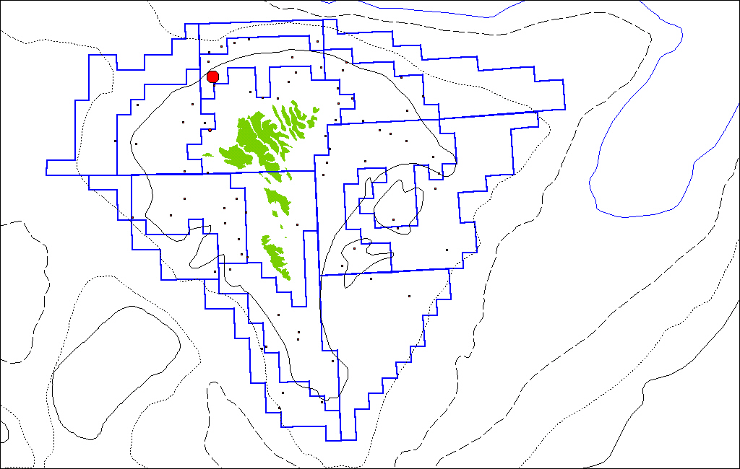

Spring 1995

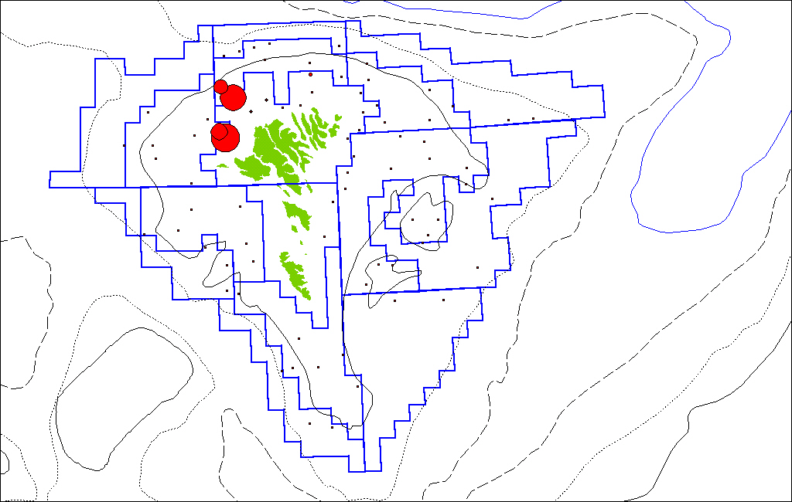

Spring 1996

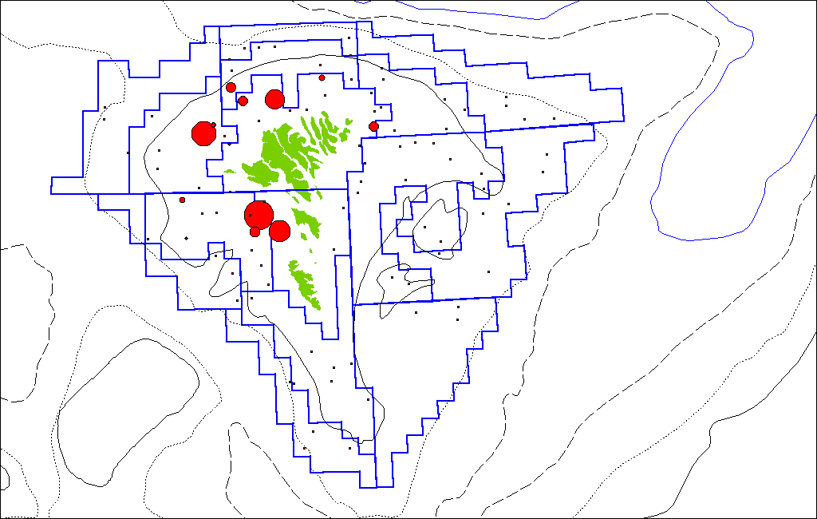

Spring 1997

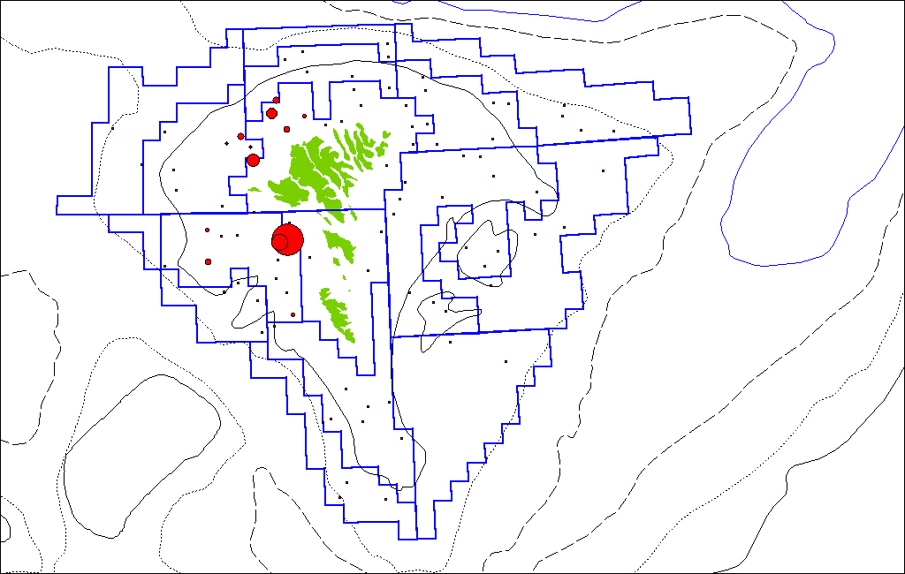

Spring 1998

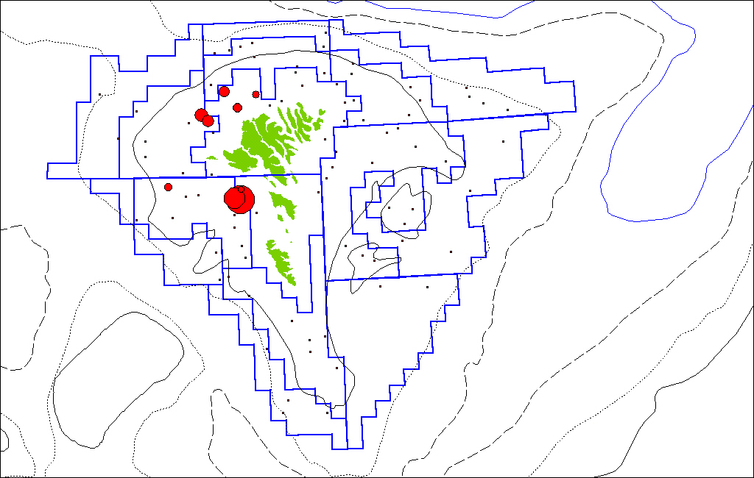

Spring 1999

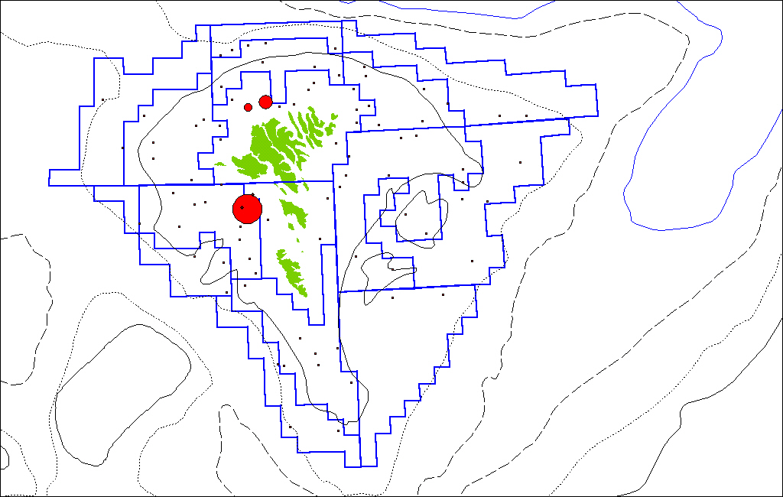

Spring 2000

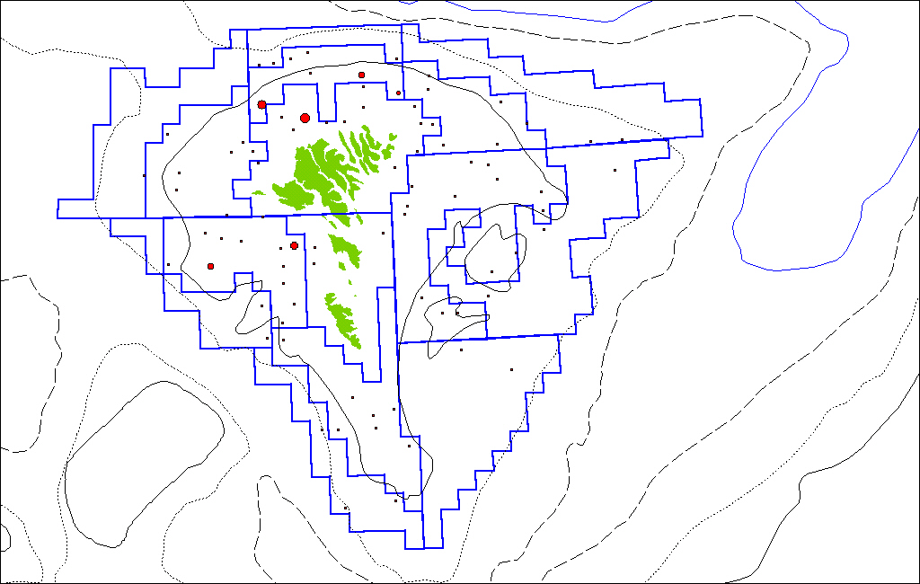

Spring 2001

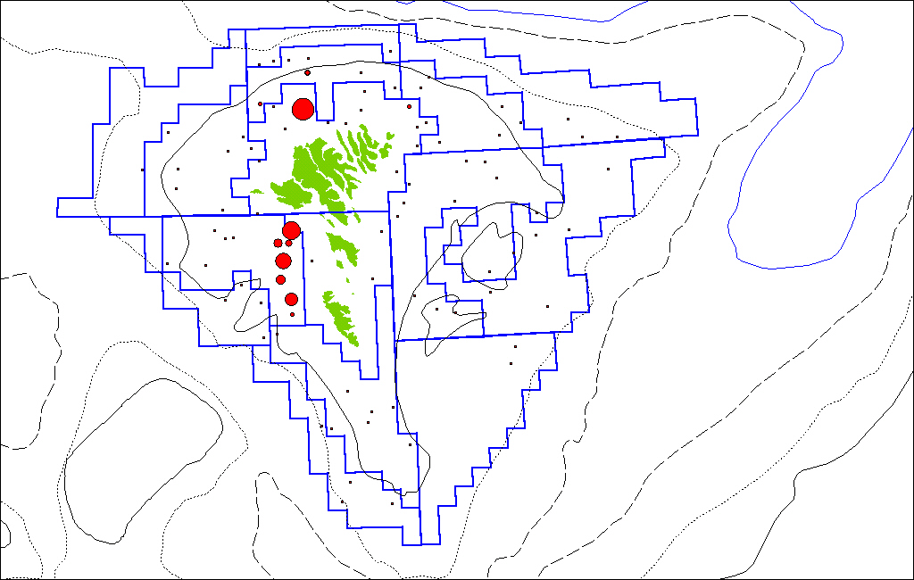

Spring 2002

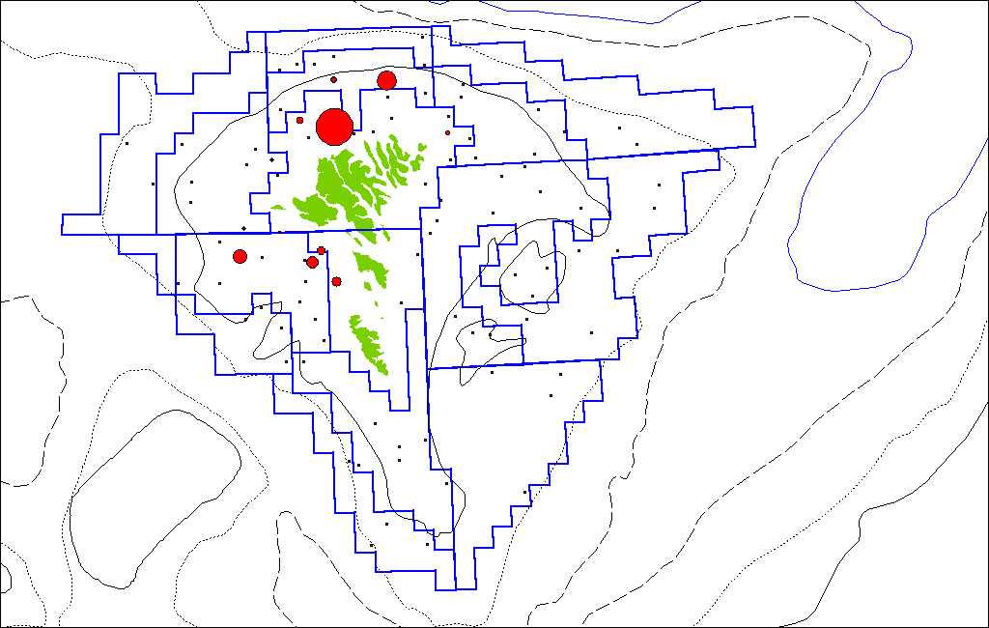

Spring 2003

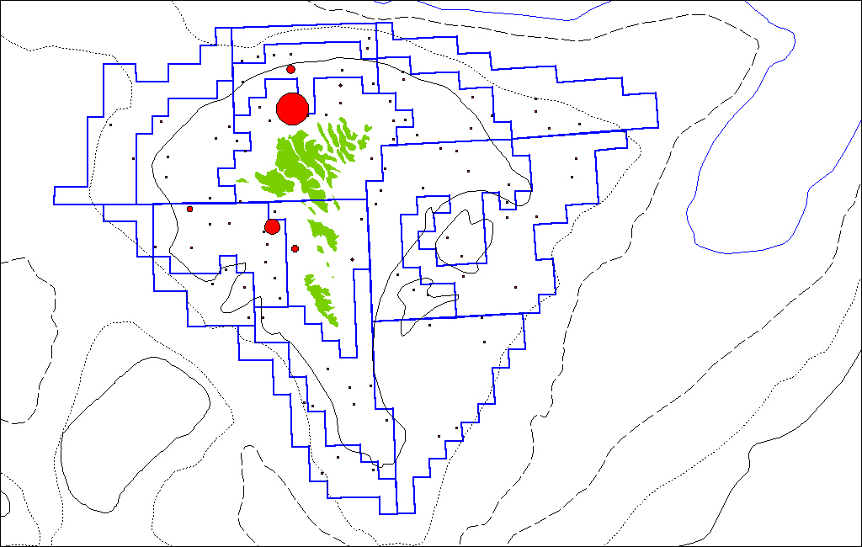

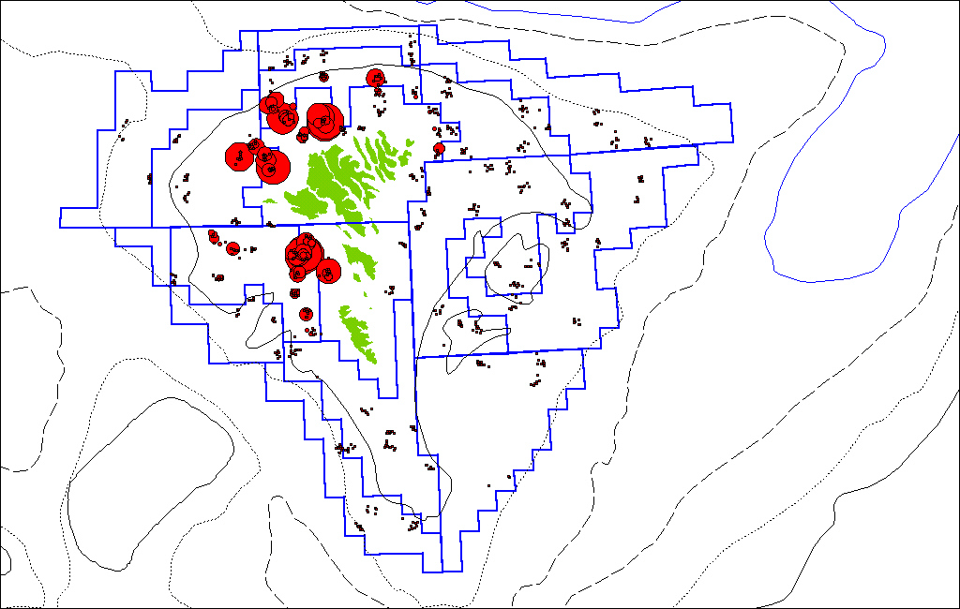
Figure 1. CPUE for the Faroese spring survey by year and the whole period (1994-2003) pooled.

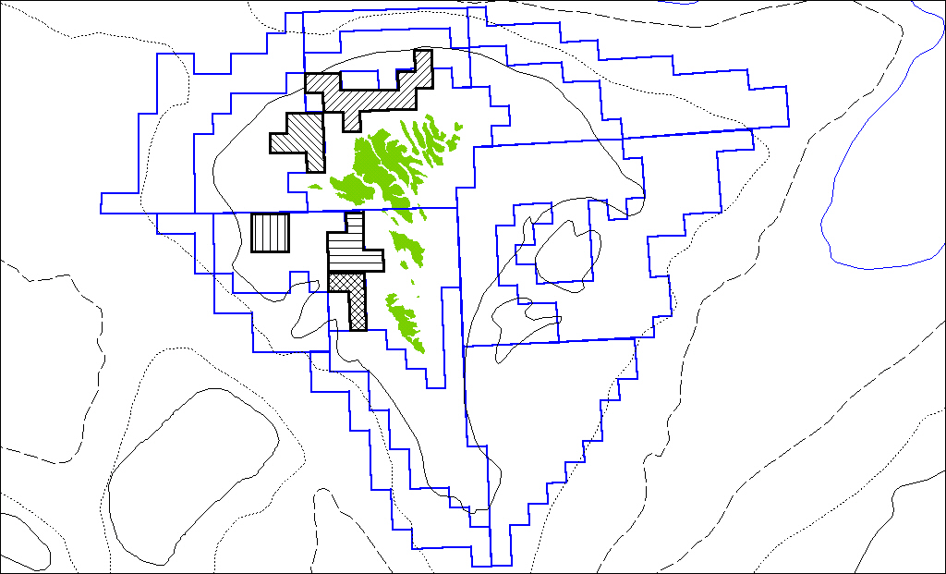
Figure 2. Adding 5 new “spawning strata”.

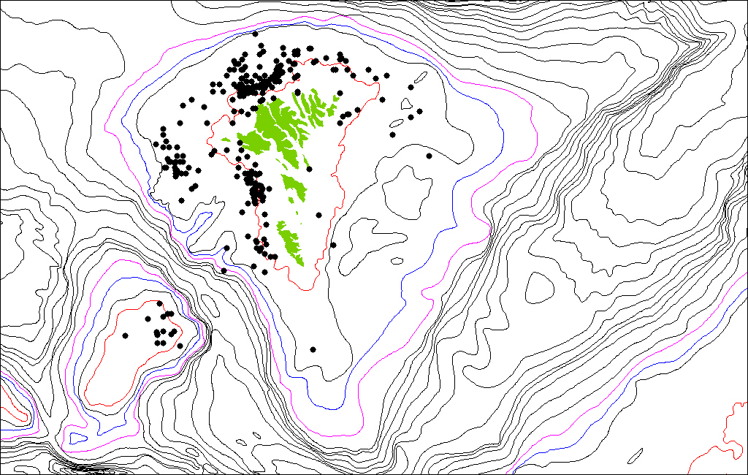
Fig. 3. Tagged cod recaptured during March. (don’t be confused by cod recaptured on the Faroe Bank. They are all tagged on the Faroe Bank).

Figure 4. The figure shows the new stratification of the spring survey. The colours refer to the traditional stratification (15 stations) but note that the numbers inside the squares refer to the actual stratification (the strata 16-20 are added).

Fig. 5. Estimated catch in all 542 squares with the traditional stratification and the new stratification.

Fig. 6. Estimated catch in all 542 squares in the spring survey (new stratification) and the summer survey (traditional stratification).

Fig. 7. Catch curves for the Faroese spring survey (traditional stratification).

Fig. 8. Catch curves by age for the Faroese spring survey (traditional stratification). The data points in 1994 are marked red.

Fig. 9. Catch curves for the Faroese spring survey (new stratification)

Fig. 10. Catch curves by age for the Faroese spring survey (new stratification). The data points in 1994 are marked red.

Table 1. Estimated catch per stratum (the whole area of the stratum) as well as stations per stratum with the traditional stratification.

Stratum: | 1 | 2 | 3 | 4 | 5 | 6 | 7 | 8 | 9 | 10 | 11 | 12 | 13 | 14 | 15 | 16 | 17 | 18 | 19 | 20 | Sum
Area: | 45 | 30 | 21 | 12 | 25 | 44 | 62 | 58 | 56 | 39 | 24 | 33 | 21 | 34 | 38 | 0 | 0 | 0 | 0 | 0 | 542
 | Tonnes cod per strata
Year\stratum | 1 | 2 | 3 | 4 | 5 | 6 | 7 | 8 | 9 | 10 | 11 | 12 | 13 | 14 | 15 | 16 | 17 | 18 | 19 | 20 | Sum
1994 | 9.1 | 0.0 | 17.3 | 0.3 | 0.7 | 0.0 | 0.8 | 0.1 | 0.1 | 1.4 | 0.6 | 3.7 | 0.1 | 11.8 | 1.3 | 0.0 | 0.0 | 0.0 | 0.0 | 0.0 | 47
1995 | 57.1 | 0.7 | 28.1 | 2.5 | 4.5 | 0.1 | 3.0 | 0.2 | 0.4 | 4.0 | 1.1 | 3.8 | 0.8 | 84.5 | 1.0 | 0.0 | 0.0 | 0.0 | 0.0 | 0.0 | 192
1996 | 77.8 | 82.9 | 19.8 | 0.5 | 1.4 | 0.9 | 3.3 | 1.5 | 0.3 | 1.2 | 0.9 | 63.6 | 0.4 | 66.9 | 0.6 | 0.0 | 0.0 | 0.0 | 0.0 | 0.0 | 322
1997 | 47.5 | 14.2 | 15.3 | 1.0 | 1.1 | 1.0 | 6.0 | 0.4 | 0.2 | 1.5 | 0.4 | 76.3 | 0.5 | 27.2 | 0.8 | 0.0 | 0.0 | 0.0 | 0.0 | 0.0 | 194
1998 | 41.5 | 29.5 | 7.3 | 0.8 | 3.7 | 0.5 | 8.6 | 0.6 | 0.1 | 1.3 | 0.2 | 86.4 | 0.1 | 57.6 | 0.2 | 0.0 | 0.0 | 0.0 | 0.0 | 0.0 | 238
1999 | 38.1 | 8.4 | 1.8 | 0.2 | 0.5 | 0.1 | 1.5 | 0.2 | 0.1 | 1.3 | 0.2 | 107.7 | 0.3 | 6.0 | 0.4 | 0.0 | 0.0 | 0.0 | 0.0 | 0.0 | 167
2000 | 18.0 | 0.0 | 29.6 | 0.4 | 1.9 | 0.2 | 1.6 | 0.1 | 0.2 | 1.2 | 0.4 | 22.7 | 3.2 | 5.7 | 0.2 | 0.0 | 0.0 | 0.0 | 0.0 | 0.0 | 85
2001 | 38.1 | 53.6 | 13.1 | 0.1 | 2.2 | 0.3 | 1.4 | 0.2 | 0.1 | 1.7 | 0.3 | 69.7 | 0.4 | 3.6 | 0.1 | 0.0 | 0.0 | 0.0 | 0.0 | 0.0 | 185
2002 | 86.5 | 43.0 | 36.7 | 0.5 | 1.8 | 0.1 | 4.0 | 0.7 | 0.5 | 1.6 | 0.4 | 32.2 | 0.5 | 16.6 | 0.3 | 0.0 | 0.0 | 0.0 | 0.0 | 0.0 | 225
2003 | 56.7 | 34.1 | 13.9 | 0.1 | 0.5 | 0.9 | 3.2 | 0.8 | 0.6 | 1.3 | 0.5 | 29.1 | 0.1 | 5.0 | 0.1 | 0.0 | 0.0 | 0.0 | 0.0 | 0.0 | 147
2004 | 11.8 | 9.0 | 8.1 | 0.1 | 0.5 | 1.3 | 1.9 | 0.6 | 0.8 | 1.7 | 0.2 | 4.7 | 0.1 | 2.1 | 0.2 | 0.0 | 0.0 | 0.0 | 0.0 | 0.0 | 43
Average | 43.8 | 25.0 | 17.4 | 0.6 | 1.7 | 0.5 | 3.2 | 0.5 | 0.3 | 1.7 | 0.5 | 45.4 | 0.6 | 26.1 | 0.5 | 0.0 | 0.0 | 0.0 | 0.0 | 0.0 | 167.7
 | Stations per strata
Year\stratum | 1 | 2 | 3 | 4 | 5 | 6 | 7 | 8 | 9 | 10 | 11 | 12 | 13 | 14 | 15 | 16 | 17 | 18 | 19 | 20 | Sum
1994 | 11 | 2 | 8 | 4 | 6 | 4 | 15 | 6 | 5 | 6 | 4 | 9 | 3 | 6 | 2 | 0 | 0 | 0 | 0 | 0 | 91
1995 | 12 | 2 | 6 | 4 | 6 | 4 | 16 | 5 | 5 | 6 | 3 | 7 | 4 | 8 | 3 | 0 | 0 | 0 | 0 | 0 | 91
1996 | 14 | 4 | 6 | 4 | 6 | 4 | 15 | 6 | 5 | 7 | 4 | 11 | 4 | 7 | 3 | 0 | 0 | 0 | 0 | 0 | 100
1997 | 14 | 4 | 6 | 2 | 6 | 4 | 15 | 6 | 5 | 7 | 4 | 11 | 4 | 7 | 3 | 0 | 0 | 0 | 0 | 0 | 98
1998 | 14 | 3 | 6 | 4 | 6 | 4 | 15 | 6 | 5 | 7 | 4 | 11 | 4 | 7 | 3 | 0 | 0 | 0 | 0 | 0 | 99
1999 | 14 | 4 | 6 | 4 | 6 | 4 | 15 | 6 | 5 | 7 | 4 | 10 | 5 | 7 | 3 | 0 | 0 | 0 | 0 | 0 | 100
2000 | 14 | 4 | 6 | 4 | 6 | 4 | 15 | 6 | 5 | 7 | 4 | 11 | 4 | 7 | 3 | 0 | 0 | 0 | 0 | 0 | 100
2001 | 14 | 4 | 6 | 4 | 6 | 4 | 15 | 6 | 5 | 7 | 4 | 11 | 4 | 7 | 3 | 0 | 0 | 0 | 0 | 0 | 100
2002 | 14 | 4 | 6 | 4 | 6 | 4 | 15 | 6 | 5 | 7 | 4 | 11 | 4 | 7 | 3 | 0 | 0 | 0 | 0 | 0 | 100
2003 | 14 | 4 | 6 | 4 | 6 | 4 | 15 | 6 | 5 | 7 | 4 | 11 | 4 | 7 | 3 | 0 | 0 | 0 | 0 | 0 | 100
2004 | 14 | 4 | 6 | 4 | 6 | 4 | 15 | 6 | 5 | 7 | 4 | 11 | 4 | 7 | 3 | 0 | 0 | 0 | 0 | 0 | 100

Table 2. Estimated catch per stratum (the whole area of the stratum) as well as stations per stratum with the traditional stratification.

Stratum: | 1 | 2 | 3 | 4 | 5 | 6 | 7 | 8 | 9 | 10 | 11 | 12 | 13 | 14 | 15 | 16 | 17 | 18 | 19 | 20 | Sum
Area: | 36 | 28 | 17 | 12 | 25 | 44 | 62 | 58 | 56 | 39 | 24 | 21 | 21 | 30 | 38 | 11 | 6 | 4 | 6 | 4 | 542
 | Tonnes cod per strata
Year\stratum | 1 | 2 | 3 | 4 | 5 | 6 | 7 | 8 | 9 | 10 | 11 | 12 | 13 | 14 | 15 | 16 | 17 | 18 | 19 | 20 | Sum
1994 | 1.0 | 0.0 | 2.6 | 0.3 | 0.7 | 0.0 | 0.8 | 0.1 | 0.1 | 1.4 | 0.6 | 0.6 | 0.1 | 8.3 | 1.3 | 13.7 | 4.3 | 0.8 | 0.2 | 0.6 | 38
1995 | 5.7 | 0.7 | 4.5 | 2.5 | 4.5 | 0.1 | 3.0 | 0.2 | 0.4 | 4.0 | 1.1 | 1.8 | 0.8 | 5.5 | 1.0 | 38.0 | 28.2 | 0.6 | 0.5 | 0.5 | 104
1996 | 30.7 | 7.3 | 5.0 | 0.5 | 1.4 | 0.9 | 3.3 | 1.5 | 0.3 | 1.2 | 0.9 | 7.4 | 0.4 | 7.3 | 0.6 | 36.6 | 20.8 | 4.5 | 33.3 | 0.7 | 164
1997 | 12.4 | 9.1 | 7.0 | 1.0 | 1.1 | 1.0 | 6.0 | 0.4 | 0.2 | 1.5 | 0.4 | 15.6 | 0.5 | 6.7 | 0.8 | 18.1 | 13.9 | 3.5 | 24.2 | 3.4 | 127
1998 | 4.0 | 1.5 | 3.0 | 0.8 | 3.7 | 0.5 | 8.6 | 0.6 | 0.1 | 1.3 | 0.2 | 1.5 | 0.1 | 1.9 | 0.2 | 24.2 | 17.5 | 7.0 | 32.8 | 0.8 | 110
1999 | 3.8 | 0.1 | 1.0 | 0.2 | 0.5 | 0.1 | 1.5 | 0.2 | 0.1 | 1.3 | 0.2 | 8.0 | 0.3 | 2.5 | 0.4 | 20.4 | 1.4 | 3.5 | 36.5 | 1.1 | 83
2000 | 2.5 | 0.0 | 13.3 | 0.4 | 1.9 | 0.2 | 1.6 | 0.1 | 0.2 | 1.2 | 0.4 | 11.8 | 3.2 | 4.6 | 0.2 | 18.8 | 0.9 | 2.8 | 4.8 | 1.4 | 70
2001 | 8.2 | 2.8 | 8.1 | 0.1 | 2.2 | 0.3 | 1.4 | 0.2 | 0.1 | 1.7 | 0.3 | 2.8 | 0.4 | 0.9 | 0.1 | 21.2 | 1.0 | 2.2 | 22.4 | 13.3 | 90
2002 | 17.7 | 4.0 | 13.6 | 0.5 | 1.8 | 0.1 | 4.0 | 0.7 | 0.5 | 1.6 | 0.4 | 1.7 | 0.5 | 10.6 | 0.3 | 53.5 | 3.7 | 11.5 | 11.8 | 0.5 | 139
2003 | 5.4 | 14.3 | 15.3 | 0.1 | 0.5 | 0.9 | 3.2 | 0.8 | 0.6 | 1.3 | 0.5 | 1.1 | 0.1 | 1.6 | 0.1 | 30.3 | 1.4 | 4.7 | 12.1 | 0.8 | 95
2004 | 6.0 | 3.2 | 8.2 | 0.1 | 0.5 | 1.3 | 1.9 | 0.6 | 0.8 | 1.7 | 0.2 | 0.9 | 0.1 | 1.5 | 0.2 | 4.6 | 0.4 | 2.4 | 1.4 | 0.1 | 36
Average | 8.9 | 3.9 | 7.4 | 0.6 | 1.7 | 0.5 | 3.2 | 0.5 | 0.3 | 1.7 | 0.5 | 4.8 | 0.6 | 4.7 | 0.5 | 25.4 | 8.5 | 4.0 | 16.4 | 2.1 | 96.0
 | Stations per strata
Year\stratum | 1 | 2 | 3 | 4 | 5 | 6 | 7 | 8 | 9 | 10 | 11 | 12 | 13 | 14 | 15 | 16 | 17 | 18 | 19 | 20 | Sum
1994 | 8 | 1 | 5 | 4 | 6 | 4 | 15 | 6 | 5 | 6 | 4 | 2 | 3 | 3 | 2 | 5 | 4 | 1 | 3 | 4 | 91
1995 | 8 | 2 | 4 | 4 | 6 | 4 | 16 | 5 | 5 | 6 | 3 | 2 | 4 | 4 | 3 | 6 | 4 | 1 | 1 | 3 | 91
1996 | 9 | 2 | 4 | 4 | 6 | 4 | 15 | 6 | 5 | 7 | 4 | 3 | 4 | 4 | 3 | 6 | 4 | 2 | 5 | 3 | 100
1997 | 9 | 2 | 4 | 2 | 6 | 4 | 15 | 6 | 5 | 7 | 4 | 3 | 4 | 4 | 3 | 6 | 4 | 2 | 5 | 3 | 98
1998 | 9 | 1 | 4 | 4 | 6 | 4 | 15 | 6 | 5 | 7 | 4 | 3 | 4 | 4 | 3 | 6 | 4 | 2 | 5 | 3 | 99
1999 | 9 | 2 | 4 | 4 | 6 | 4 | 15 | 6 | 5 | 7 | 4 | 2 | 5 | 4 | 3 | 6 | 4 | 2 | 5 | 3 | 100
2000 | 9 | 3 | 4 | 4 | 6 | 4 | 15 | 6 | 5 | 7 | 4 | 4 | 4 | 4 | 3 | 6 | 4 | 2 | 4 | 2 | 100
2001 | 9 | 2 | 4 | 4 | 6 | 4 | 15 | 6 | 5 | 7 | 4 | 3 | 4 | 4 | 3 | 6 | 4 | 2 | 5 | 3 | 100
2002 | 9 | 2 | 4 | 4 | 6 | 4 | 15 | 6 | 5 | 7 | 4 | 3 | 4 | 4 | 3 | 6 | 4 | 2 | 5 | 3 | 100
2003 | 9 | 2 | 4 | 4 | 6 | 4 | 15 | 6 | 5 | 7 | 4 | 3 | 4 | 4 | 3 | 6 | 4 | 2 | 5 | 3 | 100
2004 | 9 | 2 | 4 | 4 | 6 | 4 | 15 | 6 | 5 | 7 | 4 | 3 | 4 | 4 | 3 | 6 | 4 | 2 | 5 | 3 | 100

Table 3. Coefficient of variation (%) for the Faroese spring survey. Upper part shows the results from the tradditional stratification and the lower part the new stratification.
Table 4. CPUE indicies by age for the spring survey with traditional stratification (upper part) and the new stratification (lower part of the table).

