Table 2.3.1.2. Faroe Bank (sub-division Vb2) COD. Landings of Faroese fleets (in percents) of total Faroese catch (gutted weight)

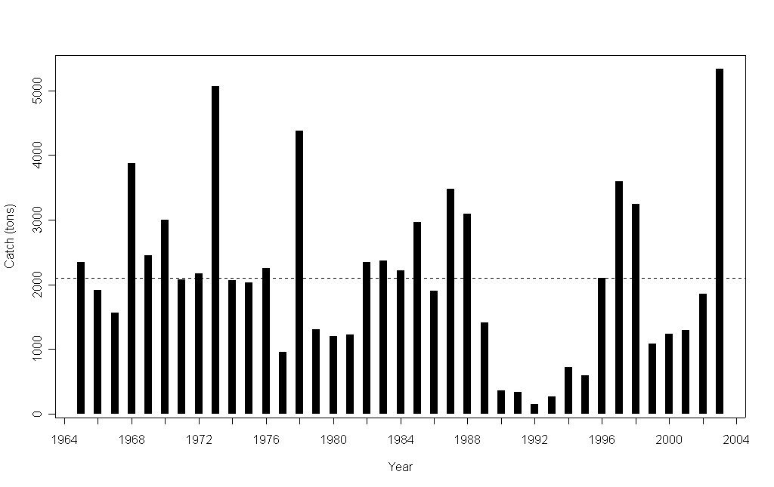

Figure 2.3.1.1. Faroe Bank (sub-division Vb2) COD. Reported landings 1965-2003. Since 1992 only catches from Faroese and Norwegian vessels are considered to be taken on Faroe Bank.

Figure 2.3.1.1.0. Fishing days for longline gear type
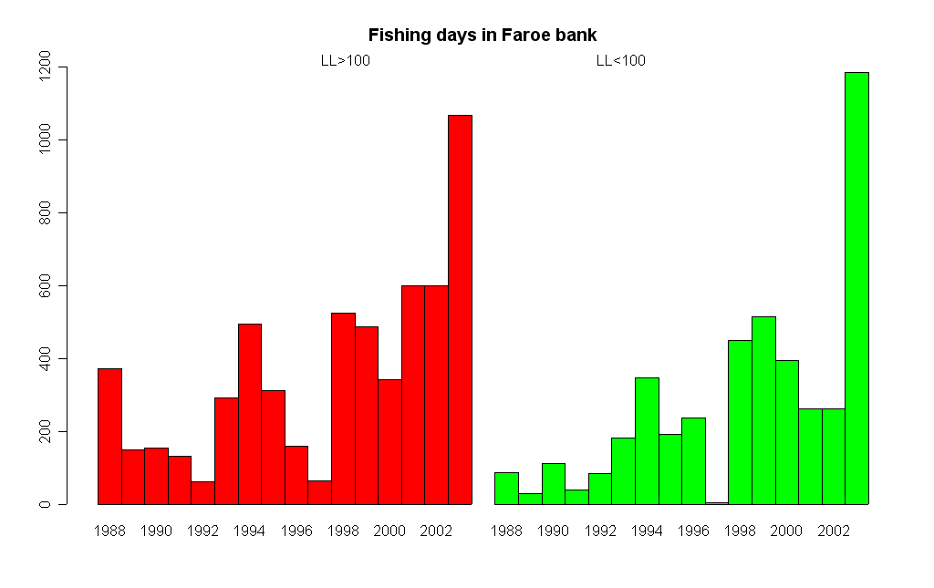

Figure 2.3.2.1. Faroe Bank (sub-division Vb2) COD. Catch per unit of effort in the spring groundfish survey and autumn groundfish survey . If one large haul (14 tonnes) is replaced by 4 tonnes (more typical for that particular station) the CPUE drops from about 1300 kg/hour to about 530 kg/hour.
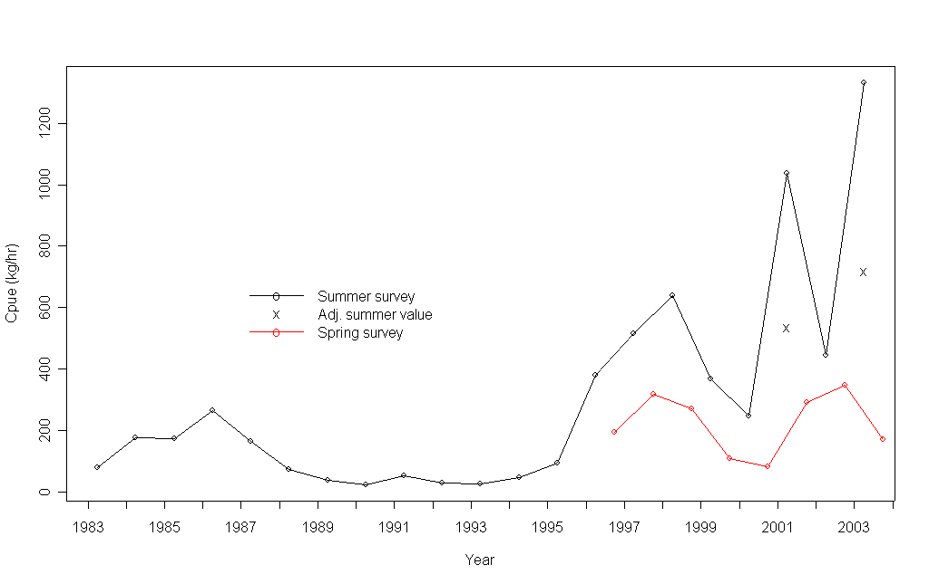

Figure 2.3.2.2.Faroe Bank (sub-division Vb2) COD. Length distributions in the spring survey 1983-2003.
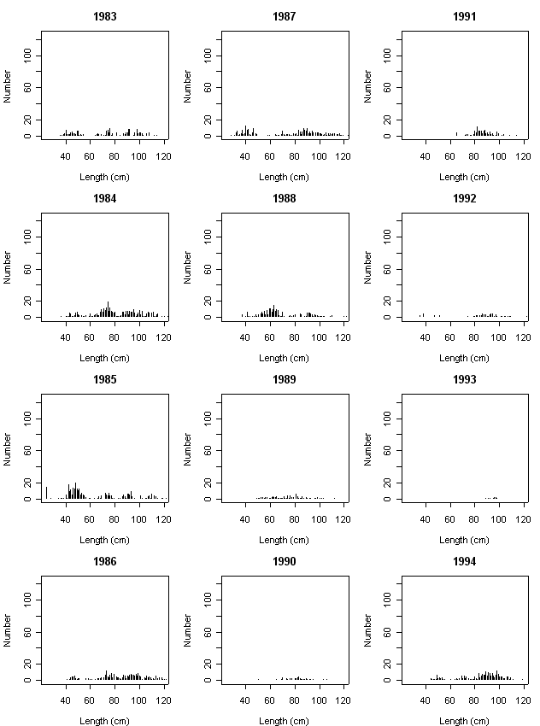

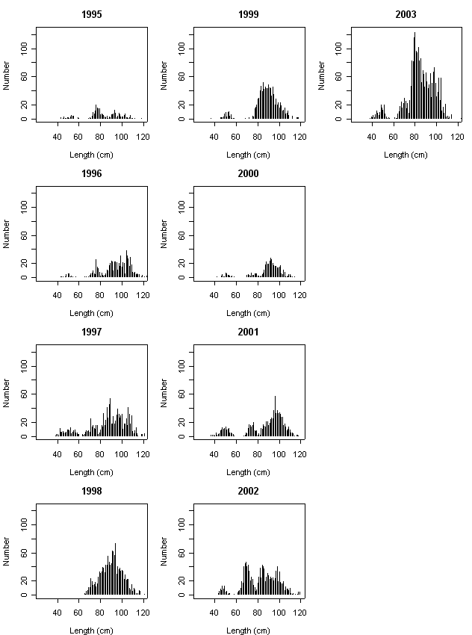 Figure2.3.2.2 (Continue)

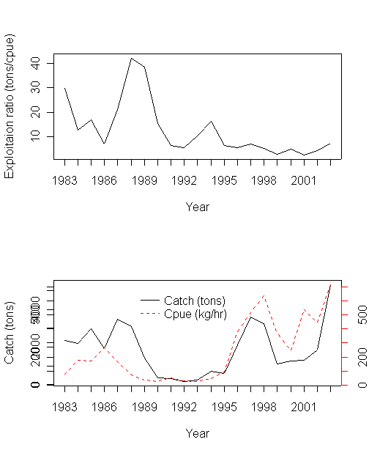

Figure 2.3.2.3.Faroe Bank (Sub-division Vb2) COD. Exploitation ratio (ratio of landings to spring survey interpreted as an index of exploitation rate.). Second plot CPUE in spring survey and landings (1983-2003)

Figure 2.3.2.4. Faroe Bank (Sub-division Vb2) COD. Relative fishing mortality rate,Selectivity and log catch residuals
from catch at age analysis.

