NWWG 2004 Working Document nr. 13

Sebastes marinus in ICES Division Va.
Figures and Tables

Kristján Kristinsson and Thorsteinn Sigurdsson
Marine Research Institute
Skulagata 4, 101 Reykjavik
Iceland

Table 1: Official redfish catch (in tons) from the Directorate of fisheries of the Icelandic fishing fleet in 2003 in ICES Division Va, divided by species, gear type and month.
 | Month
Gear type | Jan. | Feb. | March |  | April |  | May |  | June |  | July |  | Aug. |  | Sept. |  | Oct. |  | Nov. |  | Dec. |  | Total

Sebastes marinus
Long line | 89 | 45 | 73 |  | 75 |  | 67 |  | 97 |  | 42 |  | 55 |  | 105 |  | 101 |  | 77 |  | 68 |  | 893
Gill net | 21 | 22 | 35 |  | 19 |  | 16 |  | 2 |  | 3 |  | 2 |  | 3 |  | 56 |  | 17 |  | 22 |  | 218
Hook and line | 0 | 0 | 2 |  | 12 |  | 46 |  | 34 |  | 57 |  | 30 |  | 6 |  | 5 |  | 1 |  | 0 |  | 193
Danish Seine | 18 | 31 | 68 |  | 36 |  | 28 |  | 18 |  | 15 |  | 8 |  | 34 |  | 22 |  | 18 |  | 29 |  | 324
Bottom trawl | 1,999 | 2,725 | 6,711 |  | 8,399 |  | 2,919 |  | 2,468 |  | 2,113 |  | 2,396 |  | 1,882 |  | 3,007 |  | 2,366 |  | 1,509 |  | 38,495
Pelagic trawl | 0 | 0 | 0 |  | 621 |  | 1 |  | 0 |  | 0 |  | 0 |  | 3 |  | 0 |  | 0 |  | 0 |  | 625
Lobster trawl | 0 | 1 | 6 |  | 3 |  | 73 |  | 211 |  | 163 |  | 19 |  | 30 |  | 16 |  | 0 |  | 0 |  | 524
Other | 0 | 0 | 0 |  | 0 |  | 1 |  | 0 |  | 1 |  | 0 |  | 0 |  | 1 |  | 0 |  | 0 |  | 3
Total S. marinus | 2,127 | 2,824 | 6,895 |  | 9,165 |  | 3,151 |  | 2,830 |  | 2,394 |  | 2,510 |  | 2,063 |  | 3,208 |  | 2,479 |  | 1,628 |  | 41,274

Sebastes mentella
Long line | 0 | 0 | 0 |  | 0 |  | 0 |  | 0 |  | 0 |  | 0 |  | 0 |  | 0 |  | 0 |  | 0 |  | 1
Gill net | 0 | 0 | 0 |  | 0 |  | 0 |  | 0 |  | 0 |  | 0 |  | 0 |  | 25 |  | 0 |  | 0 |  | 25
Bottom trawl | 878 | 1,406 | 1,948 |  | 1,926 |  | 426 |  | 228 |  | 5,030 |  | 2,841 |  | 863 |  | 1,327 |  | 1,233 |  | 1,105 |  | 19,211
Pelagic trawl | 0 | 0 | 0 |  | 295 |  | 10 |  | 767 |  | 418 |  | 0 |  | 730 |  | 0 |  | 0 |  | 0 |  | 2,219
Other | 0 | 0 | 0 |  | 0 |  | 0 |  | 0 |  | 0 |  | 0 |  | 0 |  | 24 |  | 0 |  | 0 |  | 24
Total S. mentella | 878 | 1,406 | 1,948 |  | 2,221 |  | 436 |  | 995 |  | 5,448 |  | 2,841 |  | 1,593 |  | 1,376 |  | 1,233 |  | 1,105 |  | 21,480

Sebastes viviparus
Long line | 0 | 0 |  | 0 |  | 0 |  | 0 |  | 0 |  | 0 |  | 0 |  | 1 |  | 0 |  | 0 |  | 0 | 2
Bottom trawl | 0 | 0 |  | 0 |  | 0 |  | 0 |  | 0 |  | 0 |  | 0 |  | 0 |  | 0 |  | 0 |  | 1 | 1
Total S. vivipaurs | 0 | 0 |  | 0 |  | 0 |  | 0 |  | 0 |  | 0 |  | 0 |  | 1 |  | 0 |  | 0 |  | 1 | 3
Total Sebastes | 3,005 | 4,230 |  | 8,843 |  | 11,386 |  | 3,587 |  | 3,825 |  | 7,842 |  | 5,351 |  | 3,657 |  | 4,584 |  | 3,712 |  | 2,734 | 62,757

Figure 1: Total catch (in thousands tonnes) of S. marinus from Iceland grounds (ICES Division Va) 1978-2003.

Figure 2: Nominal catch of Sebastes marinus and deep-sea S. mentella (in thousands tonnes) from Iceland grounds (ICES division Va) 1950-2003.
Figure 3: Catch of S. marinus (in tons) in Icelandic waters 1998-2004, divided by month.
Table 2: The redfish catch (in tons) in Icelandic waters in 2003, divided by species, nations, and vessel type (i.e. freezer vessels or fresh landings vessels). The division between S. marinus and S. mentella is based on samples and reported catch from log-books.
 |  | Total | S. marinus |  |  | S. mentella
 |  | Catch (t) | % | Catch |  | % | Catch | Source of information
Freezing vessels |  | 31,401 | 42.1% | 13,220 |  | 57.9% | 18,181 | Landings reports
Fresh landings |  | 25,633 | 74.7% | 19,148 |  | 25.3% | 6,485 | split.catch
Landings in Germany, |  |  |  |  |  |  |  | Based on reports
UK, and containers |  | 5,722 | 71.6% | 4,097 |  | 28.4% | 1,625 | from Germany
Germany/UK |  | 1,105 | 1.0% | 11 |  | 99.0% | 1,094 | Information from
UK |  | 1,081 | 1.0% | 11 |  | 99.0% | 1,070 | various laboratories
Norway |  | 19 | 0.0% | - |  | 100.0% | 19
Faeroe Island |  | 93 | 100.0% | 93 |  | 0.0% | -
Total catch |  | 65,054 | 56.23% | 36,579 |  | 43.77% | 28,475
S. viviparus |  | 3
Total catch | 65,054
Icelandic catch | 62,756

Table 3: The catch (in tons) of Sebastes marinus and S. mentella in Icelandic waters in 2003 divided by nations.
Nation | Catch | Proportion  S. marinus | Catch  S. marinus | Catch  S. mentella
Iceland | 62,756 | 58.1% | 36,465 | 26,291
Germany | 1,105 | 1.0% | 11 | 1,094
UK | 1,081 | 1.0% | 11 | 1,070
Norway | 19 | 0.0% | - | 19
Faeroe Islands | 93 | 100.0% | 93 | -
TOTAL | 65,054 | 56% | 36,579 | 28,475

Table 4: Proportion of S. marinus and S. mentella catch of the total redfish catch in Icelandic waters 1992-2003.
Year | S. marinus | S. mentella
1991
1992 | 54% | 46%
1993 | 47% | 53%
1994 | 40% | 60%
1995 | 46% | 54%
1996 | 49% | 51%
1997 | 49% | 51%
1998 | 53% | 47%
1999 | 60% | 40%
2000 | 60% | 40%
2001 | 67% | 33%
2002 | 72% | 28%
2003 | 56% | 44%
Average | 52% | 48%

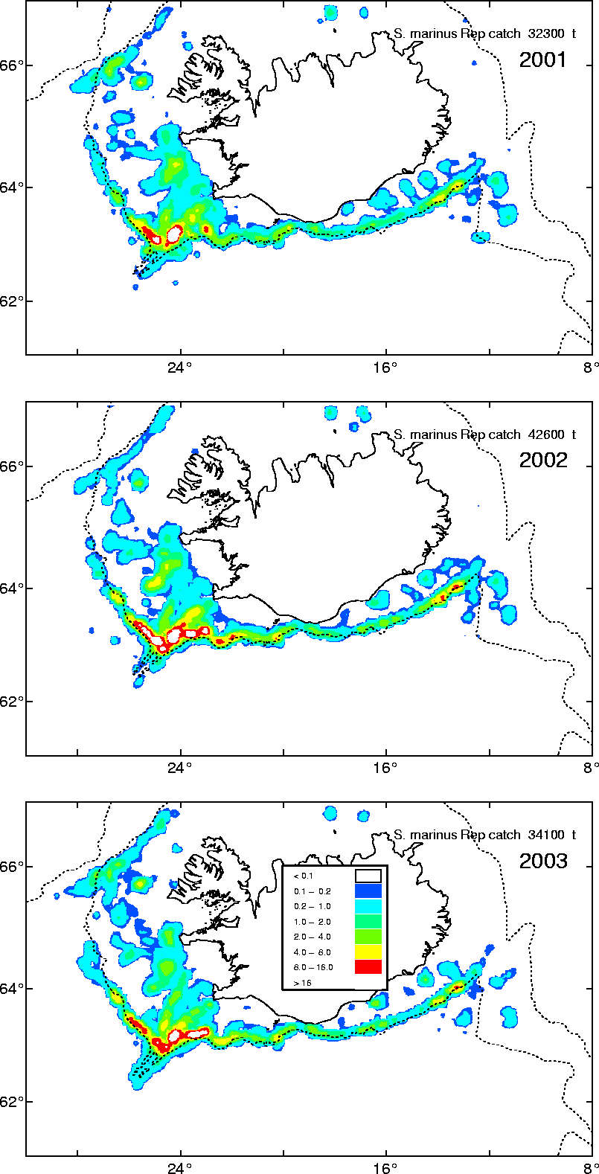
Figure 4: Geographical distribution of S. marinus catch in Iceland grounds (ICES Division Va) 2001-2003 as reported in Icelandic log-books.
Figure 5: Un-standardized CPUE from the Icelandic bottom trawlers in 1986-2003. The 10% and 50% mean that at least 10% or 50% of the catch in each haul was S. marinus.
Figure 6: Standardized CPUE of the Icelandic bottom trawlers 1986-2003. The results are based on a generalized linear model.

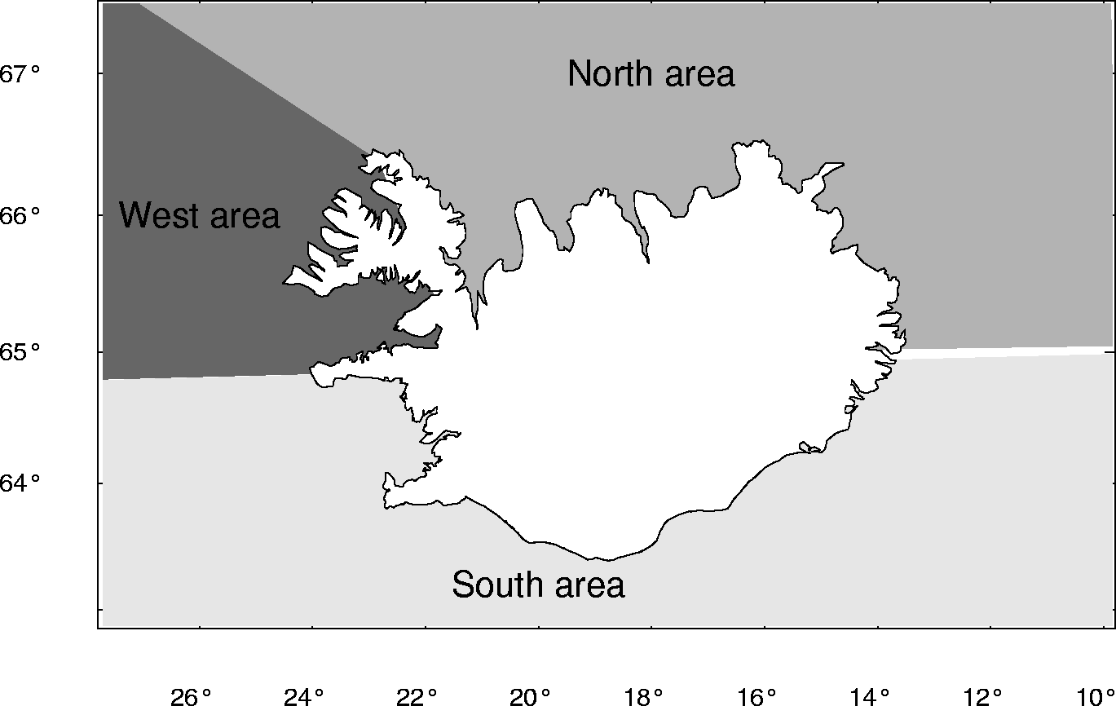
Figure 7: Area division of the groundfish bottom trawl survey conducted annually in March 1985-2004.
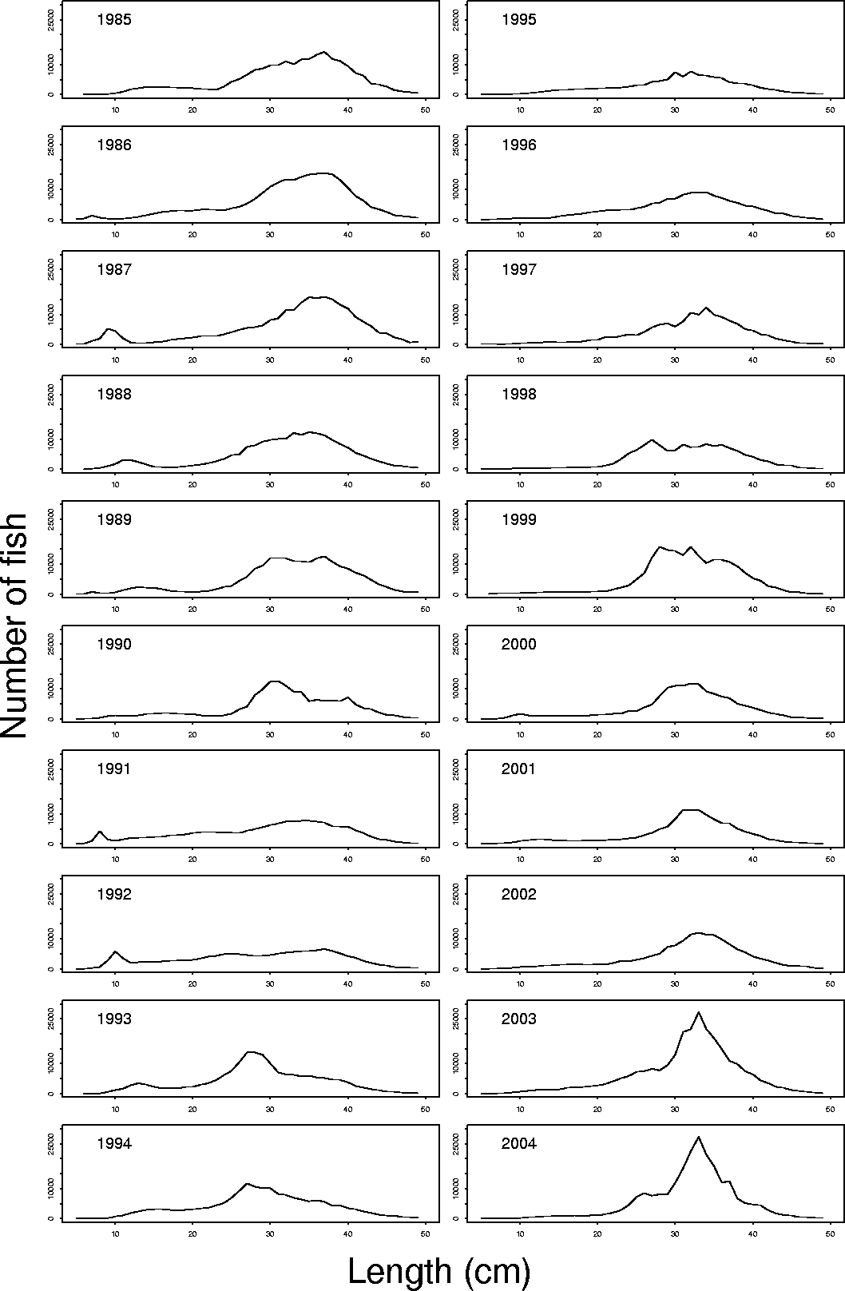
Figure 8: Length distribution of S. marinus from the spring bottom trawl survey in Icelandic waters 1985-2004 – all area.

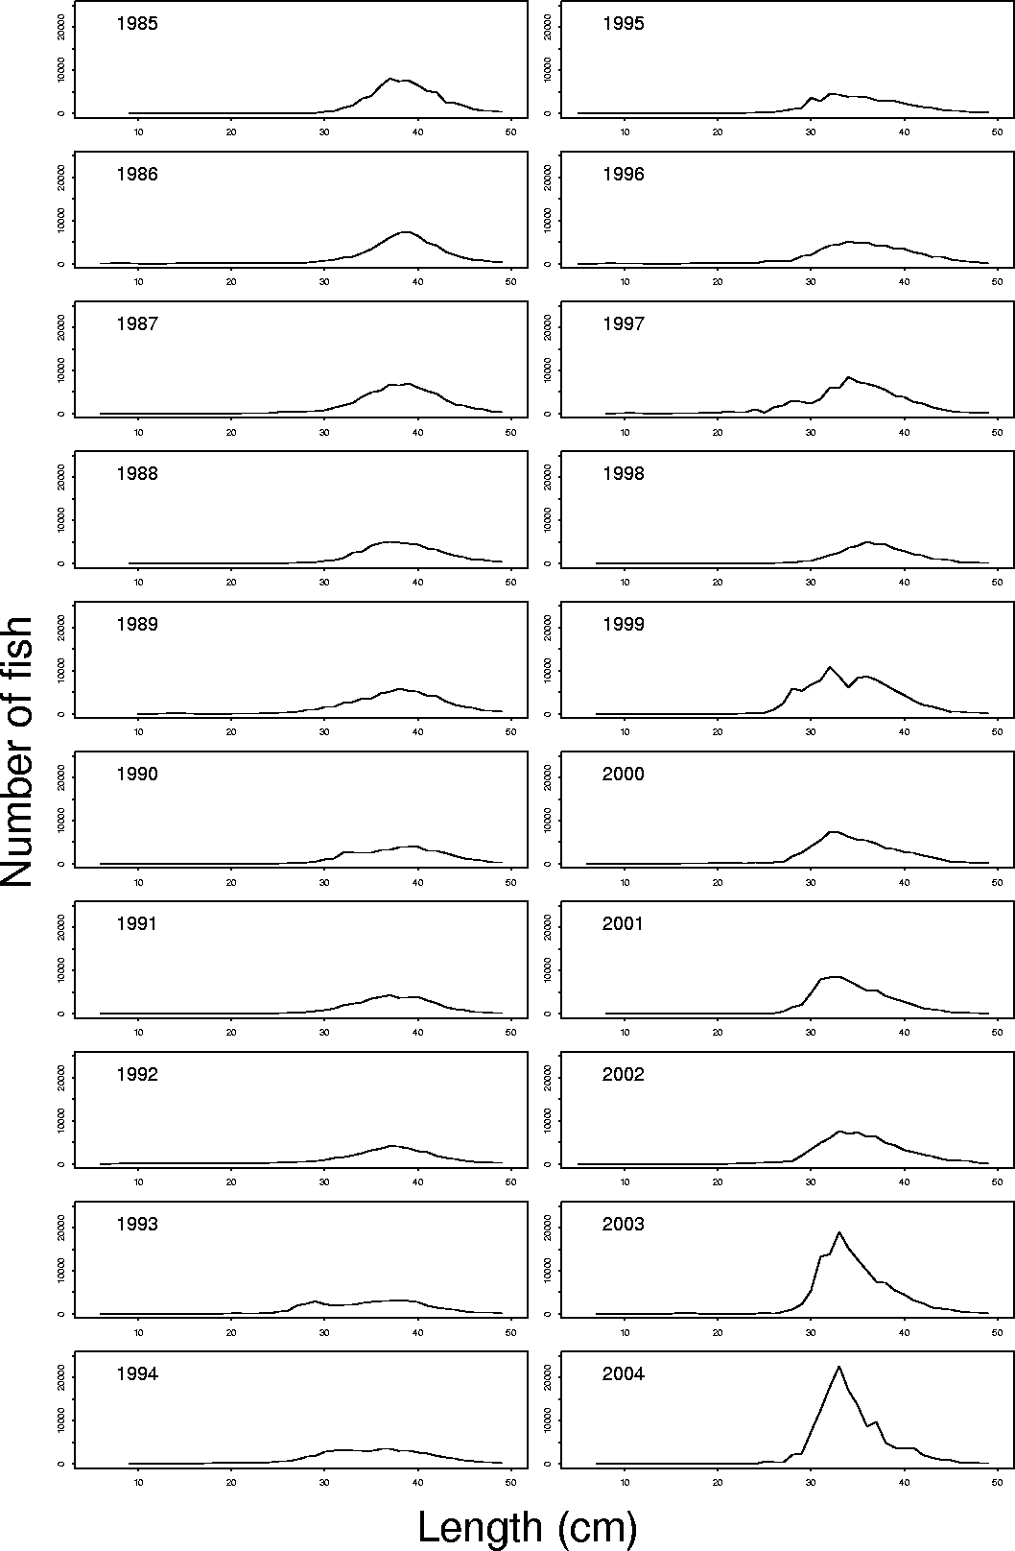
Figure 9: Length distribution of S. marinus from the spring bottom trawl survey in Icelandic waters 1985-2004 – South area.

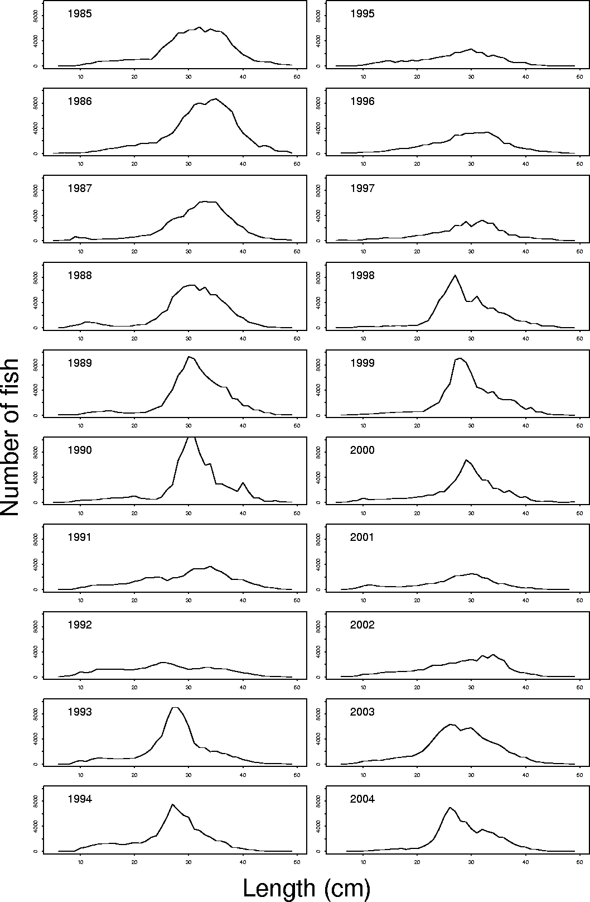
Figure 10: Length distribution of S. mentella from the spring bottom trawl survey in Icelandic waters 1985-2004 – West area.

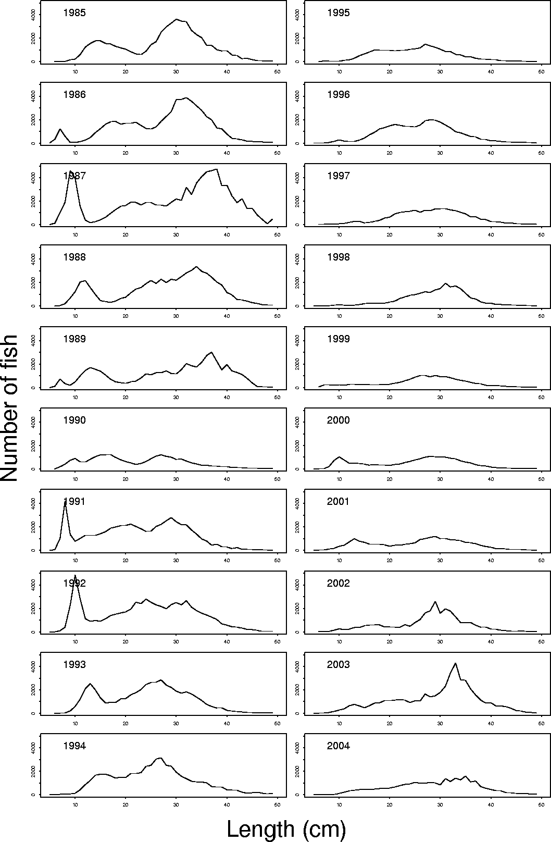
Figure 11: Length distribution of S. marinus from the spring bottom trawl survey in Icelandic waters 1985-2004 – North area.

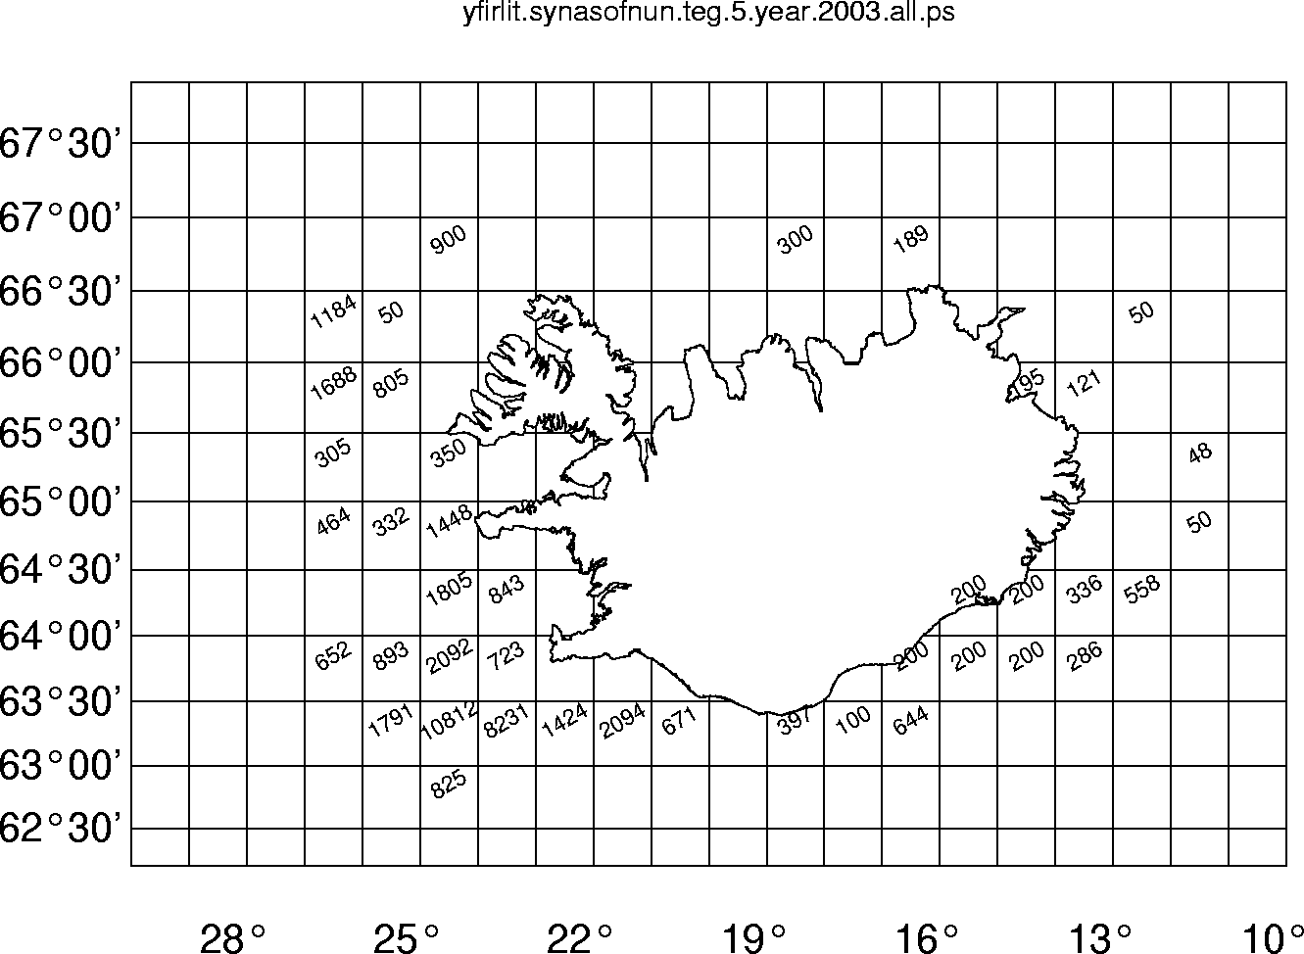
Figure 12: Number of S. marinus sampled from the commercial fleet in Icelandic waters, divided by statistical square.
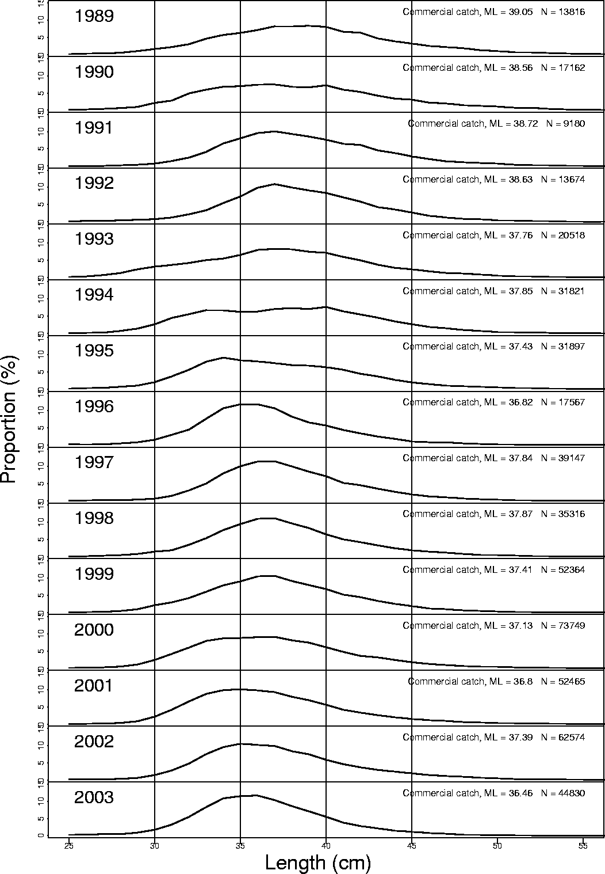
Figure 13: Length distribution of S. marinus from the commercial catch 1989-2003. Also shown are the mean length (ML) of S. marinus in the catch and the number of fish (N) sampled.
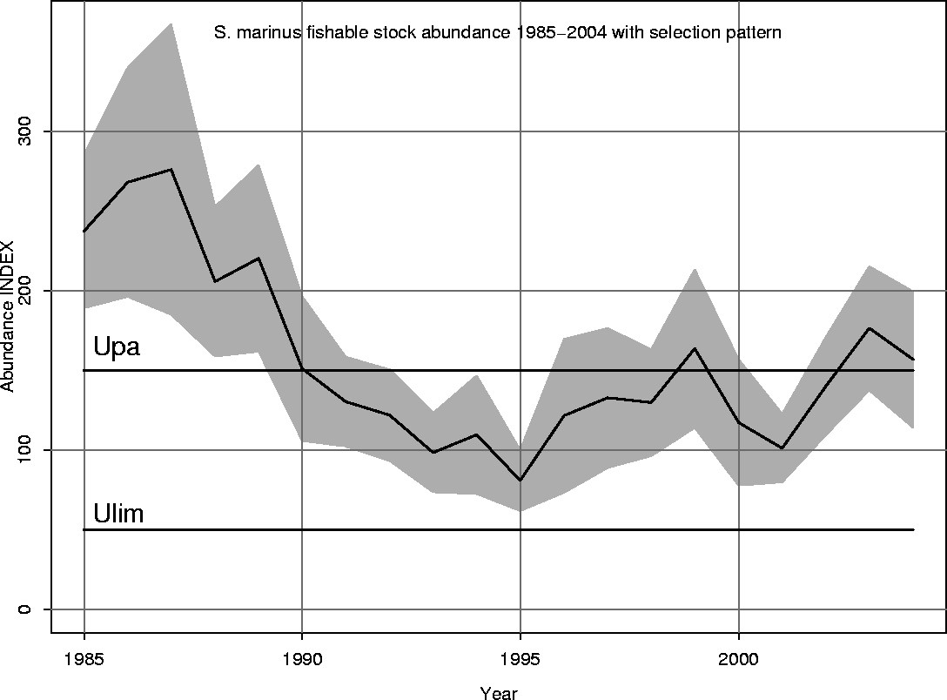
Figure 14: Abundance index of the fishable stock of S. marinus 1985-2004 (with selection pattern, see Figure 15).

Figure 15: Selection pattern of S. marinus from the groundfish survey.
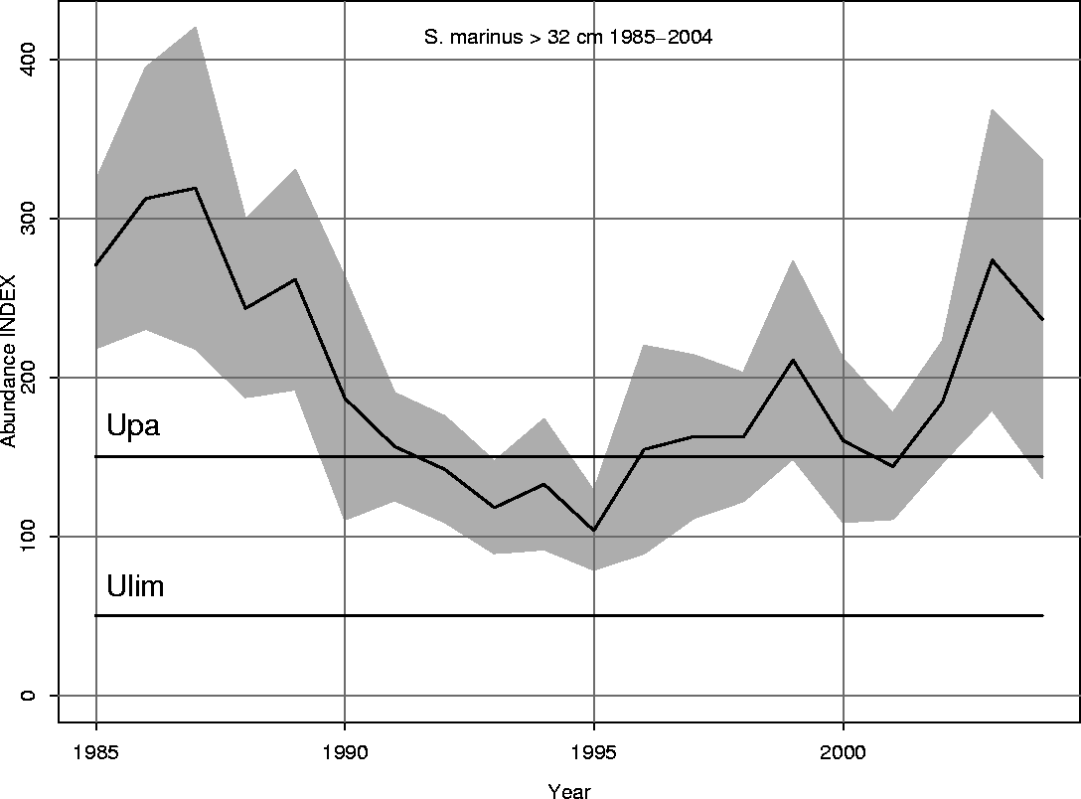
Figure 16: Abundance index of S. marinus bigger than 32 cm in the spring groundfish survey 1985-2004.

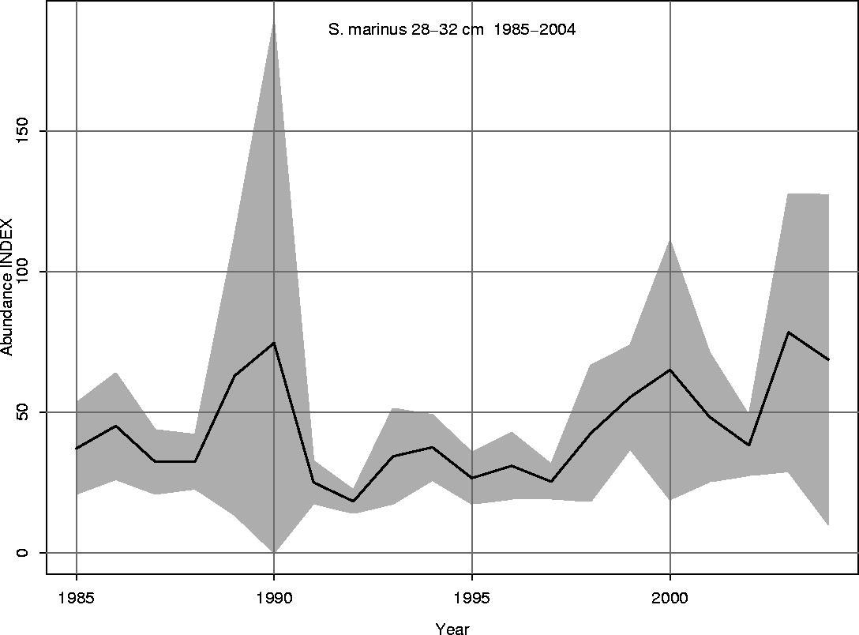
Figure 17: Abundance index of S. marinus (28-32 cm) in the spring groundfish survey 1985-2004.
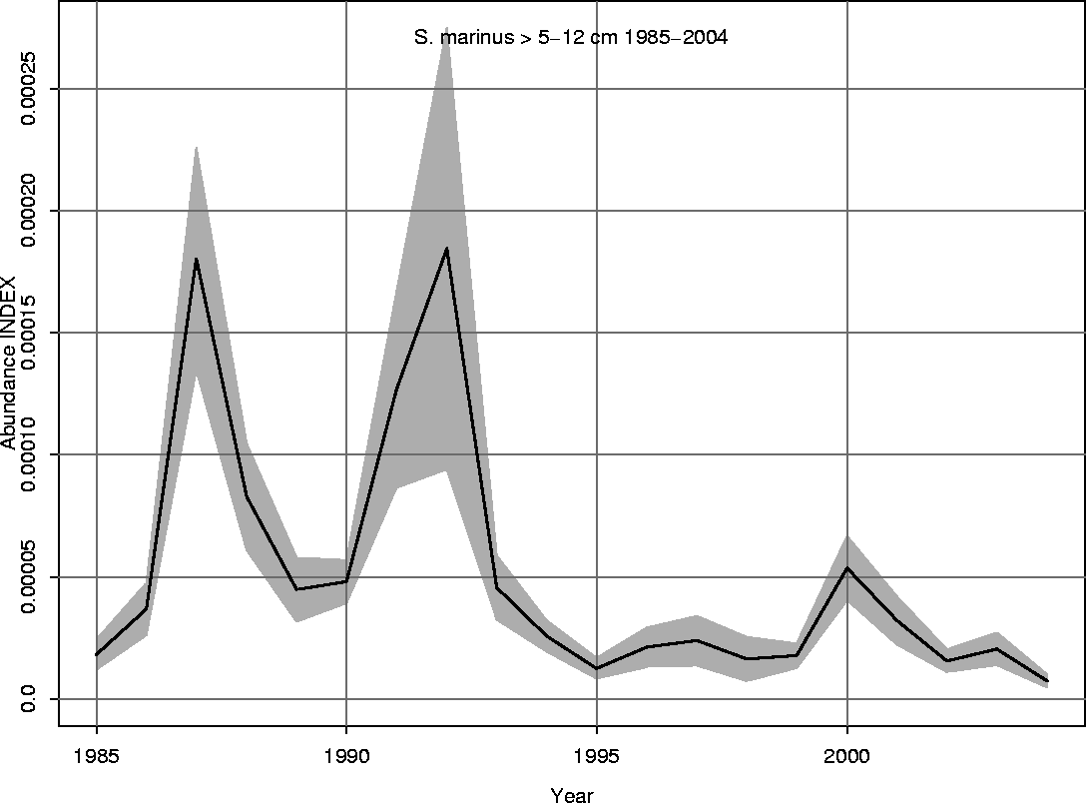
Figure 18: Abundance index of juvenile S. marinus in the spring groundfish survey 1985-2004.

Table 5: Abundance index divided by depth intervals from the Icelandic spring survey.
 | Depth intervals
Year | < 100 m | 100-200 m | 200-400 m | 400-500 m | 0-400 m | Total
1985 | 7.0 | 90.7 | 139.7 | 23.6 | 237.4 | 261.1
1986 | 2.0 | 86.1 | 179.9 | 12.1 | 268.0 | 280.1
1987 | 2.0 | 123.8 | 150.2 | 10.0 | 276.0 | 286.0
1988 | 1.1 | 94.6 | 110.1 | 4.0 | 205.8 | 209.7
1989 | 1.1 | 101.4 | 117.8 | 10.9 | 220.2 | 231.1
1990 | 2.3 | 67.9 | 81.0 | 22.2 | 151.2 | 173.4
1991 | 1.7 | 75.9 | 52.6 | 8.3 | 130.3 | 138.6
1992 | 1.2 | 62.2 | 58.5 | 9.4 | 121.9 | 131.3
1993 | 0.7 | 47.5 | 50.2 | 16.6 | 98.4 | 115.0
1994 | 0.5 | 57.7 | 51.4 | 1.3 | 109.6 | 110.9
1995 | 0.3 | 36.0 | 44.6 | 11.2 | 81.0 | 92.1
1996 | 0.8 | 44.3 | 76.5 | 21.1 | 121.5 | 142.6
1997 | 1.0 | 60.3 | 71.5 | 33.6 | 132.7 | 166.4
1998 | 1.6 | 56.9 | 71.2 | 2.7 | 129.7 | 132.4
1999 | 0.7 | 55.5 | 107.3 | 44.4 | 163.6 | 207.9
2000 | 2.0 | 46.7 | 68.5 | 8.1 | 117.2 | 125.4
2001 | 1.6 | 33.1 | 66.6 | 5.8 | 101.2 | 107.0
2002 | 1.8 | 64.0 | 74.2 | 11.4 | 140.1 | 151.4
2003 | 8.7 | 60.2 | 107.5 | 28.8 | 176.4 | 205.2
2004 | 7.9 | 57.2 | 91.6 | 102.3 | 156.7 | 259.0

Table 6: Abundance index by area of S. marinus from the groundfish survey conducted annually in the spring on the Icelandic continental shelf.
 | Area around Iceland
Year | North | South | Southwest | Southeast
1985 | 33.8 | 227.3 | 200.2 | 28.3
1986 | 41.5 | 238.6 | 217.8 | 21.8
1987 | 66.5 | 219.6 | 185.9 | 34.8
1988 | 37.9 | 171.8 | 149.1 | 40.7
1989 | 31.6 | 199.5 | 172.7 | 29.3
1990 | 8.4 | 165.0 | 149.2 | 29.7
1991 | 13.4 | 125.2 | 110.2 | 17.0
1992 | 18.2 | 113.1 | 100.6 | 13.3
1993 | 9.2 | 105.7 | 89.0 | 18.8
1994 | 12.5 | 98.4 | 69.1 | 30.2
1995 | 5.0 | 87.1 | 72.8 | 15.7
1996 | 7.7 | 134.9 | 121.9 | 13.1
1997 | 10.6 | 155.8 | 112.5 | 43.3
1998 | 10.7 | 121.7 | 94.7 | 27.3
1999 | 7.1 | 200.8 | 178.4 | 22.4
2000 | 6.2 | 119.1 | 95.6 | 23.5
2001 | 8.4 | 98.6 | 81.7 | 16.9
2002 | 8.7 | 142.7 | 114.5 | 28.3
2003 | 20.9 | 184.4 | 162.3 | 22.0
2004 | 13.6 | 245.4 | 211.0 | 51.9

Table 7: Abundance index divided by Bormicon areas of S. marinus from the spring survey conducted annually in the spring on the Icelandic continental shelf.
 | Bormicon Area
Year | Area 1 | Area 2 | Area 3 | Area 4 | Area 5 | Area 6 | Area 7 | Area 8 | Area 9 | Area 10
1985 | 147.1 | 21.0 | 5.8 | 1.1 | 4.5 | 1.4 | 1.2 | 3.4 | 23.7 | 53.1
1986 | 161.3 | 24.1 | 6.1 | 3.3 | 5.8 | 2.1 | 1.1 | 4.6 | 16.1 | 56.5
1987 | 147.9 | 17.8 | 41.8 | 0.8 | 4.1 | 2.0 | 1.1 | 6.4 | 27.3 | 38.0
1988 | 115.8 | 11.9 | 16.3 | 1.7 | 6.2 | 1.7 | 18.0 | 2.2 | 20.4 | 33.4
1989 | 133.3 | 7.2 | 19.2 | 1.4 | 3.2 | 0.7 | 2.5 | 5.8 | 21.0 | 39.5
1990 | 123.3 | 4.3 | 0.3 | 0.1 | 2.8 | 0.9 | 14.0 | 1.0 | 14.7 | 25.9
1991 | 86.9 | 7.5 | 2.5 | 0.2 | 2.4 | 0.8 | 2.0 | 4.9 | 10.0 | 23.3
1992 | 83.1 | 2.5 | 8.9 | 0.4 | 4.6 | 1.9 | 0.8 | 3.9 | 8.6 | 17.5
1993 | 75.6 | 2.8 | 1.9 | 0.5 | 3.0 | 1.0 | 2.1 | 1.3 | 15.4 | 13.4
1994 | 51.5 | 2.3 | 0.6 | 0.4 | 7.7 | 1.5 | 1.0 | 4.3 | 25.0 | 17.6
1995 | 54.0 | 1.1 | 0.6 | 0.1 | 2.2 | 1.0 | 1.4 | 3.2 | 11.2 | 18.8
1996 | 87.7 | 2.8 | 1.4 | 0.5 | 1.7 | 1.3 | 0.0 | 3.5 | 9.6 | 34.1
1997 | 90.6 | 2.3 | 4.4 | 0.2 | 2.6 | 1.2 | 0.0 | 3.6 | 39.7 | 21.9
1998 | 69.9 | 3.3 | 3.7 | 0.2 | 2.0 | 1.4 | 0.3 | 5.1 | 22.0 | 24.7
1999 | 154.4 | 2.8 | 0.7 | 0.2 | 2.3 | 1.2 | 0.0 | 5.7 | 16.8 | 24.0
2000 | 74.1 | 1.5 | 0.9 | 0.4 | 2.2 | 1.2 | 0.0 | 3.4 | 20.1 | 21.6
2001 | 59.0 | 1.6 | 3.0 | 0.3 | 1.7 | 1.8 | 0.0 | 1.9 | 15.0 | 22.7
2002 | 86.1 | 1.9 | 2.2 | 0.4 | 2.6 | 1.6 | 0.1 | 2.4 | 25.8 | 28.4
2003 | 127.3 | 7.2 | 5.0 | 3.8 | 2.9 | 1.9 | 0.0 | 5.4 | 16.6 | 35.1
2004 | 193.1 | 3.5 | 2.4 | 0.6 | 4.0 | 3.1 | 17.5 | 6.2 | 28.2 | 17.9

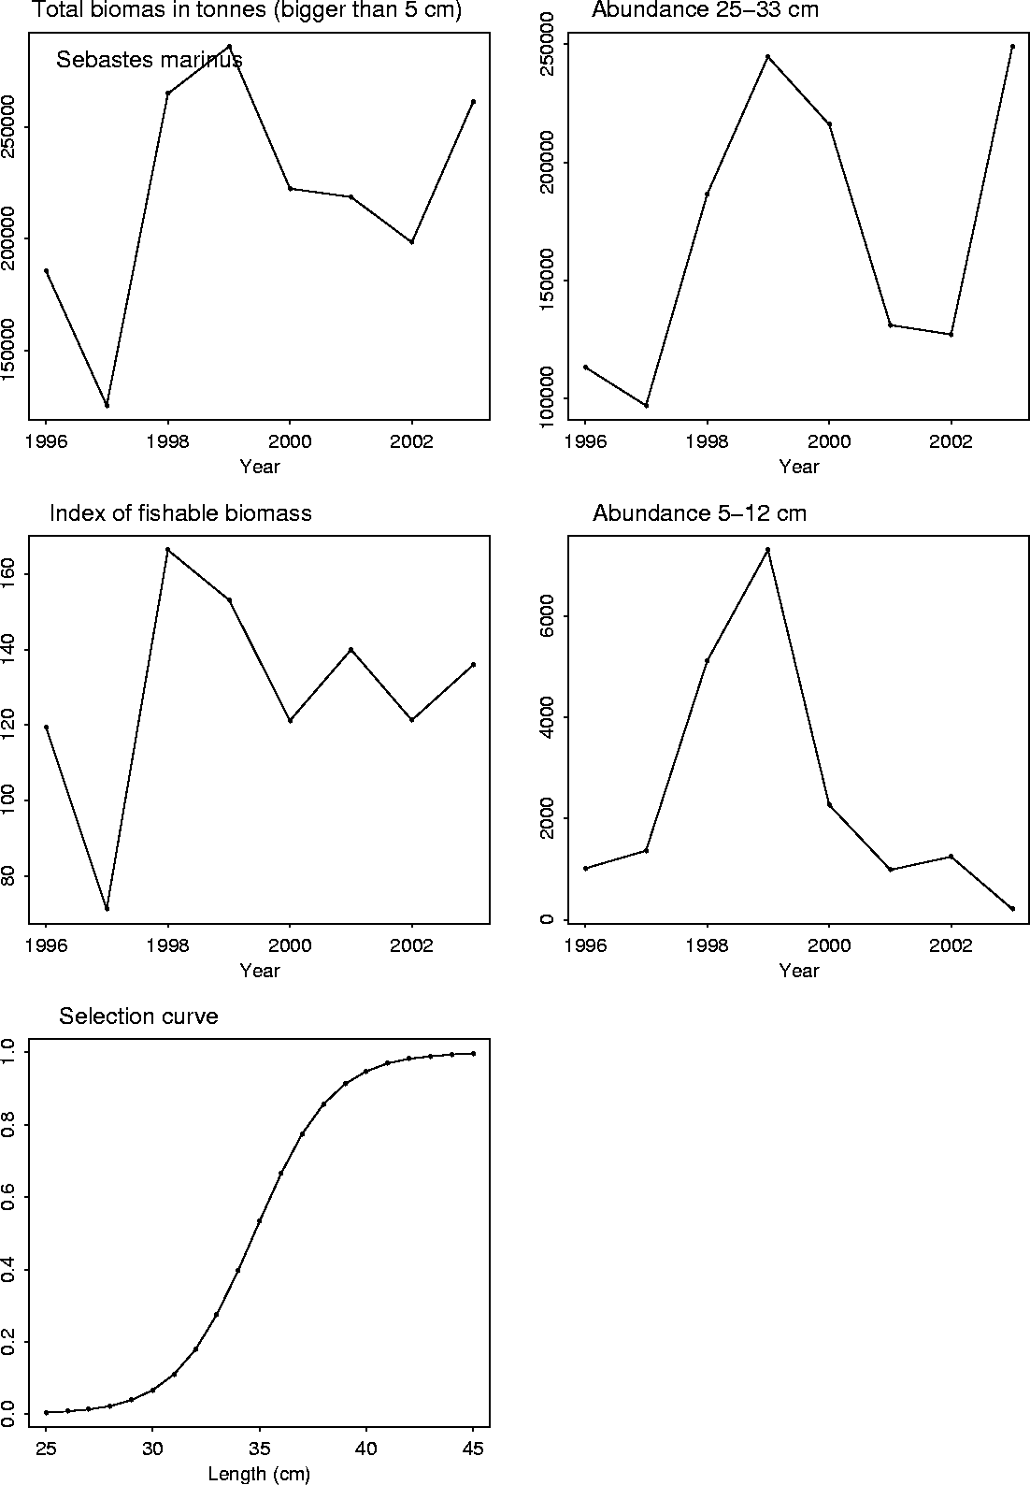
Figure 19: Biomass and abundance indexes of S. marinus from the autumn bottom trawl survey 1996-2003, conducted annually in October.

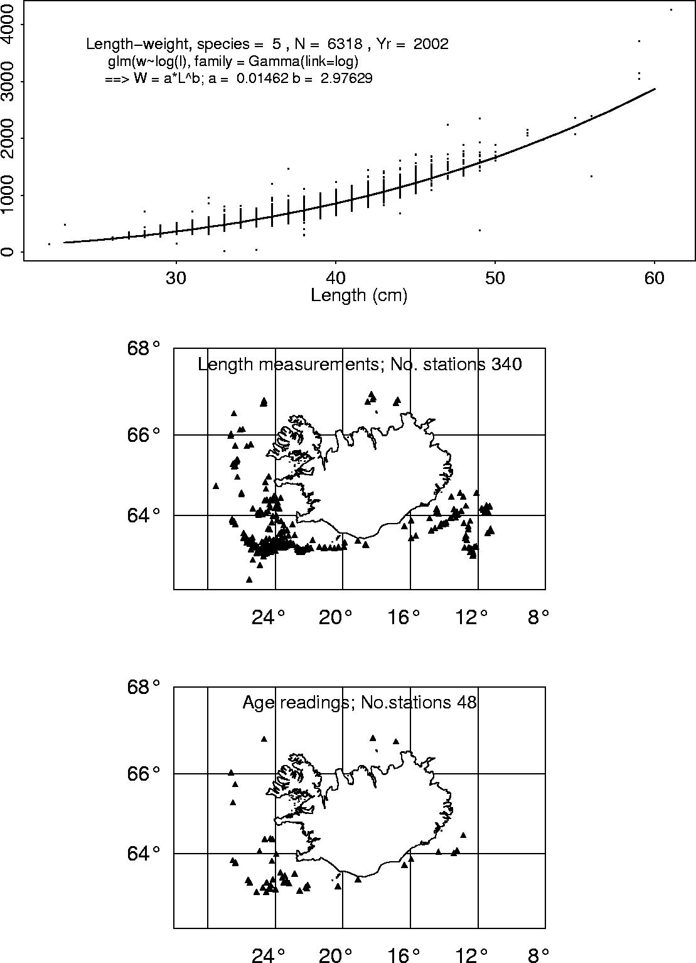
Figure 20: Weight-length relationship of S. marinus in Icelandic waters 2002 from the commercial catch. The figure also shows geographic location of sampling.

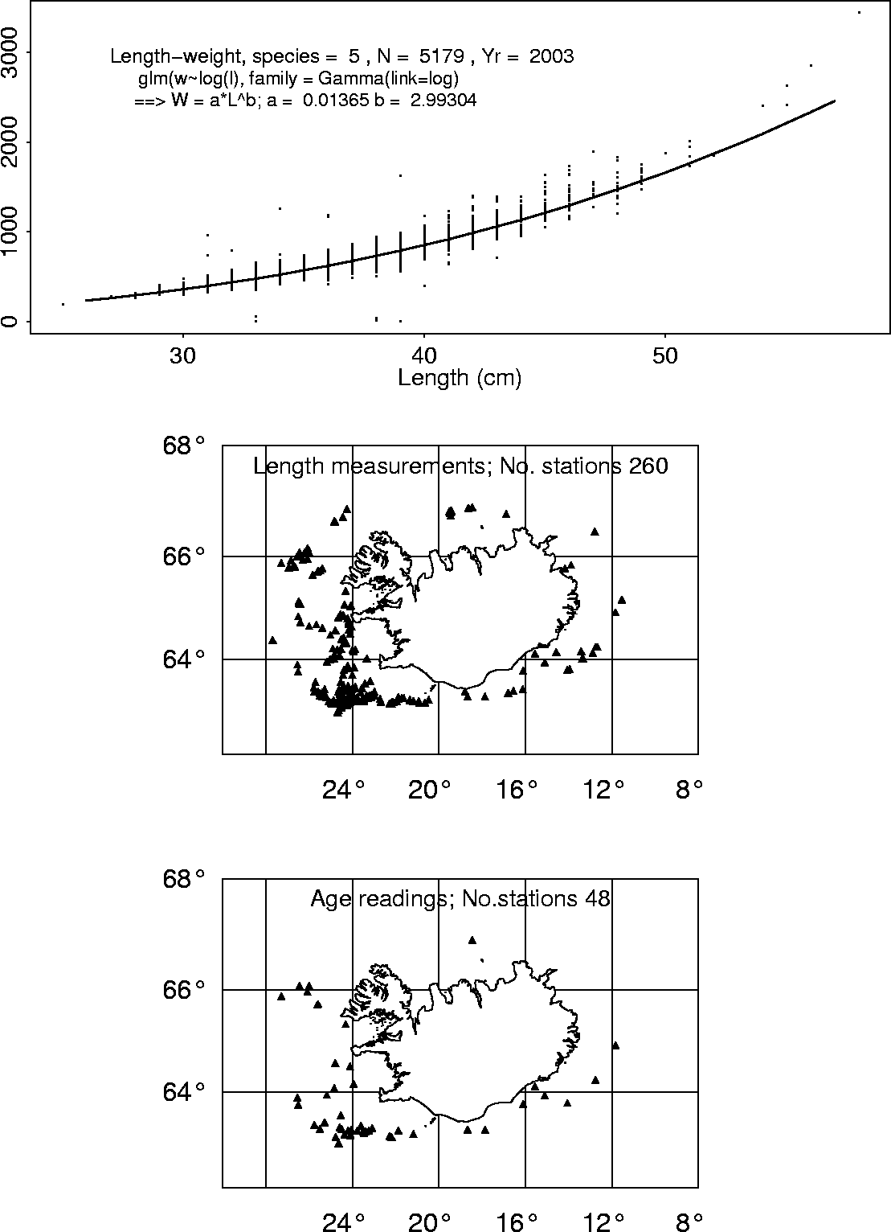
Figure 21: Weight-length relationship of S. marinus in Icelandic waters 2003 from the commercial catch. The figure also shows geographic location of sampling.

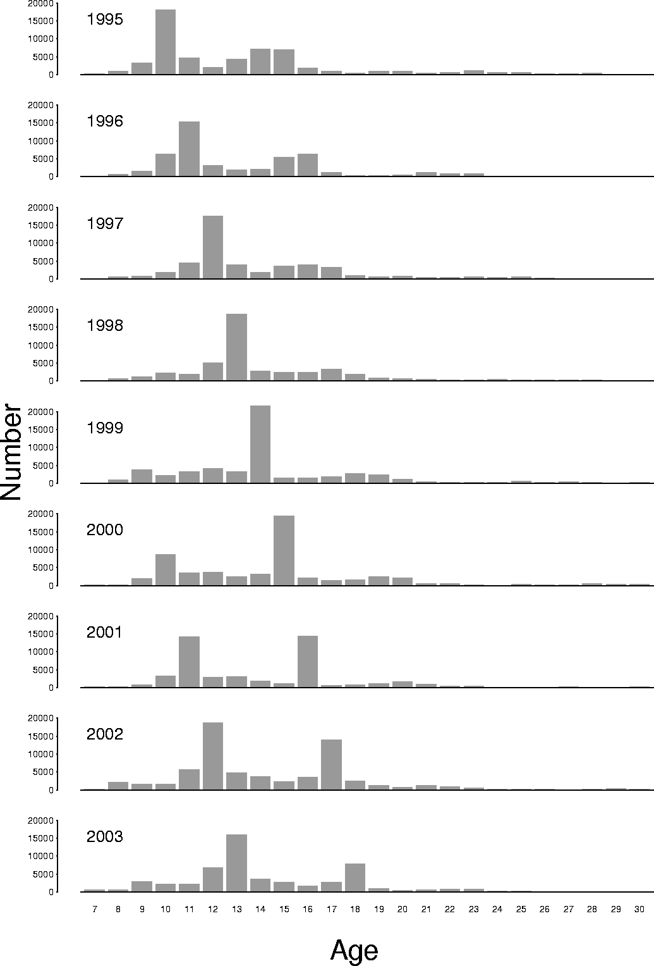
Figure 22: Age distribution of S. marinus from the commercial catch in Icelandic waters 1989-2003.
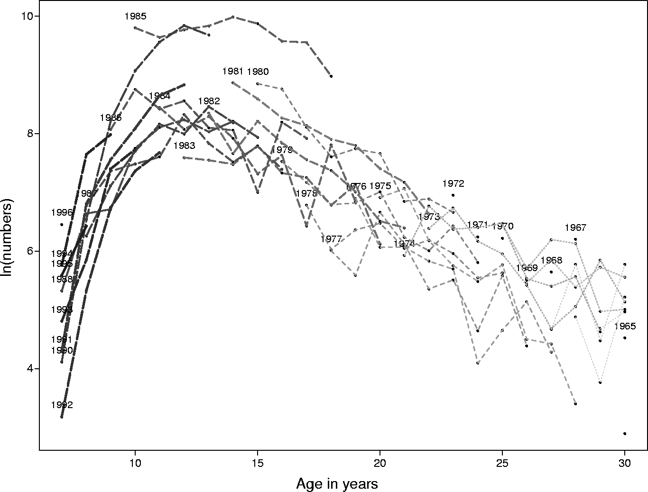
Figure 23: Catch curve based on the catch data 1995-2003 in ICES Division Va.

Table 8: Estimation of total mortality (Z) of various age groups of S. marinus based on catch in numbers.
 | Estimated | Estimated
Age | 2003 | 2004
12-25 | 0.145 | 0.166
13-25 | 0.173 | 0.195
14-25 | 0.198 | 0.220
15-25 | 0.214 | 0.238
15-20 | 0.197 | 0.232
13+ | 0.171 | 0.196
14+ | 0.193 | 0.219
15+ | 0.205 | 0.234
20+ | 0.179 | 0.197

Table 9: Number of S. marinus by age groups based on catch in numbers (CaNo).
 | Year
Age | 1995 | 1996 | 1997 | 1998 | 1999 | 2000 | 2001 | 2002 | 2003
7 | 204 | 0 | 61 | 73 | 24 | 122 | 316 | 267 | 634
8 | 876 | 762 | 523 | 690 | 905 | 207 | 347 | 2093 | 619
9 | 3196 | 1569 | 820 | 1231 | 3729 | 1918 | 847 | 1637 | 2923
10 | 17981 | 6328 | 1776 | 2319 | 2208 | 8696 | 3259 | 1579 | 2277
11 | 4634 | 15303 | 4521 | 2002 | 3314 | 3497 | 14151 | 5682 | 2165
12 | 1979 | 3210 | 17482 | 5183 | 4121 | 3770 | 2961 | 18676 | 6830
13 | 4228 | 1892 | 3977 | 18639 | 3294 | 2515 | 3066 | 4715 | 15951
14 | 7061 | 2123 | 1770 | 2750 | 21645 | 3148 | 1831 | 3672 | 3599
15 | 6965 | 5382 | 3676 | 2423 | 1502 | 19345 | 1096 | 2394 | 2800
16 | 1845 | 6350 | 3886 | 2543 | 1524 | 2058 | 14355 | 3607 | 1627
17 | 879 | 1301 | 3300 | 3407 | 1909 | 1407 | 619 | 14027 | 2748
18 | 405 | 416 | 886 | 2008 | 2709 | 1592 | 879 | 2448 | 7910
19 | 988 | 267 | 577 | 914 | 2298 | 2429 | 1108 | 1256 | 935
20 | 1003 | 428 | 780 | 646 | 1104 | 2118 | 1639 | 670 | 456
21 | 374 | 1166 | 430 | 452 | 424 | 511 | 942 | 1300 | 600
22 | 593 | 869 | 480 | 339 | 212 | 486 | 405 | 982 | 758
23 | 1041 | 841 | 585 | 314 | 296 | 247 | 386 | 619 | 780
24 | 514 | 0 | 477 | 601 | 241 | 60 | 104 | 256 | 333
25 | 502 | 0 | 636 | 383 | 645 | 319 | 105 | 265 | 277
26 | 247 | 0 | 235 | 298 | 225 | 252 | 90 | 170 | 80
27 | 282 | 0 | 106 | 348 | 489 | 108 | 221 | 83 | 72
28 | 493 | 0 | 131 | 322 | 219 | 458 | 157 | 260 | 30
29 | 0 | 0 | 108 | 43 | 88 | 305 | 144 | 346 | 102
30 | 92 | 0 | 18 | 143 | 184 | 321 | 258 | 149 | 170
Table 10: Proportion of number by age groups.
 | Year
Age | 1995 | 1996 | 1997 | 1998 | 1999 | 2000 | 2001 | 2002 | 2003
7 | 0.36 | 0.00 | 0.13 | 0.15 | 0.05 | 0.22 | 0.64 | 0.40 | 1.16
8 | 1.55 | 1.58 | 1.11 | 1.44 | 1.70 | 0.37 | 0.70 | 3.12 | 1.13
9 | 5.67 | 3.26 | 1.74 | 2.56 | 7.00 | 3.43 | 1.72 | 2.44 | 5.35
10 | 31.89 | 13.13 | 3.76 | 4.82 | 4.14 | 15.56 | 6.61 | 2.35 | 4.16
11 | 8.22 | 31.74 | 9.57 | 4.17 | 6.22 | 6.26 | 28.71 | 8.46 | 3.96
12 | 3.51 | 6.66 | 37.01 | 10.78 | 7.73 | 6.75 | 6.01 | 27.81 | 12.49
13 | 7.50 | 3.92 | 8.42 | 38.77 | 6.18 | 4.50 | 6.22 | 7.02 | 29.17
14 | 12.52 | 4.40 | 3.75 | 5.72 | 40.60 | 5.63 | 3.71 | 5.47 | 6.58
15 | 12.35 | 11.16 | 7.78 | 5.04 | 2.82 | 34.61 | 2.22 | 3.56 | 5.12
16 | 3.27 | 13.17 | 8.23 | 5.29 | 2.86 | 3.68 | 29.13 | 5.37 | 2.98
17 | 1.56 | 2.70 | 6.99 | 7.09 | 3.58 | 2.52 | 1.26 | 20.89 | 5.03
18 | 0.72 | 0.86 | 1.88 | 4.18 | 5.08 | 2.85 | 1.78 | 3.64 | 14.47
19 | 1.75 | 0.55 | 1.22 | 1.90 | 4.31 | 4.35 | 2.25 | 1.87 | 1.71
20 | 1.78 | 0.89 | 1.65 | 1.34 | 2.07 | 3.79 | 3.32 | 1.00 | 0.83
21 | 0.66 | 2.42 | 0.91 | 0.94 | 0.80 | 0.91 | 1.91 | 1.94 | 1.10
22 | 1.05 | 1.80 | 1.02 | 0.71 | 0.40 | 0.87 | 0.82 | 1.46 | 1.39
23 | 1.85 | 1.75 | 1.24 | 0.65 | 0.56 | 0.44 | 0.78 | 0.92 | 1.43
24 | 0.91 | 0.00 | 1.01 | 1.25 | 0.45 | 0.11 | 0.21 | 0.38 | 0.61
25 | 0.89 | 0.00 | 1.35 | 0.80 | 1.21 | 0.57 | 0.21 | 0.39 | 0.51
26 | 0.44 | 0.00 | 0.50 | 0.62 | 0.42 | 0.45 | 0.18 | 0.25 | 0.15
27 | 0.50 | 0.00 | 0.22 | 0.72 | 0.92 | 0.19 | 0.45 | 0.12 | 0.13
28 | 0.87 | 0.00 | 0.28 | 0.67 | 0.41 | 0.82 | 0.32 | 0.39 | 0.05
29 | 0.00 | 0.00 | 0.23 | 0.09 | 0.16 | 0.55 | 0.29 | 0.51 | 0.19
30 | 0.16 | 0.00 | 0.04 | 0.30 | 0.34 | 0.57 | 0.52 | 0.22 | 0.31

Table 11: Mean length of S. marinus from the commercial catch.
 | Year
Age | 1995 | 1996 | 1997 | 1998 | 1999 | 2000 | 2001 | 2002 | 2003
7 | 28.1 |  | 34.0 | 29.0 | 27.0 | 28.6 | 30.2 | 32.7 | 28.7
8 | 31.1 | 32.3 | 31.5 | 31.1 | 30.8 | 28.4 | 30.4 | 31.6 | 29.3
9 | 32.9 | 33.5 | 34.6 | 32.8 | 31.6 | 31.6 | 32.2 | 32.6 | 32.6
10 | 33.5 | 34.8 | 34.6 | 33.6 | 34.3 | 32.8 | 32.9 | 34.0 | 33.2
11 | 34.8 | 35.0 | 34.9 | 34.6 | 34.1 | 33.9 | 34.0 | 34.5 | 34.5
12 | 36.3 | 36.1 | 36.2 | 35.7 | 35.7 | 35.1 | 35.2 | 35.2 | 35.0
13 | 39.1 | 36.9 | 37.1 | 36.5 | 36.8 | 36.3 | 35.9 | 36.3 | 35.6
14 | 38.6 | 36.9 | 38.2 | 38.0 | 37.2 | 37.6 | 36.6 | 37.4 | 36.4
15 | 39.4 | 39.0 | 39.5 | 39.2 | 37.9 | 37.9 | 38.0 | 38.4 | 37.4
16 | 40.5 | 40.1 | 40.8 | 40.8 | 39.4 | 39.2 | 38.7 | 39.4 | 38.0
17 | 41.1 | 37.4 | 40.4 | 41.4 | 41.0 | 38.9 | 39.2 | 39.7 | 39.3
18 | 40.1 | 40.9 | 41.9 | 41.8 | 41.4 | 41.4 | 39.8 | 39.7 | 39.1
19 | 43.5 | 42.0 | 43.2 | 43.0 | 41.3 | 41.2 | 40.9 | 40.9 | 39.2
20 | 43.4 | 38.7 | 44.2 | 43.2 | 42.6 | 41.7 | 42.8 | 41.5 | 40.3
21 | 45.5 | 42.5 | 42.4 | 43.3 | 43.2 | 42.2 | 41.8 | 42.8 | 41.9
22 | 43.3 | 44.3 | 42.7 | 43.5 | 41.9 | 40.2 | 41.8 | 42.5 | 42.3
23 | 46.0 | 41.3 | 43.8 | 46.0 | 43.8 | 42.2 | 43.3 | 44.4 | 41.6
24 | 45.2 |  | 44.8 | 42.9 | 40.5 | 42.4 | 48.8 | 46.0 | 43.5
25 | 47.7 |  | 44.1 | 45.6 | 46.9 | 44.0 | 44.5 | 43.1 | 43.0
26 | 47.3 |  | 43.8 | 45.6 | 44.7 | 45.3 | 46.6 | 43.1 | 41.1
27 | 44.5 |  | 45.1 | 44.3 | 45.6 | 49.8 | 45.8 | 42.1 | 44.2
28 | 47.0 |  | 48.4 | 42.4 | 42.3 | 43.3 | 45.5 | 43.6 | 41.0
29 |  |  | 46.7 | 44.4 | 44.5 | 44.0 | 42.2 | 47.4 | 42.5
30 | 47.0 |  | 50.0 | 48.3 | 44.8 | 45.8 | 47.1 | 43.6 | 44.1

Table 12: Weight of the catch by age.
 | Year
Age | 1995 | 1996 | 1997 | 1998 | 1999 | 2000 | 2001 | 2002 | 2003
7 | 62 | 0 | 33 | 24 | 7 | 40 | 122 | 130 | 201
8 | 374 | 355 | 230 | 285 | 367 | 65 | 137 | 911 | 211
9 | 1596 | 814 | 481 | 598 | 1643 | 852 | 393 | 768 | 1366
10 | 9436 | 3652 | 1037 | 1214 | 1247 | 4308 | 1615 | 842 | 1121
11 | 2719 | 9007 | 2698 | 1135 | 1840 | 1894 | 7725 | 3191 | 1196
12 | 1319 | 2074 | 11559 | 3258 | 2643 | 2277 | 1799 | 11076 | 3950
13 | 3534 | 1302 | 2822 | 12552 | 2309 | 1703 | 1973 | 3098 | 9764
14 | 5671 | 1458 | 1369 | 2086 | 15583 | 2375 | 1246 | 2633 | 2358
15 | 5971 | 4374 | 3134 | 2039 | 1143 | 14878 | 835 | 1857 | 1976
16 | 1730 | 5599 | 3662 | 2410 | 1309 | 1777 | 11629 | 3030 | 1216
17 | 852 | 923 | 3033 | 3408 | 1849 | 1184 | 520 | 12049 | 2264
18 | 368 | 383 | 900 | 2046 | 2699 | 1624 | 783 | 2098 | 6419
19 | 1134 | 264 | 644 | 1015 | 2272 | 2427 | 1063 | 1173 | 760
20 | 1144 | 336 | 945 | 726 | 1205 | 2191 | 1792 | 662 | 409
21 | 503 | 1200 | 450 | 521 | 482 | 544 | 965 | 1410 | 603
22 | 677 | 1022 | 524 | 390 | 222 | 447 | 418 | 1027 | 790
23 | 1427 | 795 | 689 | 425 | 345 | 270 | 435 | 741 | 754
24 | 664 | 0 | 590 | 662 | 223 | 64 | 168 | 362 | 379
25 | 762 | 0 | 752 | 515 | 936 | 393 | 130 | 294 | 303
26 | 365 | 0 | 271 | 399 | 279 | 340 | 125 | 185 | 74
27 | 350 | 0 | 136 | 425 | 650 | 193 | 291 | 83 | 83
28 | 725 | 0 | 204 | 359 | 230 | 528 | 203 | 297 | 27
29 | 0 | 0 | 150 | 54 | 107 | 371 | 153 | 500 | 106
30 | 133 | 0 | 30 | 225 | 231 | 441 | 374 | 174 | 197

Table 13: Proportion of weight by age.
 | Year
Age | 1995 | 1996 | 1997 | 1998 | 1999 | 2000 | 2001 | 2002 | 2003
7 | 0.15 | 0.00 | 0.09 | 0.07 | 0.02 | 0.10 | 0.35 | 0.27 | 0.55
8 | 0.90 | 1.06 | 0.63 | 0.78 | 0.92 | 0.16 | 0.39 | 1.88 | 0.58
9 | 3.85 | 2.42 | 1.32 | 1.63 | 4.13 | 2.07 | 1.13 | 1.58 | 3.74
10 | 22.73 | 10.88 | 2.85 | 3.30 | 3.13 | 10.46 | 4.63 | 1.73 | 3.07
11 | 6.55 | 26.84 | 7.42 | 3.09 | 4.62 | 4.60 | 22.14 | 6.57 | 3.27
12 | 3.18 | 6.18 | 31.81 | 8.86 | 6.64 | 5.53 | 5.15 | 22.79 | 10.81
13 | 8.51 | 3.88 | 7.77 | 34.14 | 5.80 | 4.14 | 5.66 | 6.38 | 26.73
14 | 13.66 | 4.35 | 3.77 | 5.67 | 39.13 | 5.77 | 3.57 | 5.42 | 6.46
15 | 14.38 | 13.04 | 8.62 | 5.54 | 2.87 | 36.12 | 2.39 | 3.82 | 5.41
16 | 4.17 | 16.68 | 10.08 | 6.56 | 3.29 | 4.31 | 33.33 | 6.24 | 3.33
17 | 2.05 | 2.75 | 8.35 | 9.27 | 4.64 | 2.87 | 1.49 | 24.80 | 6.20
18 | 0.89 | 1.14 | 2.48 | 5.57 | 6.78 | 3.94 | 2.24 | 4.32 | 17.57
19 | 2.73 | 0.79 | 1.77 | 2.76 | 5.71 | 5.89 | 3.05 | 2.41 | 2.08
20 | 2.76 | 1.00 | 2.60 | 1.97 | 3.03 | 5.32 | 5.14 | 1.36 | 1.12
21 | 1.21 | 3.58 | 1.24 | 1.42 | 1.21 | 1.32 | 2.77 | 2.90 | 1.65
22 | 1.63 | 3.04 | 1.44 | 1.06 | 0.56 | 1.09 | 1.20 | 2.11 | 2.16
23 | 3.44 | 2.37 | 1.90 | 1.15 | 0.87 | 0.66 | 1.25 | 1.53 | 2.06
24 | 1.60 | 0.00 | 1.62 | 1.80 | 0.56 | 0.15 | 0.48 | 0.75 | 1.04
25 | 1.83 | 0.00 | 2.07 | 1.40 | 2.35 | 0.95 | 0.37 | 0.61 | 0.83
26 | 0.88 | 0.00 | 0.75 | 1.09 | 0.70 | 0.83 | 0.36 | 0.38 | 0.20
27 | 0.84 | 0.00 | 0.37 | 1.16 | 1.63 | 0.47 | 0.83 | 0.17 | 0.23
28 | 1.75 | 0.00 | 0.56 | 0.98 | 0.58 | 1.28 | 0.58 | 0.61 | 0.08
29 | 0.00 | 0.00 | 0.41 | 0.15 | 0.27 | 0.90 | 0.44 | 1.03 | 0.29
30 | 0.32 | 0.00 | 0.08 | 0.61 | 0.58 | 1.07 | 1.07 | 0.36 | 0.54

Table 14: Mean weight by age of S. marinus in the commercial catch 1995-2003.
 | Year
Age | 1995 | 1996 | 1997 | 1998 | 1999 | 2000 | 2001 | 2002 | 2003
7 | 305 |  | 544 | 328 | 271 | 324 | 384 | 488 | 317
8 | 427 | 466 | 439 | 414 | 406 | 316 | 396 | 435 | 340
9 | 499 | 519 | 587 | 486 | 441 | 444 | 464 | 469 | 467
10 | 525 | 577 | 584 | 523 | 565 | 495 | 496 | 534 | 492
11 | 587 | 589 | 597 | 567 | 555 | 542 | 546 | 562 | 552
12 | 666 | 646 | 661 | 629 | 641 | 604 | 608 | 593 | 578
13 | 836 | 688 | 709 | 673 | 701 | 677 | 644 | 657 | 612
14 | 803 | 687 | 773 | 759 | 720 | 754 | 681 | 717 | 655
15 | 857 | 813 | 853 | 841 | 761 | 769 | 762 | 776 | 706
16 | 938 | 882 | 942 | 948 | 859 | 863 | 810 | 840 | 747
17 | 969 | 710 | 919 | 1000 | 968 | 842 | 840 | 859 | 824
18 | 909 | 921 | 1015 | 1019 | 996 | 1020 | 891 | 857 | 811
19 | 1147 | 990 | 1117 | 1110 | 989 | 999 | 959 | 934 | 813
20 | 1141 | 786 | 1211 | 1124 | 1092 | 1034 | 1094 | 988 | 898
21 | 1345 | 1029 | 1048 | 1152 | 1138 | 1065 | 1024 | 1085 | 1004
22 | 1142 | 1175 | 1092 | 1149 | 1046 | 919 | 1032 | 1046 | 1041
23 | 1371 | 944 | 1178 | 1352 | 1167 | 1093 | 1127 | 1197 | 967
24 | 1292 |  | 1236 | 1100 | 927 | 1065 | 1625 | 1412 | 1136
25 | 1518 |  | 1183 | 1345 | 1452 | 1230 | 1233 | 1111 | 1093
26 | 1480 |  | 1157 | 1342 | 1239 | 1348 | 1388 | 1086 | 933
27 | 1240 |  | 1286 | 1221 | 1330 | 1782 | 1320 | 999 | 1151
28 | 1470 |  | 1552 | 1115 | 1052 | 1155 | 1294 | 1143 | 917
29 |  |  | 1391 | 1243 | 1217 | 1217 | 1061 | 1446 | 1039
30 | 1446 |  | 1684 | 1577 | 1256 | 1376 | 1447 | 1172 | 1160

Table 15: Survey indexes, based on different methods. Raw index indicates standardized survey index and smooth index is a three years running average. Raw and smooth effort is based on raw and smooth survey index respectively.
 |  | 0-400 |  |  |  | All |  |  |  | Median |  |  |  | GLM
 | Catch | Index | Index | Effort | Effort | Index | Index | Effort | Effort | Index | Index | Effort | Effort | Index | Index | Effort | Effort
Year | Va | Raw | Smooth | Raw | Smooth | Raw | Smooth | Raw | Smooth | Raw | Smooth | Raw | Smooth | Raw | Smooth | Raw | Smooth
1985 | 67,312 | 1000 | 1000 | 67 | 67 | 1000 | 1000 | 67 | 67 | 1000 | 1000 | 67 | 67 | 1000 | 1000 | 67 | 67
1986 | 67,772 | 1129 | 1064 | 60 | 64 | 1072 | 1036 | 63 | 65 | 1064 | 1032 | 64 | 66 | 1187 | 1093 | 57 | 62
1987 | 69,212 | 1163 | 1097 | 60 | 63 | 1095 | 1056 | 63 | 66 | 901 | 988 | 77 | 70 | 1041 | 1076 | 66 | 64
1988 | 80,472 | 867 | 1053 | 93 | 76 | 868 | 1012 | 93 | 80 | 744 | 903 | 108 | 89 | 846 | 1025 | 95 | 79
1989 | 51,825 | 928 | 986 | 56 | 53 | 891 | 951 | 58 | 54 | 491 | 712 | 106 | 73 | 871 | 920 | 59 | 56
1990 | 63,156 | 637 | 810 | 99 | 78 | 714 | 824 | 88 | 77 | 386 | 540 | 164 | 117 | 682 | 800 | 93 | 79
1991 | 49,677 | 549 | 704 | 91 | 71 | 536 | 714 | 93 | 70 | 610 | 496 | 81 | 100 | 522 | 692 | 95 | 72
1992 | 51,464 | 513 | 566 | 100 | 91 | 504 | 585 | 102 | 88 | 636 | 544 | 81 | 95 | 323 | 509 | 159 | 101
1993 | 45,890 | 415 | 492 | 111 | 93 | 446 | 495 | 103 | 93 | 588 | 611 | 78 | 75 | 511 | 452 | 90 | 102
1994 | 38,669 | 462 | 463 | 84 | 83 | 426 | 459 | 91 | 84 | 634 | 619 | 61 | 62 | 588 | 474 | 66 | 82
1995 | 41,516 | 341 | 406 | 122 | 102 | 357 | 410 | 116 | 101 | 396 | 539 | 105 | 77 | 221 | 440 | 188 | 94
1996 | 33,202 | 512 | 438 | 65 | 76 | 544 | 442 | 61 | 75 | 649 | 560 | 51 | 59 | 457 | 422 | 73 | 79
1997 | 35,618 | 559 | 471 | 64 | 76 | 634 | 512 | 56 | 70 | 600 | 548 | 59 | 65 | 635 | 438 | 56 | 81
1998 | 36,310 | 546 | 539 | 66 | 67 | 506 | 561 | 72 | 65 | 627 | 625 | 58 | 58 | 526 | 539 | 69 | 67
1999 | 39,824 | 689 | 598 | 58 | 67 | 793 | 644 | 50 | 62 | 510 | 579 | 78 | 69 | 898 | 686 | 44 | 58
2000 | 41,110 | 494 | 576 | 83 | 71 | 478 | 592 | 86 | 69 | 541 | 559 | 76 | 73 | 404 | 610 | 102 | 67
2001 | 34,986 | 426 | 536 | 82 | 65 | 408 | 560 | 86 | 63 | 517 | 523 | 68 | 67 | 461 | 588 | 76 | 60
2002 | 48,648 | 590 | 503 | 82 | 97 | 578 | 488 | 84 | 100 | 430 | 496 | 113 | 98 | 671 | 512 | 72 | 95
2003 | 36,526 | 743 | 586 | 49 | 62 | 782 | 589 | 47 | 62 | 843 | 597 | 43 | 61 | 973 | 702 | 38 | 52
2004 |  | 660 | 664 |  |  | 1054 | 805 |  |  | 741 | 671 |  |  | 959 | 868

Table 16: Catch projection for S. marinus for 2005 based on survey indexes that were estimated using different methods. Effort used is the effort in 2003. The formula calculating the catch for 2005 is: Average survey index 2002-2004 * Effort 2003.
 | 0-400 m |  | All |  | Median |  | GLM
 | Catch | Effort | Catch | Effort | Catch | Effort | Catch | Effort
50% | 20,692 | 31 | 24,936 | 31 | 20,548 | 31 | 22,586 | 26
75% | 31,038 | 47 | 37,404 | 46 | 30,823 | 46 | 33,879 | 39
100% | 41,385 | 62 | 49,872 | 62 | 41,097 | 61 | 45,172 | 52
125% | 51,731 | 78 | 62,339 | 77 | 51,371 | 77 | 56,465 | 65

Table 17: Catch projection for S. marinus for 2005 based on survey indexes that were estimated using different methods. The effort used is the average effort in 1985-2003. The formula calculating the catch for 2005 is: Average survey index 2002-2004 * Average effort 1985-2003.
 | 0-400 m |  | All |  | Median |  | GLM
 | Catch | Effort | Catch | Effort | Catch | Effort | Catch | Effort
50% | 24,868 | 37 | 29,852 | 37 | 25,475 | 38 | 32,367 | 37
75% | 37,301 | 56 | 44,778 | 56 | 38,212 | 57 | 48,551 | 56
100% | 49,735 | 75 | 59,704 | 74 | 50,949 | 76 | 64,734 | 75
125% | 62,169 | 94 | 74,630 | 93 | 63,687 | 95 | 80,918 | 93

Table 18: Comparison of catch projection for S. marinus 2003-2005 using smooth effort (effort based on three years CPUE average from 0-400 m, see Table 15) and raw effort (effort based on raw CPUE from 0-400 m, see Table 15).
 | Smooth Effort |  |  |  |  |  | Raw Effort
 | 2003 |  | 2004 |  | 2005 |  | 2003 |  | 2004 |  | 2005
 | Catch | Effort | Catch | Effort | Catch | Effort | Catch | Effort | Catch | Effort | Catch | Effort
50% | 20,657 | 41 | 24,178 | 41 | 16,331 | 25 | 16,416 | 33 | 28,338 | 48 | 20,692 | 31
75% | 30,986 | 62 | 36,267 | 62 | 24,496 | 37 | 24,624 | 49 | 42,507 | 72 | 31,038 | 47
100% | 41,315 | 82 | 48,356 | 82 | 32,661 | 49 | 32,832 | 65 | 56,676 | 97 | 41,385 | 62
125% | 51,644 | 103 | 60,445 | 103 | 40,827 | 61 | 41,041 | 82 | 70,845 | 121 | 51,731 | 78

The GADGET procedure. The redfish assessment this year used the same settings as last year of course with one year of data added and somewhat more than one year of age data. The total survey index including tow hauls with 15 tons of redfish, were included and the high CV in the survey index was not modeled. Two cases were investigated and the results are presented in Figures 24-30.

Figure 24: Summary of results from base case. Same as last year with fixed selection all the time.

Figure 25: Comparison of results from the base case using fixed annual catch after 2003.

Figure 26: Comparison of results from base case using fixed effort after 2003.
Figure 27: Summary of results from the alternative case, where selection is estimated annually from 1998. Length at recruitment is estimated separately for the 1990 yearclass.
Figure 28: Comparison of results from the alternative case using fixed annual catch after 2003.
Figure 29: Comparison of results from the alternative case using fixed effort after 2003.
Figure 30: Comparison of results of different alternatives this year and last two years.
Figure 30 compares the results of the current assessment with last year assessment and the 2002 assessment. The current assessment is somewhat more optimistic and if 35,000 tonnes were caught annually the catchable biomass would most likely be stable for the next 5 to 10 years. Higher annual TAC than 40,000 tonnes will lead to stock reduction and is not advisable as there is no sign of recruitment can be seen.
It is therefore recommended that the TAC will not exceed 35,000. This figure is though optimistic because of uncertainties in the spring survey.

