ICES North-Western Working Group 2004
Working Doc. 9

Russian fisheries for redfish (Sebastes mentella Travin) and biological data from commercial catches in pelagic waters of NEAFC and NAFO Convention Areas in 1982-2003

By

V.N. Shibanov and S.P. Melnikov

Polar Research Institute of Marine Fisheries and Oceanography (PINRO)
6 Knipovich Street, 183763 Murmansk, Russia

Abstract

The paper presents information on Russian fisheries for redfish (Sebastes mentella Travin) in pelagic waters of NEAFC and NAFO Convention Areas in interannual and seasonal dynamics as well as biological data from commercial catches taken in 1982-2003.

Fishing pattern and effort distribution by fishing grounds are considered both by season and in interannual dynamics. A close relationship is established between distribution of commercial fleet by season, variation of catch, effort and CPUE by month and depth, and main stages of the redfish annual cycle.

In different seasons in pelagic waters of ICES Subareas XII and XIV and in the NAFO Convention Area a single stock of the redfish consisting mostly of mature individuals is being exploited.

It is found that one of reasons behind interannual shift of fishing concentrations (fishing grounds) within the feeding area is variation in oceanographic conditions in the surface layer.

A suggestion to separate out fishing grounds with different TACs on the basis of seasonal shift of the redfish concentrations is considered to be biologically groundless and inexpedient.

In an effort to conserve and rationally exploit the oceanic redfish stock it is necessary to keep a single TAC.

Introduction

At present there is no consensus of opinion regarding number of types (stocks) of the redfish (Sebastes mentella Travin) dwelling in the pelagic waters of the NEAFC and NAFO Convention Areas. In 1990’s, Icelandic scientists put forward an assumption that there were two types (stocks) of the redfish, “oceanic- type” and “pelagic deepwater” redfish, inhabiting the Irminger Sea. Recently some researchers have suggested sharing the single TAC between two fishing areas based on seasonal shift of the fishery by area and depth. Russian researchers adhere to the opinion that in the pelagic waters of the Irminger Sea and Labrador Sea a single redfish commercial stock dwells, and a single TAC should be a management measure for this stock

The main purpose of the analysis of Russian fishery for redfish in this region of the North Atlantic in year-to-year and seasonal dynamic as well as examination of biological data from commercial catches is to extend knowledge of the redfish commercial stock structure. The study of the redfish commercial stock structure is crucial for making recommendations on international management of this stock.

Material and Methods

The paper presents information on distribution, catch and effort (fishing days) of Russian fleet in the fisheries for the redfish in the pelagic waters of the NEAFC and NAFO Convention Areas during 1982-2003 based on fishing logbook data. Unstandardized average catch per unit effort (CPUE) (tonnes/fishing days) was calculated on the basis of daily information. For the period from 1999 to 2003 fisheries information is presented by month and depth range of trawlings. In the above period most of Russian vessels fished using large trawls with vertical opening of 120-140 m and mesh size in a bag of 110-135 mm. The trawling speed was 2.8-3.6 knots.

Biological data were collected by observers onboard fishing vessels during 1982-2003. Data were collected and processed according to methods applied at PINRO (Anon., 2001).

Results

Historical review of Russian fisheries. The possibility to conduct an effective mid-water fishing for redfish in the pelagic waters of the North Atlantic was evidenced by USSR scouting vessels in the beginning of 1980’s. Since 1982, Russia has been one of the active participants of the fishery for oceanic redfish in the Convention Areas of NEAFC and NAFO. For the whole period of fishery Russian catch of the redfish constitutes 0.87 million tonnes or nearly 40% of the total international catch. In the first 8 years of the fishery percentage of Russian catch was 59-100% of the international one and in subsequent years it accounted for 22-25% of that.

Fisheries information for more than 20 years allows to examine Russian fishing pattern, effort distribution by area and depth in both interannual dynamic and by season. At the first stage (1982-1988) Russian fishery for the redfish was carried out mostly in Subarea XIVb at depths less than 500 m (Figure 1a, 1b, 2 and 3). Annual catch of the redfish made up 60-65 thousand tonnes. Fishing season started in early April when redfish females formed dense spawning concentrations in the area of the Reykjanes Ridge slopes in a depth range of 300-500 m. At the end of June – first half of July feeding concentrations of the redfish were fished in a depth range of 70 to 150 m. The fishing season lasted for 4-4.5 months and finished in August. At the second stage (1989-1993) fishing areas were expanded due to fishing grounds in the Subarea XII. Duration of the fishing season was the same as at the first stage, i.e. 4-4.5 months. The fishing depth range during the feeding period widened to 350-400 m. Since late 1980’s, Russian catch of the redfish in this area has reduced. In 1999, the redfish catch was the least for the whole fishing history and constituted 9.6 thousand tones. Fishing effort in 1993 compared to the first years of the fishery decreased by 4-5 times (Figure 4). The reduction in catches was caused by overexploitation of the commercial stock in previous years as well as by the lack of strong yearclasses and curtailment of scouting works in the area. In 1994, following Icelandic fishermen, Russian fishing fleet began to fish the redfish concentrations deeper than 500 m, which gave grounds to mark out the third stage (from 1994 to the present) in the history of Russian fishery. At this stage the duration of fishing season has extended to 7 months. Area of mid-water fishery has embraced ICES Subareas XII and XIVb, and the area of East Greenland. Since 1999, Russian fleet has expanded fishing areas and started to fish for feeding concentrations of the redfish in the NAFO Convention Area (Divs. 1F, 2GHJ). Fishing effort has increased by 42.5% since 2000. The most of catch by Russian fleet is taken at depths more than 600 m. Structure of Russian fishing fleet has experienced considerable changes when outdated vessels of BMRTPT-type are replaced by modern middle- and gross-tonnage vessels of STM-, BMRTIB- and BATM-type.

Seasonal fishing pattern in the Russian fishery. In recent years fishing pattern of the Russian fishery for the redfish on the whole is the same as in the international fishery (Anon., 2002; Anon., 2003). The fishery begins in April in the northwestern Irminger Sea (ICES Subarea XIV) along 200-mile EEZ of Iceland at depths more than 600 m (Figure 5-9). In May-June the fishery covers the most part of Subarea XIV and the main fishing depths are below 600 m. In July, following feeding migration of the redfish towards the main southwestern direction, fishing fleet shifts to the area of East Greenland and Subarea XII, and concurrently the fishery is continued in Subarea XIV. In August, fishing effort is mostly concentrated in the NAFO Convention Area and in the East Greenland where redfish feeding concentrations are mainly fished at depths shallower than 400 m. In September, the fleet is observed to shift from the NAFO Convention area to the east, to Subarea XII. It is caused by migration of a part of individuals after coupling to the open Irminger Sea. In the first ten days of October the fishery in the NAFO Convention Area usually ends. In Subarea XII, the redfish fishery is over at the end of October. Thus, 60% of Russian catch and fishing effort fall on the first half of the year in Subarea XIV, and 40% of the catch and fishing effort fall on the second half of the year in Subarea XII and NAFO Convention Area.

Unstandardized average catch per unit effort (CPUE) by year, depth and season. For the whole period of fishery unstandardized CPUE decreased from 30.6 tonnes/fishing days in 1982 to 17.1 tonnes/fishing days in 2003 or by 44.2%. In the early 1980’s, unstandardized CPUE varied within the range of 30.6-22.8 tonnes/fishing days. After the first years of the stock exploitation CPUE dropped in 1989 down to a minimum of 10.0 tonnes/fishing days (Figure 10). The rise of CPUE in 1994-1996 was mainly due to CPUE increase at depths greater than 600 m (Figure 11). Since 2000, Russian fishing vessels have been observed to increase CPUE. During recent 5 years, two peaks of CPUE have been noted, in June and August, which are related to seasonal peculiarities of formation of fishing concentrations. In June in Subarea XIV at depths below 600 m when fishing for post-spawning concentrations CPUE reaches 17.7 tonnes/fishing days. In August in the NAFO Convention Area at depths shallower than 400 m when catching feeding concentrations, CPUE constitutes 21.4 tonnes/ fishing days (Figure 12).

Biological samples of redfish from commercial catches. Size composition of the redfish from commercial catches by years is shown in Figures 13a and 13b. Analysis of dynamics of the size composition for the whole period of fishery did not reveal a direct relationship between mean length of redfish and size of catch. Variability of the redfish size composition was mainly related to areas and depths of fishing. Maximum mean length of the redfish (37.7 - 40.4 cm) in commercial catches have been observed since second half of 1990’s in the northern open Irminger Sea in Subarea XIVb, where at depths below 500 m concentrations of large mature individuals are fished. In the southern Irminger Sea in Subarea XII, where fishery was mainly conducted at depths above 500 m, average size of redfish in catches was lower (34.3-36.8 cm). In the NAFO Convention Area, average size of the redfish in catches was the least (33.9-34.8 cm).

Sex ratio of the redfish in commercial catches by years is presented in Figure 14. In the first years of fishery catches were dominated by females (70-78%). By the mid-1990’s, the percentage of females decreased twice (down to 39%). Such disproportion in the sex composition was probably caused by adverse effect of the fishery on the structure of the redfish population. The fishery based during the first one and a half decades primarily on spawning and post-spawning concentrations comprising mostly females, led to their overfishing and to the increase of male proportion. The increase of female percentage in 1996-1999 up to 54-73% was due to the shift of fishing effort towards greater depths, where their proportion was higher (Melnikov, 1998, Bakay and Melnikov, 2001). The shift of fishing effort in recent years towards fishing for feeding concentrations, where males prevail, has resulted in stabilization of female proportion at the level of 42-47%.

Discussion

Analysis of commercial data indicates a close relationship between seasonal distribution of fishing fleet, variation of catch, effort and CPUE by month and depth, and the main stages of the redfish annual life cycle. The shift of the fleet towards southwest in the fishing season was caused by redistribution of the redfish concentrations during their seasonal migration within the population area. In spring and summer in the northern Irminger Sea the fishery is based on spawning and post-spawning concentrations. In the second half of year these concentrations start their migration to southwest, to the southern ICES Subarea XII and NAFO Convention Area. The fishing fleet shifts to the same direction at the same time (Figure 5). Therefore, in the first half of year in the so-called “southwestern area” fishing is impossible because of the absences of fishing concentrations there, which in this period are distributed in the northern Irminger Sea. Evidently, fishery for the redfish in the north of the whole fishing area in the first half of year and in the southwest of the whole fishing area in the second half of year is carried out on concentrations of the single population of S. mentella but not on locally isolated components of the stock. Analysis of the redfish size composition from both commercial catches and survey data (Melnikov and Bakay, 2002) shows that average size of individuals in ICES Subarea XII and NAFO Convention Area is 6 cm less than that in Subarea XIV. Such variability is caused by geographical differentiation of the redfish size composition over the population area. However, despite the difference in the size composition, the majority of individuals in all fishing areas are mature. In Subarea XIV mature redfish account for 92%, in Subarea XII 86% of the redfish are mature and in the NAFO Convention Area mature individuals constitute 88% (Melnikov and Bakay, 2002). Thus, the fishery for redfish is based on the adult mature part of the stock and does not impair the recruitment. A suggestion by some researchers to separate out fishing grounds with different TACs by season just on the basis of the fact of seasonal migration of the redfish concentrations and related to that variation in size composition of catches is groundless from biological standpoint. It is well known that to have distinct reproductive, nursery and feeding areas is typical of the majority of large stocks of commercial fishes (cod, haddock, herring, blue whiting, mackerel etc.). A common feature of fish migration cycle is the occurrence of larger individuals in catches taken on spawning grounds and an increase of smaller fish proportion over feeding area.

Russian summer trawl-acoustic surveys in 1982-1993 showed that the main redfish concentrations were not found further to the west than 42°N but occurred within 200-mile fishing zone of the East Greenland. Since 1994, a shift of the concentrations in westerly direction, to the Labrador Sea, has been observed. The largest shift of the fishing concentrations to NAFO Convention Area was registered in 1999-2001. Formation of considerable fishing concentrations in the NAFO Convention Area is not regular and is due to redistribution of the redfish concentrations from their habitual feeding area to the Irminger Sea, caused by the increased advection of Atlantic waters by the Irminger Current and rise of water temperature in the upper 200-m layer (Melnikov, Pedchenko and Shibanov, 2001). The so-called “southwestern fishing area” has been observed only in recent years but not earlier. It is probable that the variation in oceanographic conditions in the Irminger Sea (temperature decrease in the surface layer) will result in a shift of the redfish concentrations to the northeast, to the habitual feeding and fishing area as in 1982-1995.

Conclusion

- A close relationship of seasonal distribution of fishing fleet and variation of catch, effort and CPUE by month and depth with the main stages of the redfish annual life cycle is found.
- In different seasons in the pelagic waters of ICES Subareas XII and XIV and in the NAFO Convention Area the single commercial stock of redfish composed mainly of mature individuals is being exploited.
- One of the causes of year-to-year shift of the redfish commercial concentrations (fishing areas) within the feeding area is variation of oceanographic conditions in the sea surface layer.
- Separation of isolated fishing grounds with different TACs reasoning from seasonal shift of the redfish concentrations is biologically groundless and inexpedient.

References

Anon. 2001. Instructions and methodological recommendations on sampling and processing of
biological information in areas of investigations by PINRO. PINRO Press, Murmansk, 291 p. (in Russian)
Anon. 2002. Report of the North-Western Working Group. ICES C.M. 2002/ACFM:20, 411 pp.
Anon. 2003. Report of the North-Western Working Group. ICES C.M. 2003/ACFM:24, 379 pp.
Bakay, Yu.I., and S.P. Melnikov. 2002. Vertical structure of Sebastes mentella concentrations in
the pelagic open part of the Irminger Sea. NAFO SCR Doc.02/10, Serial No. N4611,
21 pp.
Melnikov, S.P. 1998. Peculiarities of deepwater redfish, Sebastes mentella, distribution by
depths in the Irminger Sea. NAFO SCR Doc.98/16, Serial No. N2995, 9 pp.
Melnikov, S.P., A.P. Pedchenko and V.N. Shibanov. 2001. On status of the pelagic redfish
aggregations in NAFO Div. 1F. NAFO SCR Doc. 01/115, Serial No. N4503, 20 pp.
Melnikov, S.P., and Yu.I. Bakay. 2002. Spatial structure of pelagic concentrations of Sebastes
mentella of the Irminger Sea and adjacent waters. NAFO SCR Doc. 02/15, Serial No. N4616, 22 pp.

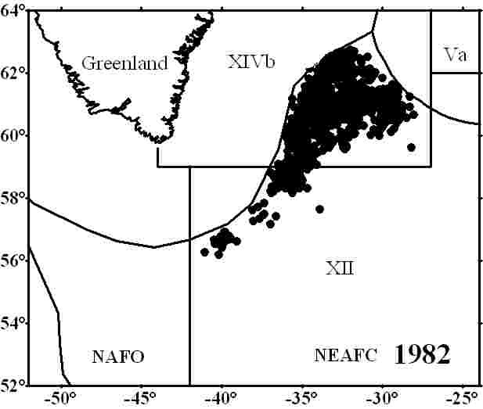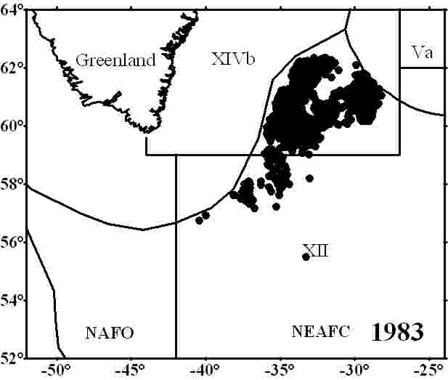
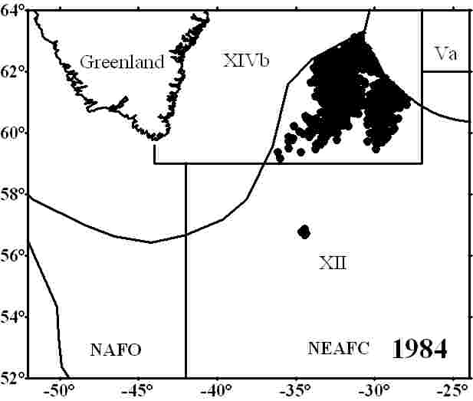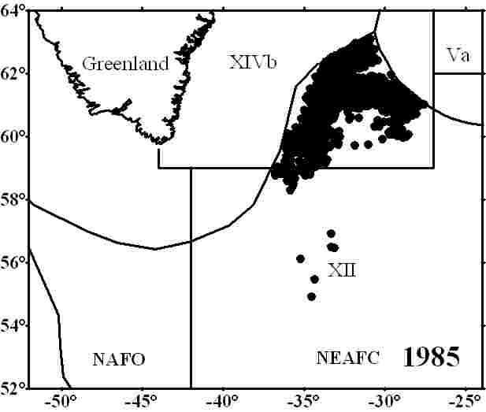
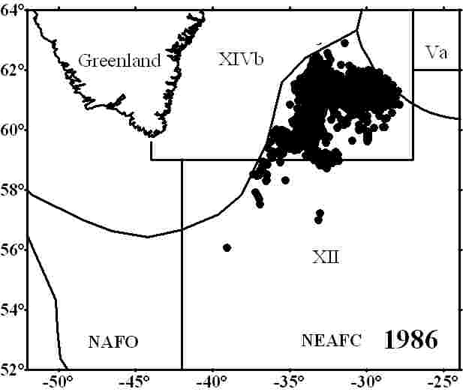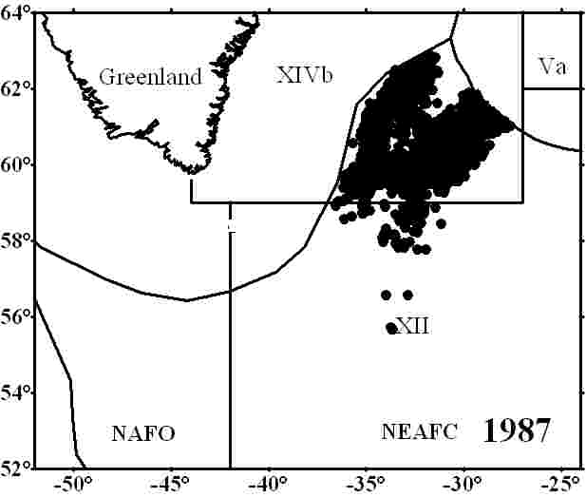
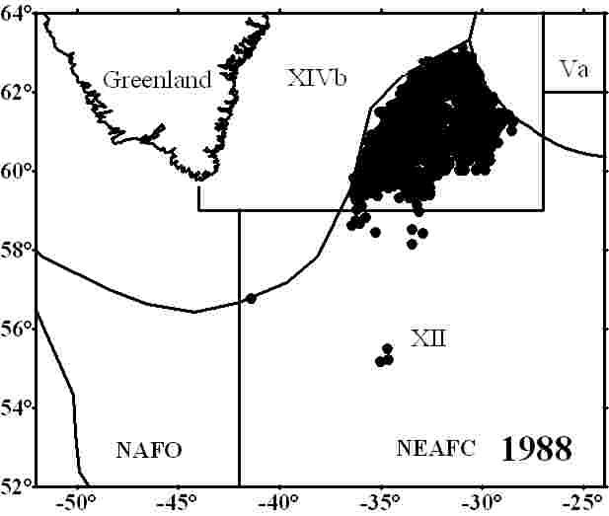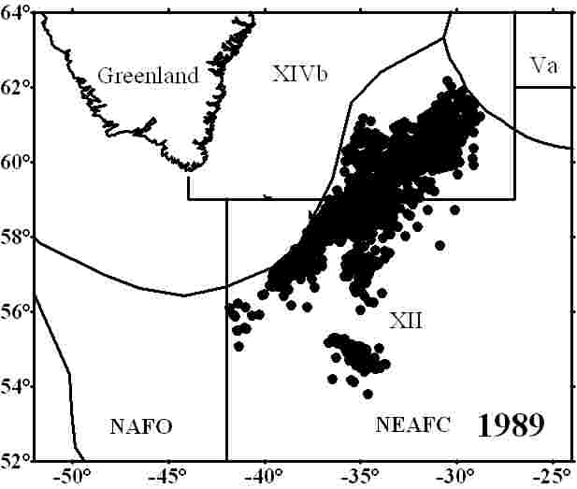
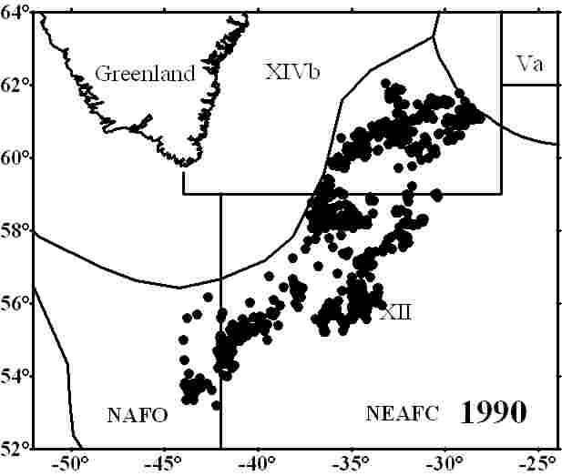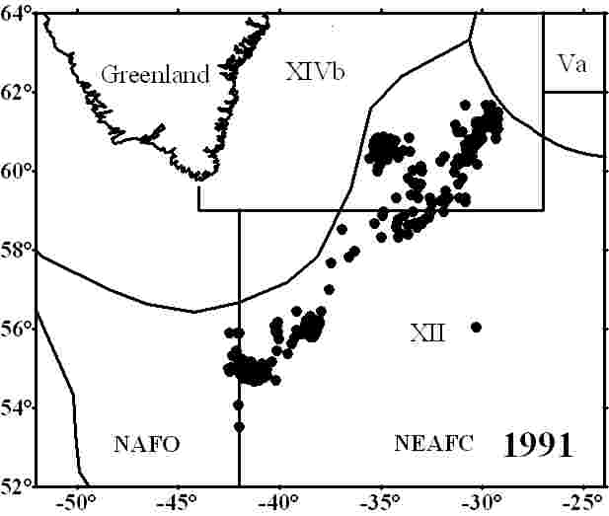
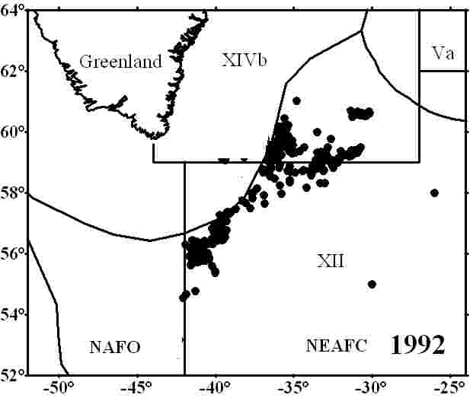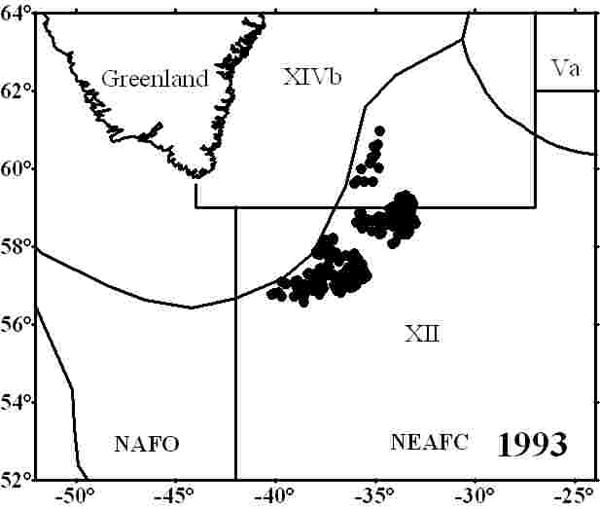

Fig. 1a. Location of the Russian fleet during fishery for S. mentella in the Irminger Sea in
1982-1993.

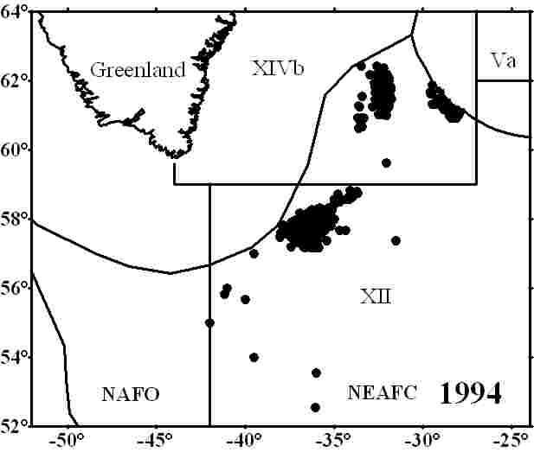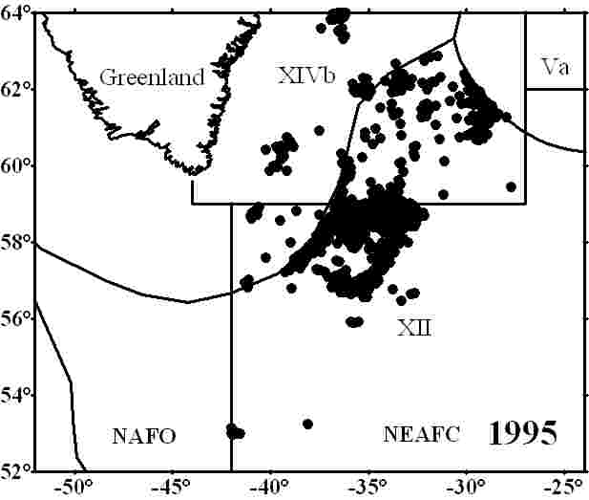
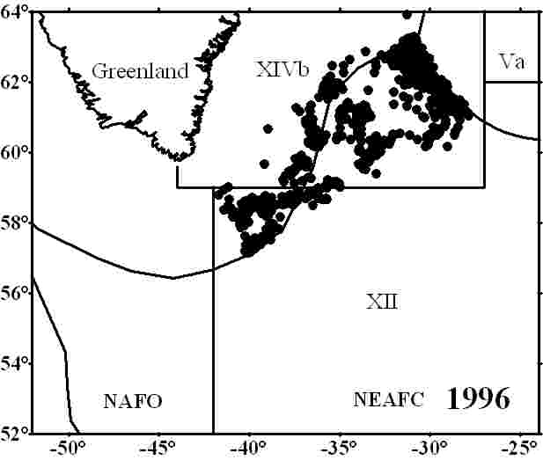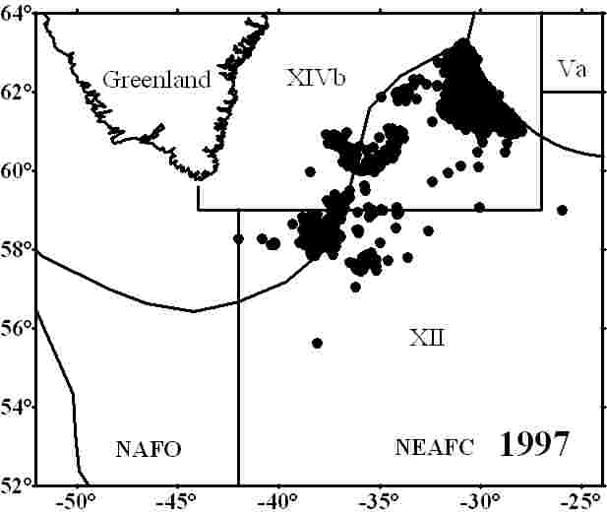
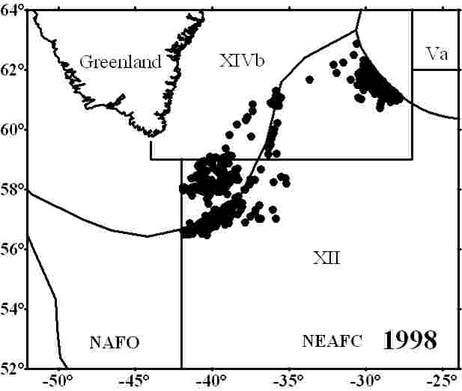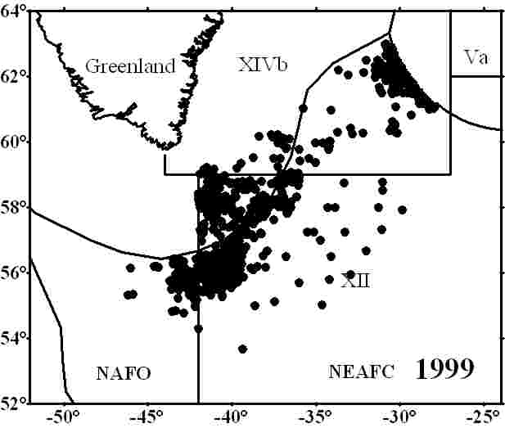
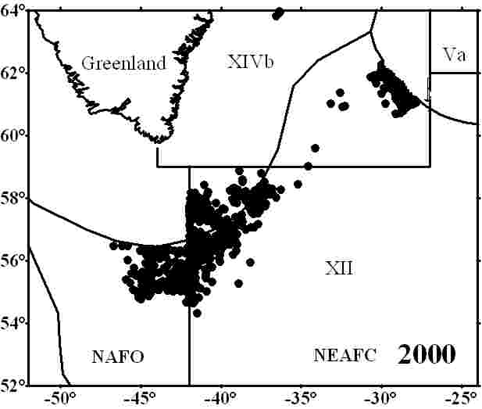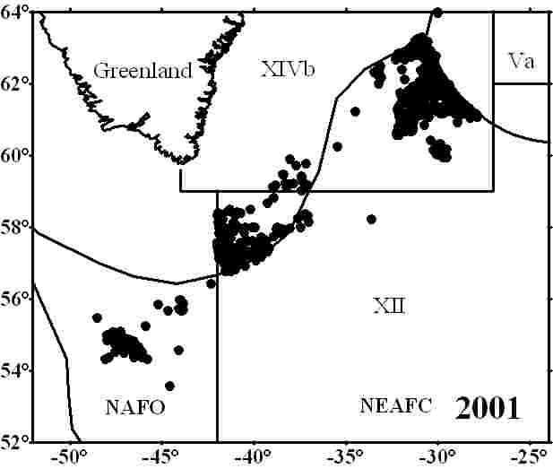
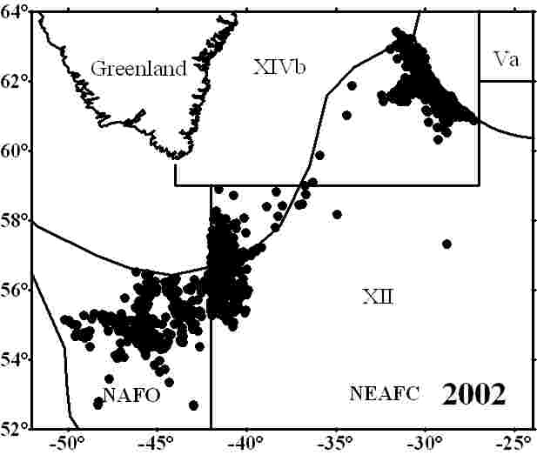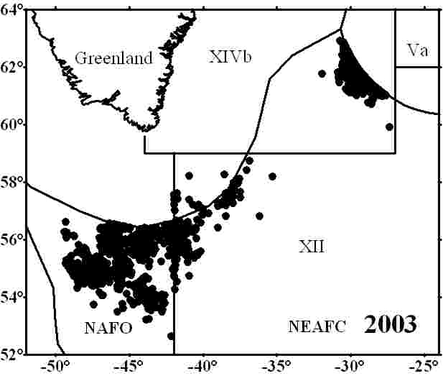

Fig. 1b. Location of the Russian fleet during fishery for S. mentella in the Irminger Sea in
1994-2003.

Fig. 2. Catch of S. mentella by Russian vessels in different layers in the Irminger Sea
in 1982-2003.

Fig. 3. Fishing effort of Russian vessels during fishery for S. mentella in different
layers in the Irminger Sea in 1982-2003.

Fig. 4. Fishing effort by the main types of Russian vessels during fishery for S. mentella
in the Irminger Sea in 1982-2003.

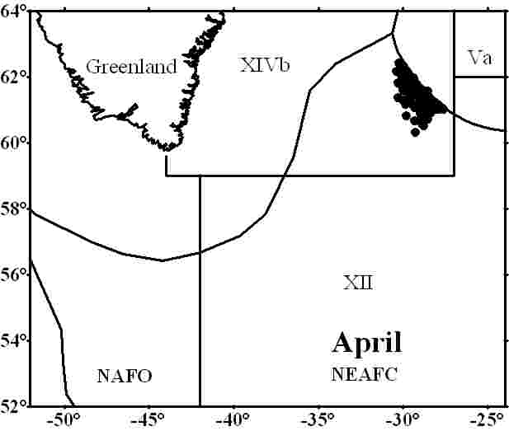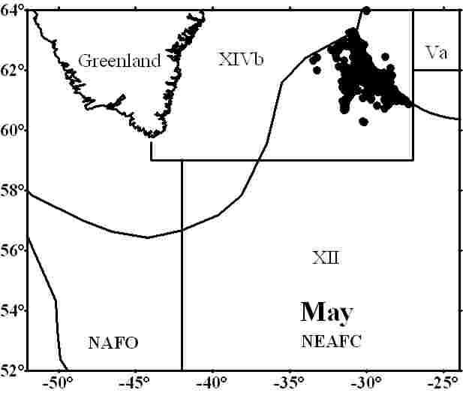
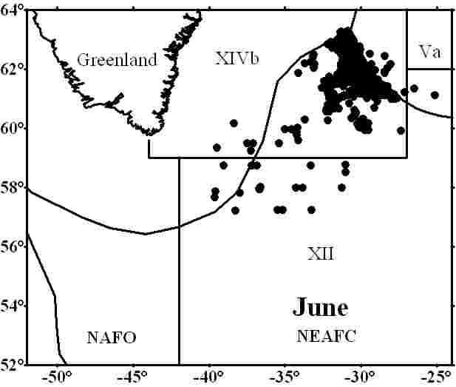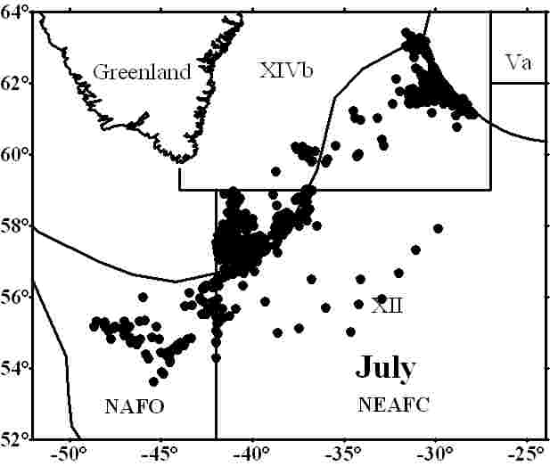
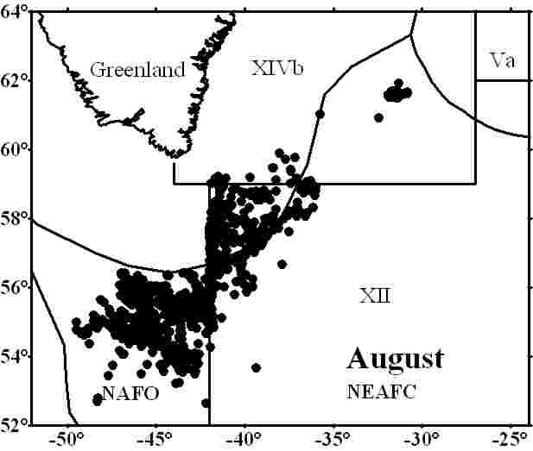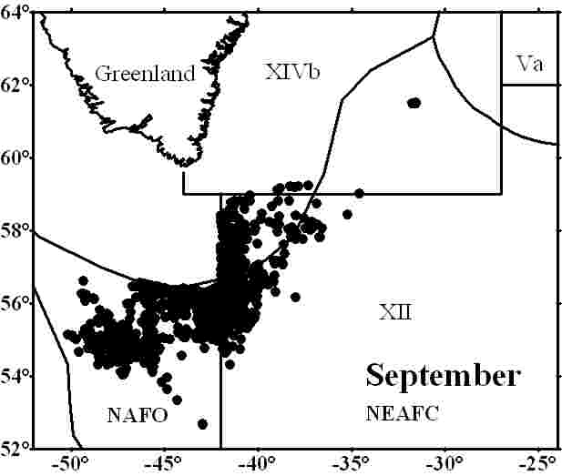
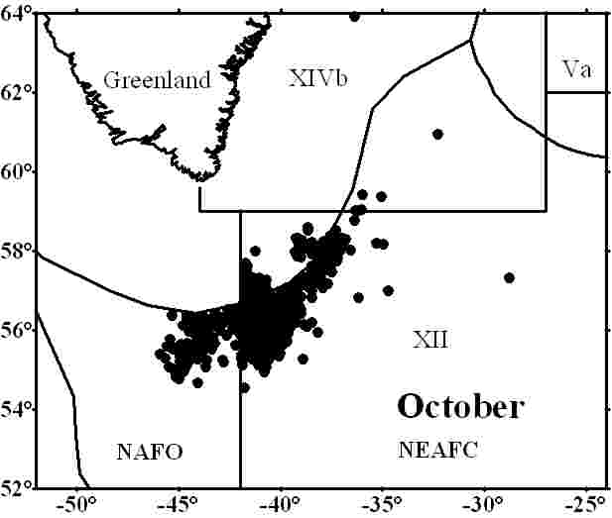

Fig. 5. Location of the Russian fleet by months during fishery for S. mentella in the
Irminger Sea in 1999-2003.

Fig. 6. Seasonal dynamics of the Russian catch of S. mentella in the Irminger Sea
in 1999-2003.

Fig. 7. Seasonal dynamics of the Russian vessels fishing effort during fishery for
S. mentella in the Irminger Sea in 1999-2003.

Fig. 8. Seasonal dynamics of S. mentella catch in different fishing layers in the
Irminger Sea in 1999-2003.

Fig. 9. Seasonal dynamics of Russian vessels fishing effort during fishery for
S.mentella catch in different fishing layers in the Irminger Sea in 1999-2003.

Fig. 10. Unstandardized mean CPUE (tonnes/fishing days) by vessels type (a) and in
general (b) during fishery for S. mentella in the Irminger Sea in 1982-2003.

Fig. 11. Unstandardized mean CPUE (tonnes/fishing days) of the Russian vessels during
fishery for S. mentella in different layers in the Irminger Sea in 1982-2003.

Fig. 12. Seasonal dynamics of unstandardized mean CPUE (tonnes/fishing days) of Russian
vessels during fishery for S. in different layers in the Irminger Sea in 1999-2003.

Fig. 13a. Length composition of S. mentella in the pelagic Irminger Sea from commercial
catches of Russian vessels in 1982-1993.

Fig. 13b. Length composition of S. mentella in the pelagic Irminger Sea from commercial
catches of Russian vessels in 1994-2003.

Fig. 14. Sex ratio of S. mentella in commercial catches of Russian vessels in the pelagic
Irminger Sea in 1982-2003.

