North WesternWorking Group 2003. working paper no 19

information on the Icelandic fishery of oceanic redfish (S.mentella Travin); information based on log-book data and sampling from the commercial fishery

By
Thorsteinn Sigurðsson
Marine Research Institute
Skúlagata 4; P.O.Box 1390
121 Reykjavík
Iceland

Description of the Icelandic fishery. Total of 44.430 t. were caught by the Icelandic fleet in 2002, compared with 42.473 tonnes in 2001. Figure 1.1 shows a contour plot of reported catches for the period 1995-2001 based on the log-book data. As shown, the catches are usually concentrated in the area between the Greenlandic EEZ and the Reykjanes Ridge, and since 1996 the catches have mostly been taken close to or inside the 200 mile boundary Southwest of Iceland, except for 2001 and 2002 where 1/3 and 15% of the catch were caught south of Cape Farwell respectively. The reason was changes in effort regulation for the fishery. Each vessel was forced to fish given proportion of it’s catches south of ca. 62°N in order to spread the effort.
In recent years the fishery have started in late April- early May close to the Icelandic 200 mile boundary and then moved northward in May-July. Then, if the TAC was not reached, the fleet moved to southwest in late summer – autumn. Figure 1.2-1.3 shows the activity of the fleet in 2000-2002. In 1999, the few vessel that had quota left in July, moved to south-west, to the area SA of Cape Farwell, where they fished above 500 m depth yielding a smaller redfish, classified as “oceanic redfish” in late July-October. In 2000, the Icelandic fleet fished nearly exclusively their catches within the Icelandic EEZ. In 2001 and 2002, as described above, 34 and 15% of the catch was fished in the southwestern area in late summer- autumn.
According to the Icelandic fishermen the fishery has been mainly from the same “redfish school” in the period from the start of the fishery in May and throughout the fishing season until July.
In the Icelandic legislation it is set whether the captain shall report their catch as a oceanic redfish or as a deep sea redfish. According to this “law”, all catch outside the Icelandic EEZ shall be reported as oceanic and in addition west of a line which is drawn approximately over the 1000 m isoline. This line is, on Figure 1.4, drawn as a red line west of the Reykjanes Ridge. The figures also show the fishery of redfish with bottom trawl within the Icelandic EEZ.
Based on figures mentioned above, it can not be excluded that the redfish caught as “deep sea redfish on the shelf” in recent years might originate from the same school as the fish caught in the oceanic redfish fishery in the same years. The fishery expanded northward in June/July, and the fishing areas at that time are close to the most important redfish areas on the shelf of Iceland. At the time when the fishing areas are closest to each other, the fishing effort towards the “oceanic quota” has been low, as by then, most of the fishing vessel had reached their allowable catch in the last years.
- Catch composition in the oceanic redfish fishery. During the last years, the Icelandic oceanic redfish fishery has shifted towards greater depths, especially after 1993 (Figure 2.1). As the depth has increased, the vessels are yielding larger redfish (Figure 2.2), which a large proportion of has been classified as a deep see type. Based on this classification (which is questionable), the proportion of each type has been calculated. Table 2.1 gives the results of this calculation based on the samples taken from the fishery since 1995. The mean proportion oceanic redfish in each sample is also shown in figure 2.3. As can be seen, the proportion at given depths can bee highly variable. However, based on this data, the results show that the proportion oceanic redfish has decreased from around 70% in 1995 and down to only 5% in 2000 (Table 2.2), but increased again in 2001 as the effort was spread. Based on the samples, the results indicate that above 600 m depth, the proportion “oceanic” is between 85-100%, as the proportion below 600 m is usually between 0-20% (Figure 2.3). Table 2.3 gives the proportion of males in the catches by months since 1995, divided by possible stocks and also for the total. As seen, the average proportion of males in the samples is usually higher in the first months of each fishing season and the fishery is then more concentrated on newly spawned females. The proportion of immmature fish has been relatively low during the, but has increased in 1999-2000 as there seems to be incoming recruitement (figure 2.4). The proportion immature is however still lower than 5% of the catches.

3. Effort and catch per unit effort by depth and time of year. Table 3.1 and Figures 3.1-3.1 gives the effort and catch as well as CPUE for the Icelandic fleet during the period 1989-2002. In Figure 3.1. the development of CPUE in three depth intervals is illustrated graphically. In general a downward trend is shown in the data from 1994 to 1997 but CPUE seems to have been relatively stable since then.
As can been in Figure 3.3, about 75-90% of the Icelandic catches in 1998-2000 were taken below 600 m depth but in 2001, about 34% of the catches are taken at depths shallower than 400 m. These changes from previous years are due to changes in the regulations as described above.In 2002 the proportion decreased again, due to loop-holes in the regulation of the fishery.
Discard has been estimated during the last years. In 2002 observations were made on several cruises. On these cruises the observers did not record any significant discard unless of some few fishes that were damaged. Therefore, it is assumed that the discard of the Icelandic fleet in 2002 were negligible.
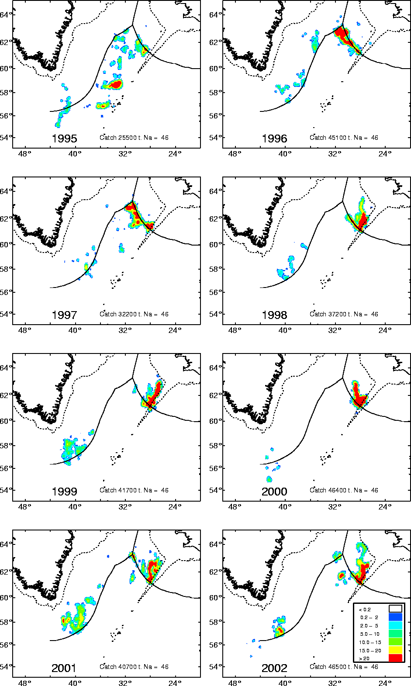
Figure 1.1. Annual Icelandic catch of redfish in the Irminger Sea 1995-2002 (tonnes per square mile). The figures are based on records from fishing vessel log-books.
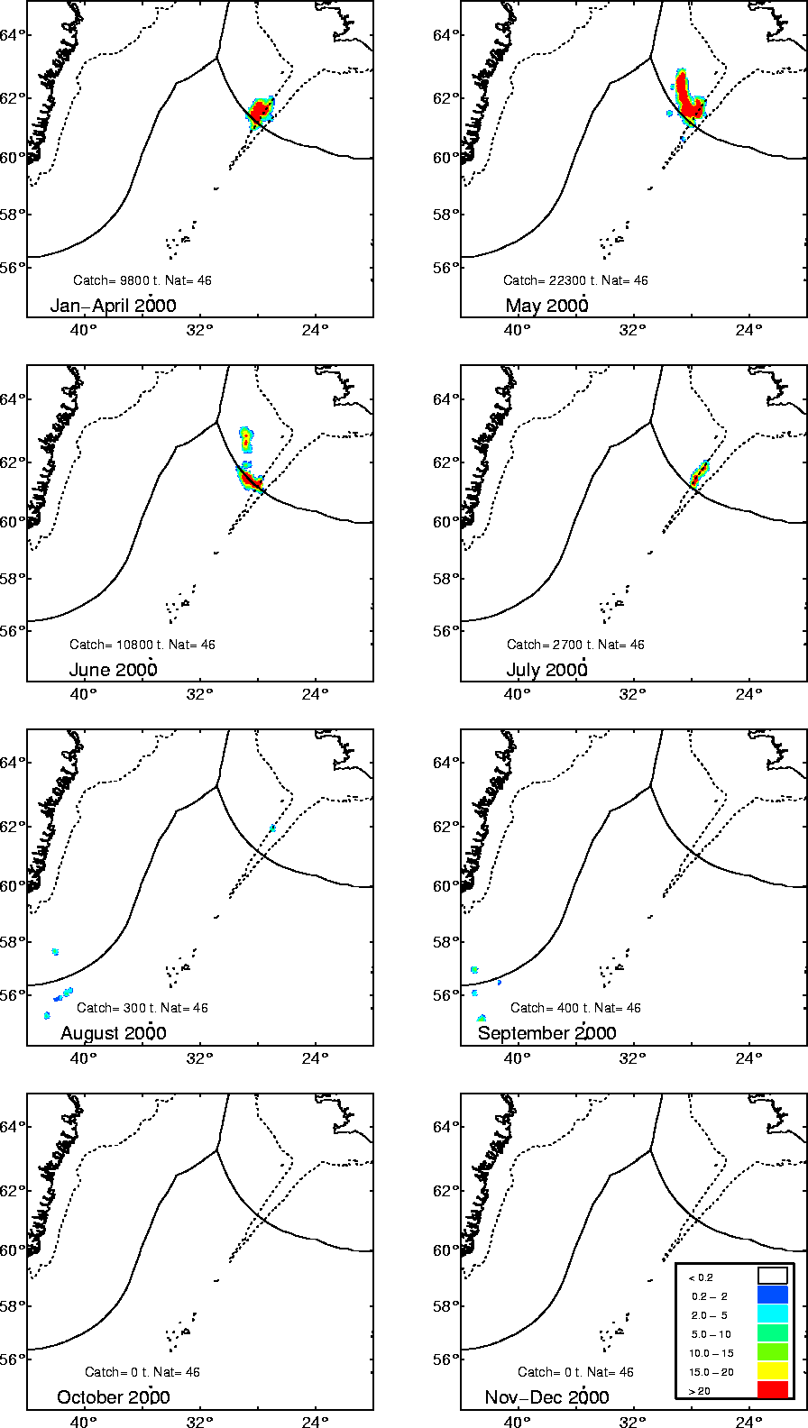
Figure 1.2. Monthly catch of Irminger Sea redfish in 2000. The figures are based on records from fishing vessel log-books.

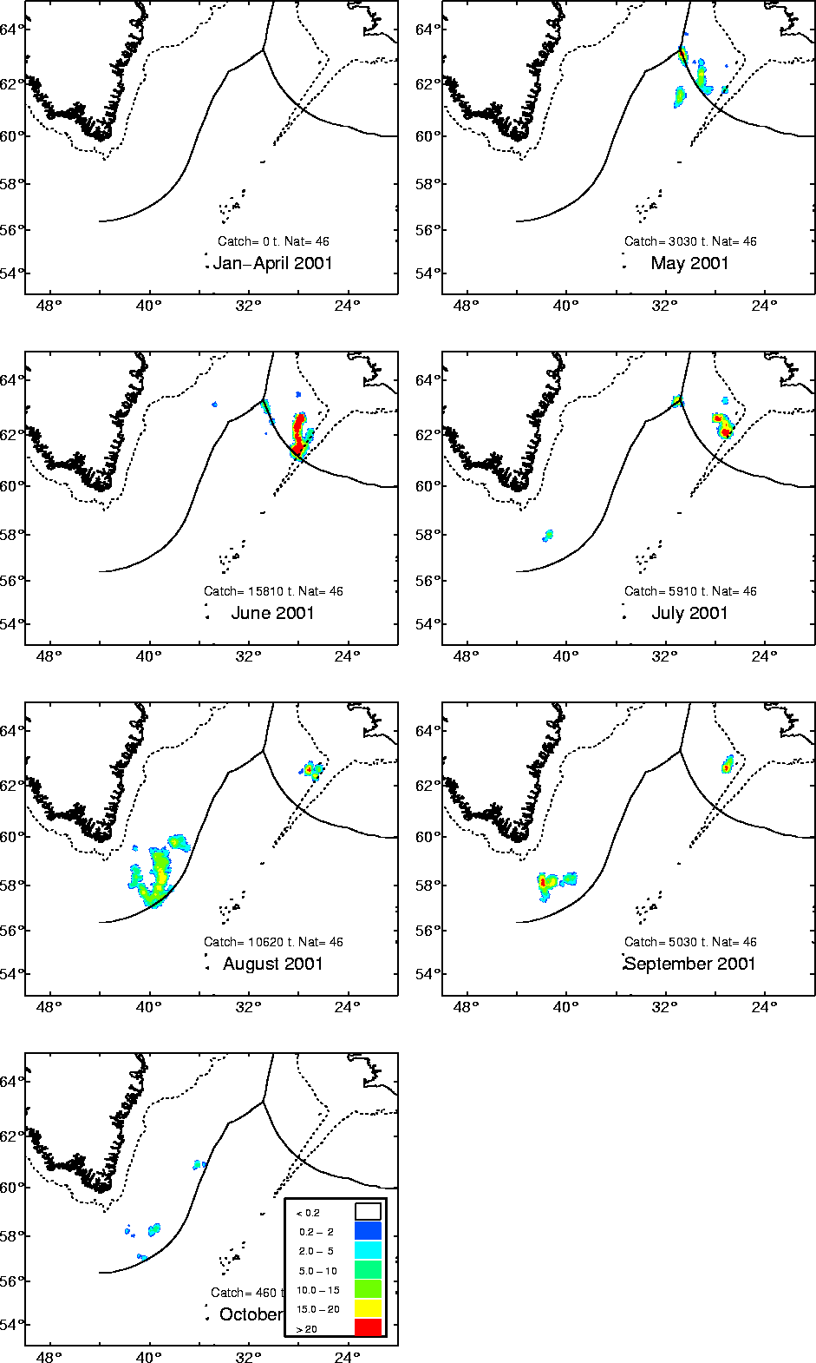
Figure 1.3. Monthly catch of Irminger Sea redfish in 2001. The figures are based on records from fishing vessel log-books.

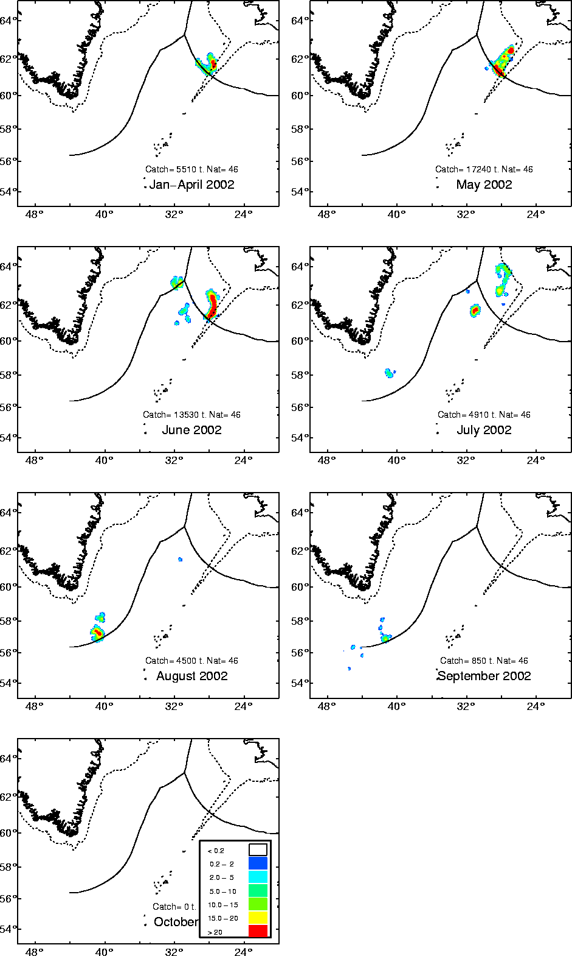
Figure 1.3. Monthly catch of Irminger Sea redfish in 2002. The figures are based on records from fishing vessel log-books.

Figure 1.4. Icelandic redfish catch southwest of Iceland in 1999-2001. The catch west of the “redfish line” (blue line) is form the pelagic redfish as the catch north and east of the line is of “shelf type”).
Figure 1.5 Length distribution of pelagic redfish caught north of 60°N, since 1995. Data from commercial fishery.
Figure 1.5 Length distribution of pelagic redfish caught south of 60°N, since 1995. Data from commercial fishery.
Figure 1.6. Catch by length in pelagic redfish fishery.
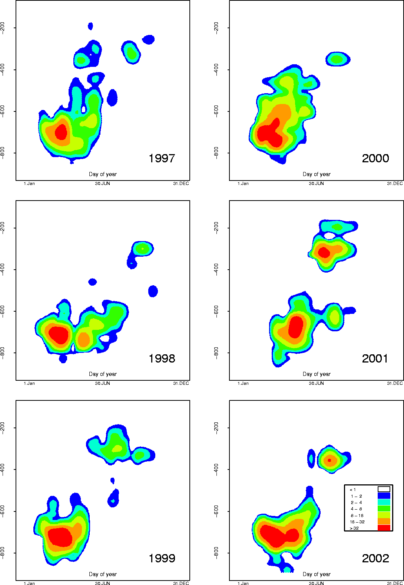
Figure 2.1. Depth distribution of Icelandic trawl hauls for oceanic redfish as reported in the log-books since Iceland began its oceanic redfish fishery in 1989. X-axis = day of year; Y axis = depth.
Figure 2.2 Length distribution of redfish caught in the oceanic redfish fishery 1995-2002. Samples from commercial fishery.
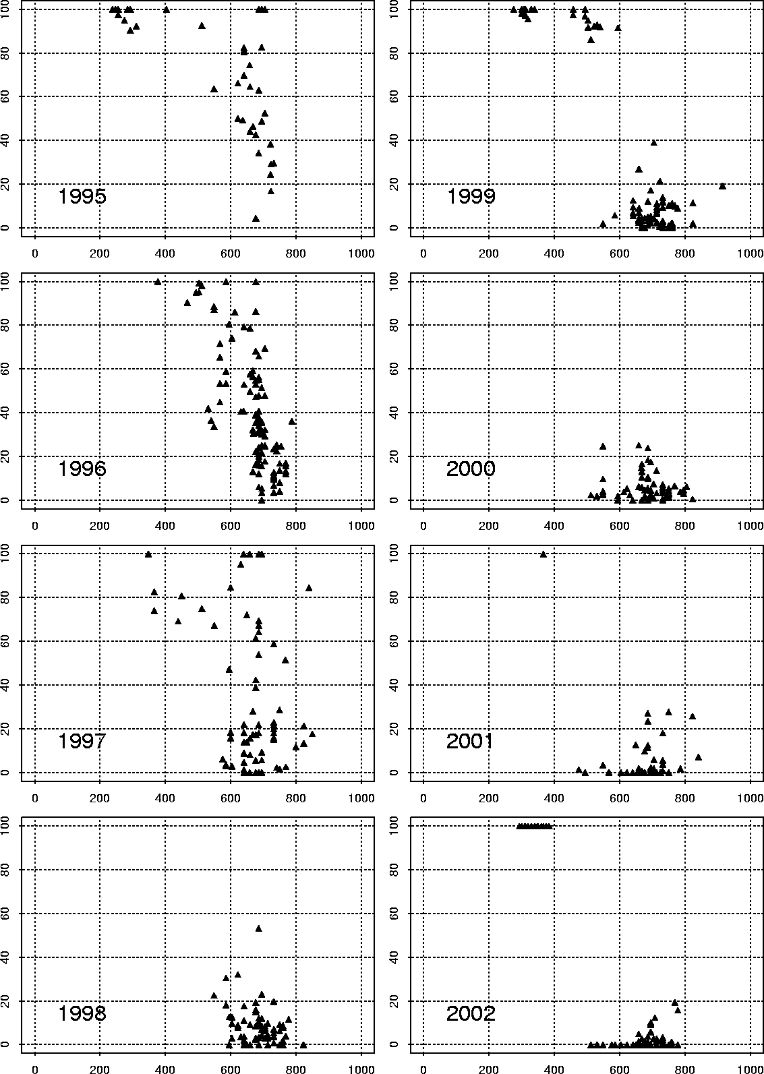
Figure 2.3. Proportion oceanic redfish in the Icelandic oceanic redfish fishery in 1995-2002. Data from commercial fishery. Each point in the figures denote sample of 50-100 fishes.
Figure 3.1. Catch per unit effort in the oceanic redfish fishery for the Icelandic fleet for different depth intervals.
Figure 3.2. Hours trawled at different depth intervals
Figure 3.3. Reported catch in the log-books at different depth intervals.
Table 2.1. Distribution of catch by depth, proportion of oceanic redfish, standard deviation of the mean proportion, reported catch of oceanic and deep sea redfish (only when depth is reported). Data based on samples from the commercial fishery and from the log-books.
Year | Depth-  range |  | St.dev |  | Prop  oceanic | Catch  Oceanic | Catch  Deep sea |  | Not  Classified
1995 | 200 | -399 | 3.44 | 97.7 |  | 4319 |  | 101
1995 | 400 | -599 | 16.44 | 87.3 |  | 2314 |  | 336
1995 | 600 | -799 | 25.45 | 60.3 |  | 7518 |  | 4957
1995 | 800 | -999 |  |  |  |  |  |  |  | 50
1995 | 1000 | -1199 |  |  |  |  |  |  |  | 26
1996 | 200 | -399 | 0.00 | 100.0 |  | 2240 |  | 0
1996 | 400 | -599 | 22.14 | 75.6 |  | 3048 |  | 981
1996 | 600 | -799 | 24.16 | 38.0 |  | 10741 |  | 17521
1996 | 800 | -999 |  |  |  |  |  |  |  | 1020
1997 | 200 | -399 | 11.38 | 87.7 |  | 1754 |  | 246
1997 | 400 | -599 | 35.66 | 46.9 |  | 1407 |  | 1593
1997 | 600 | -799 | 31.83 | 30.5 |  | 6882 |  | 15703
1997 | 800 | -999 | 31.02 | 32.5 |  | 145 |  | 301
1998 | 200 | -399 |  |  |  |  |  |  |  | 1017
1998 | 400 | -599 | 13.56 | 19.4 |  | 436 |  | 1812
1998 | 600 | -799 | 9.97 | 10.1 |  | 2788 |  | 24842
1998 | 800 | -999 |  |  |  |  |  |  |  | 289
1998 | 1200 | -1399 |  |  |  |  |  |  |  | 12
1999 | 200 | -399 | 1.47 | 99.19 |  | 4254 |  | 35
1999 | 400 | -599
1999 | 600 | -799 | 6.52 | 6.14 |  | 2326 |  | 35528
1999 | 800 | -999 | 8.33 | 10.41 |  | 185 |  | 1596
2000 | 200 | -399 |  |  |  |  |  |  |  | 47
2000 | 400 | -599 | 7.15 | 4.75 |  | 580 |  | 11612
2000 | 600 | -799 | 5.87 | 5.77 |  | 1856 |  | 30326
2000 | 800 | -999 | 3.82 | 3.15 |  | 18 |  | 562
2001 | 200 | -399 |  | 100 |  | 13087 |  | 0
2001 | 400 | -599 | 1.615 | 1.187 |  | 28 |  | 2305
2001 | 600 | -799 | 8.032 | 4.802 |  | 1260 |  | 24991
2001 | 800 | -999 | 13.233 | 16.375 |  | 131 |  | 670
2002 | 200 | -399 | 0 | 100 |  | 5236 |  | 0
2002 | 400 | -599 | 0 | 100 |  | 0 |  | 1003
2002 | 600 | -799 | 4.43 | 2.61 |  | 1011 |  | 37750
2002 | 800 | -999

Table 2.2. Results of dividing the Icelandic oceanic redfish catch according to the Icelandic samples from the fishery. The table is a summary table for table 2.1.
 | oceanic | Deep sea | Not classified | Catch  Oceanic | Catch  Deep sea | Total  Catch
1995 | 72% | 27% | 0% | 25186 | 9445 | 34631
1996 | 45% | 52% | 3% | 29182 | 33721 | 62903
1997 | 36% | 64% | 0% | 14859 | 26417 | 41276
1998 | 10% | 85% | 4% | 5504 | 46780 | 52284
1999 | 15% | 85% | 0% | 6765 | 37159 | 43924
2000 | 5% | 95% | 0% | 2455 | 42507 | 45008
2001 | 34% | 66% |  | 4423 | 27999 | 42423
2002* | 14% | 86% |  | 6229 | 38262 | 44491
*Preliminary
Table 2.3. Proportion of mature fish in the Icelandic pelagic redfish catches, by year since 1995
 | Immature | Mature
1995 | 4% | 96%
1996 | 3% | 97%
1997 | 4% | 96%
1998 | 2% | 98%
1999 | 3% | 97%
2000 | 5% | 95%
2001 | 9% | 91%
2002 | 10% | 90%

Table 2.3. Proportion males fish in the Icelandic pelagic redfish catches, by year since 1995, by month
 | April | May | June | July | August | Sept | Oct. | Year
1995 | 37% | 52% | 48% | 71% | 73% | 74% | 70% | 53%
1996 | 28% | 41% | 37% | 53% |  | 61% |  | 38%
1997 | 28% | 26% | 48% | 53% | 66% |  |  | 42%
1998 | 31% | 31% | 37% | 40% | 49% |  |  | 33%
1999 | 38% | 35% | 34% |  | 64% | 60% | 55% | 42%
2000 | 34% | 42% | 53% | 49% |  |  |  | 41%
2001 |  | 49% | 52% | 47% | 56% |  |  | 50%
2002 | 40% | 33% | 51% | 38% |  |  |  | 38%
Average | 34% | 39% | 45% | 50% | 62% | 65% | 63%

Table 3.1. Overall CPUE in the Icelandic oceanic redfish fishery (update for table 10.1.4).
Year | 89 | 90 | 91 | 92 | 93 | 94 | 95 | 96 | 97 | 98 | 99 | 2000 | 2001 | 2002
t/h | 1.11 | 1.02 | 1.52 | 1.66 | 3.27 | 2.64 | 2.00 | 1.74 | 1.11 | 1.56 | 1.55 | 1.98 | 1.40 | 1.90

