NWWG 2003. Working document no. 18

Fishery on pelagic redfish (S.mentella, Travin):
Information based on log-book data from Faroe Island, Germany, Greenland, Iceland, Norway and Russia.
By
Thorsteinn Sigurdsson, Hajo Rätz, Kjell Nedreaas, Sergei P. Melnikov and Jákup Reinert

Introduction
The pelagic fishery for redfish in the Irminger sea and adjacent waters is a multinational fishery, with vessels from up to 15 different nations participating in some years. Iceland, Germany and Russia have in recent years been major participants in the fishery in recent years and Fareo Island and Norway have participated for many years. These nations have, on average fished over 80% of the total catches in 1999-2001. In addition, Greenland has recently started to participate in the fishery and we have access to the whole logbook series from the Greenland vessel participating since 1999. Therefore, in 1999-2001 logbooks are available representing nearly 80% of the catches.

Most nations that have participated in the fishery have collected various fishery related data from different stocks and made some of these available to ICES in reports as figures and tables (i.a. ICES 2002). However, we think that it is important to make the raw data available in electronic format in one location for detailed comparisons vessel types, nations etc.

Catch data and catch composition are some of the most important input elements for assessments of fish stocks. Therefore, the objectives with the work presented here is to establish a database for fishery related data of the oceanic redfish fishery in the Irminger Sea and adjacent waters. This is done in order to improve fishery related data in the assessment work. Taking the uncertainty in stock structures of redfish stocks into account, detailed information on exploitation activities for as many fleets as possible is an important step forward in improving the assessment of the stock or each possible stock component.

This paper is a continuation of a paper presented at the NWWG meetings since 2001. It describes briefly the structure of a fishery-related database for pelagic redfish fishery in the Irminger Sea and adjacent waters and we are presenting results for the based on data already in the database. This database will, in future allow an appropriate annual analysis of the trend in catch rates standardised and corrected for national, vessel, area and seasonal effects. The results will therefore hopefully contribute significantly to the estimation of the quantitative reaction of the redfish stocks to the removed biomass by the fishing fleet of many nationalities.

At this stage the database does not include biological information, but work is in process to include biological informations.

Structure of the database
The data in the database is on haul by haul basis, but data on individual vessels have been coded so they can not be recognised.

Name | Descr | Type (no of char)
NATION | ICES code of Nation | NUMBER(2)
VESSEL | ID for vessel | NUMBER(4)
GROUP | Type of vessel | NUMBER(3)
DAY | no. of day within the month | NUMBER(2)
MONTH | number of the month | NUMBER(2)
YEAR |  | NUMBER(4)
LATTITUDE |  | NUMBER(4)
LONGITUTE |  | NUMBER(4)
GEAR_TYPE | Name of the gear | VARCHAR2(10)
CIRCUMPHERENCE | Circumference of the trawl in m | NUMBER(4)
DEPTH OF HEADLINE | Trawling depth as registered by depth sensor on the headrope of the trawl (in m) | NUMBER(4)
BOTTOM_DEPTH | in m | NUMBER(4)
TIME | Time of day | NUMBER(4)
TRAWLING DURATION(MIN) |  | NUMBER(4)
CATCH (KG) |  | NUMBER(7)

Results

Overview of data currently within the database
Following textable gives the overview of the database as it is now. A total of 31 thous hauls have been inserted to it, including all log-books the German activity since 1995, from the Icelandic fishery since Iceland started its fishery in 1989, all the activity of the Greenland vessel (since 1999), hauls from selected Norwegian vessels since 1995 and Russian fleet in 199-2000.
Nation | Period | Hauls | Catch
Faroes | 1995-2001 | 1607 | 23.946
Germany | 1995-2002 | 7883 | 130.954
Iceland* | 1989-2002 | 19872 | 392.176
Norway | 1990-2002 | 3424 | 52.156
Russia | 1997-2001 | 9346 | 130.402
Grand Total |  | 42132 | 729.634

- Including the Greenland data in 1999-2002, as there is only one vessel from Greenland.

The table below gives more detailed information on the number of hauls by year and nation.
 | 1989 | 1990 | 1991 | 1992 | 1993 | 1994 | 1995 | 1996 | 1997 | 1998 | 1999 | 2000 | 2001 | 2002
Faroes | 0 | 0 | 0 | 0 | 0 | 0 | 1783 | 2612 | 1669 | 3236 | 3751 | 2853 | 8041 | 0
Germany | 0 | 0 | 0 | 0 | 0 | 0 | 18856 | 21263 | 20446 | 17984 | 16065 | 12487 | 10662 | 13191
Iceland* | 1318 | 3997 | 6603 | 12207 | 16544 | 36135 | 25523 | 45126 | 32233 | 37196 | 41734 | 46360 | 40660 | 46539
Norway | 0 | 3785 | 1053 | 3572 | 7871 | 5445 | 3865 | 1298 | 500 | 674 | 2002 | 10315 | 6586 | 5192
Russia | 0 | 0 | 0 | 0 | 0 | 0 | 0 | 0 | 27923 | 26012 | 15340 | 26032 | 35095 | 0
Grand Total | 1318 | 7782 | 7656 | 15779 | 24414 | 41580 | 50027 | 70299 | 82772 | 85102 | 78892 | 98047 | 101044 | 64922
*Including the Greenland data in 1999-2002, as there is only one vessel from Greenland.

Overview of available information by nation is given below. Except for the depth, the information given are very similar.
Name | Type | Germany | Iceland | Greenland | Norway | Faroese | Russia
NATION | NUMBER(2) | X | x | x | x | X | x
VESSEL | NUMBER(4) | X | x | x | x | X | x
GROUP | NUMBER(3) |  |  | x |  | X | x
DAY | NUMBER(2) | X | x | x | x | X | x
MONTH | NUMBER(2) | X | x | x | x | X | x
YEAR | NUMBER(4) | X | x | x | x | X | x
LATTITUDE | NUMBER(4) | X | x | x | x | X | x
LONGITUTE | NUMBER(4) | X | x | x | x | X | x
GEAR_TYPE | VARCHAR2(10) | X | x | x | x | X | x
CIRCUMPHERENCE | NUMBER(4) | X | x | x
DEPTH OF HEADLINE | NUMBER(4) |  | x | x | x
BOTTOM_DEPTH | NUMBER(4) |  | x | x | x
TIME | NUMBER(4) | X | x | x | x
Discard | NUMBER(7) | x | incl. in C | incl. in C |  |  | incl. in C
TRAWLING DURATION(MIN) | NUMBER(4) | x | x | x | x | X | x
CATCH (KG) | NUMBER(7) | x | x | x | x | X | x

Location of the fishing activity.

Figures 1 gives the locations of the fishery, year by year since 1995 and figures 2-4 by month for the years 2000-2002. As can been seen from the figures, the fishing pattern has changed during the last years towards a two areas fishing areas.
In the first months of the fishing season (which usually starts in early April) the fishery is conducted in area west of 32°W and north of 61°N. In May and June the fishery is more or less at same areas, but in July-August, the fleet moves to areas south of 60°N and west of about 32°W where the fishery continues until October. There is very little fishing activity in the period from November until late March/early April when the next fishing season starts.
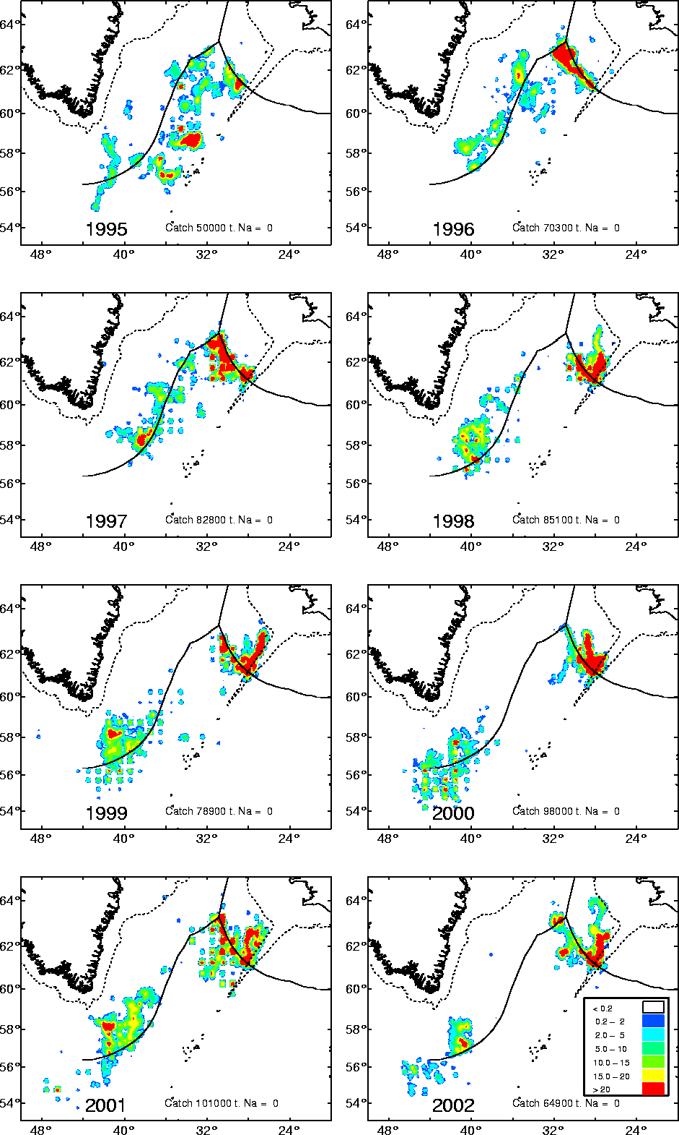
Figure 1. Fishing areas of the pelagic redfish by year from 1995-2002. Data from Germany (1995-2002), Norway (1995-2002) Greenland (1999-2002), Russia (1997-2001), Faroese (1995-2001) and Iceland (1995-2002). The scale given on the pictures indicates the catches in tonnes per square nautical mile.
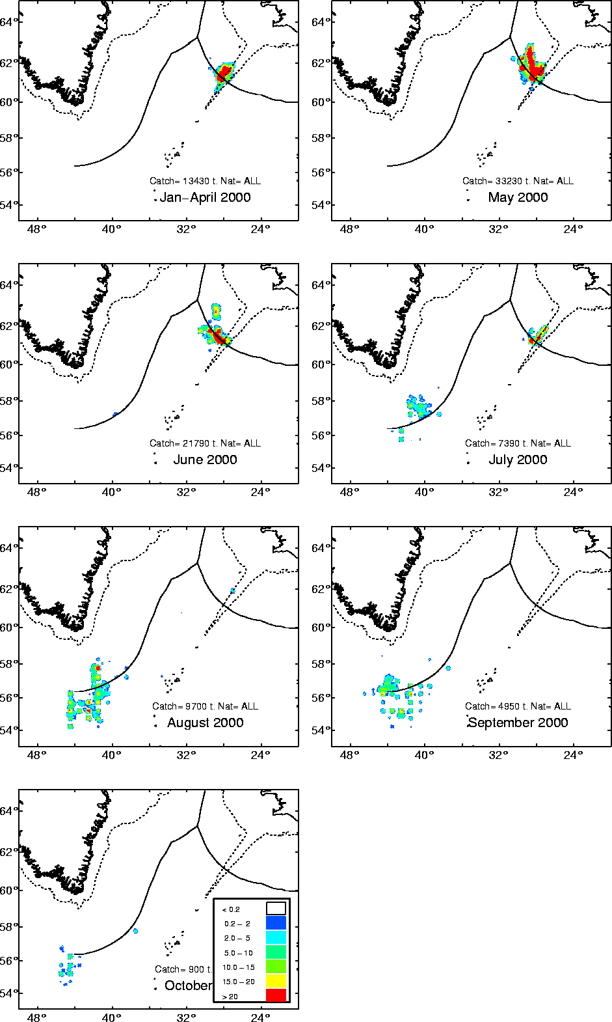
Figure 2 Fishing areas of the pelagic redfish by periods in 2000, including data from Germany, Iceland, Greenland, Fareose, Russia and Norway. The scale given on the pictures indicates the catches in tonnes per square nautical mile. Total catch registered for each period is also shown on the figures.

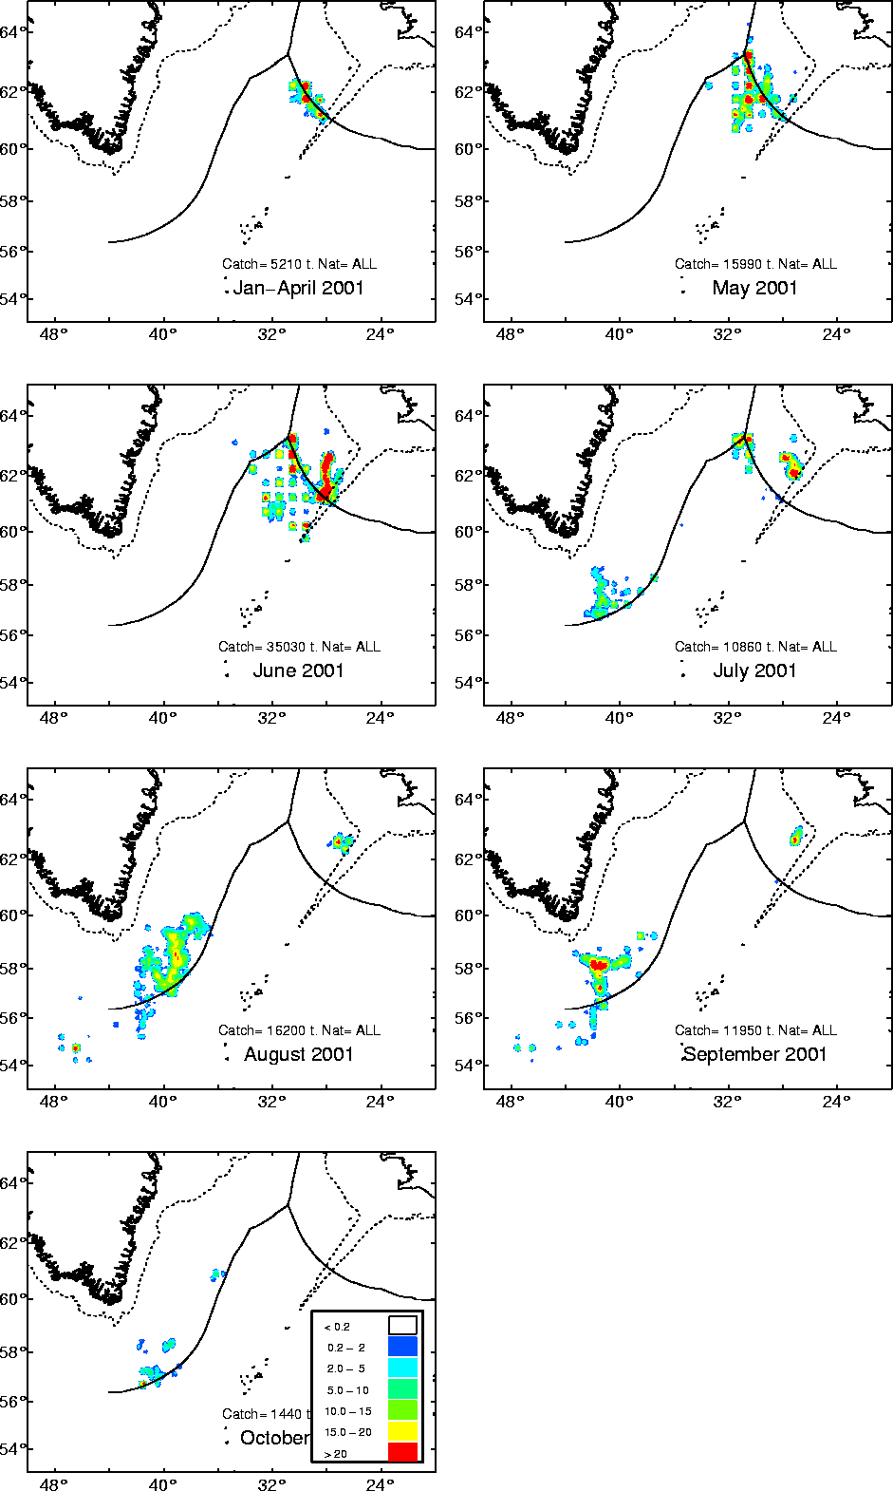
Figure 3. Fishing areas of the pelagic redfish by periods in 2001, including data from Germany, Iceland, Norway, Russia, Faroese and Greenland. The scale given on the pictures indicates the catches in tonnes per square nautical mile. Total catch registered for each period is also shown on the figures.

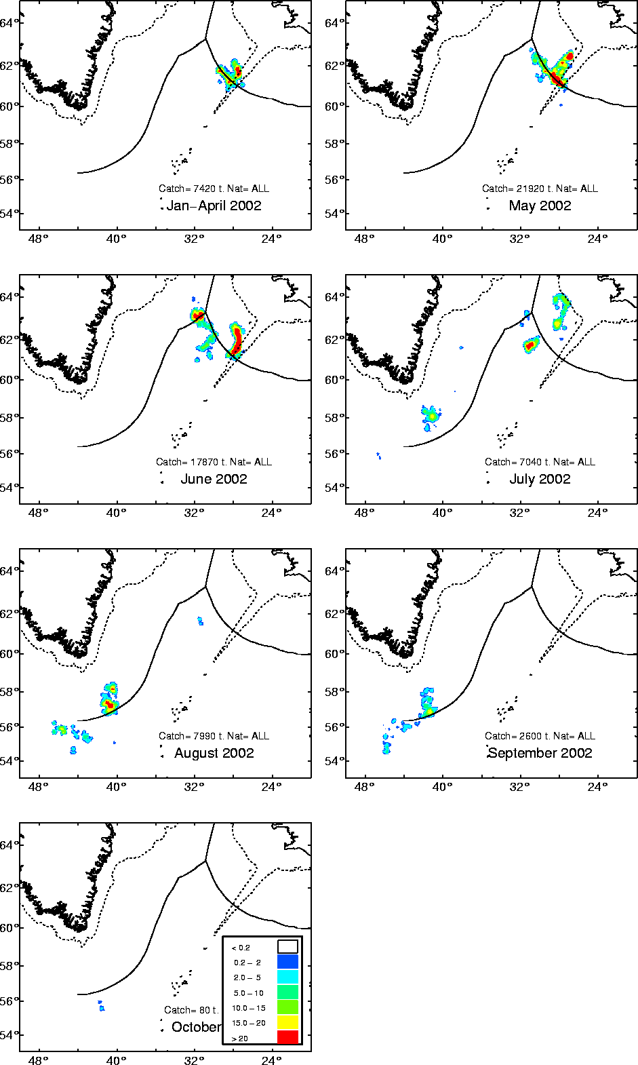
Figure 4. Fishing areas of the pelagic redfish by periods in 2002, including data from Germany, Norway, Iceland and Greenland. The scale given on the pictures indicates the catches in tonnes per square nautical mile. Total catch registered for each period is also shown on the figures.

Catch per unit of effort
Based on all data available in the database we have calculated standardised CPUE for the whole period, using the following formula:

glm(formula = log(catch) ~ log(trawling_time) + factor(year) + factor(month) + factor(vessel), family = gaussian(), data = tmp.data)

In the NWWG report 2002, the model were run on the raw data. Figure 5 show the results based on same data set including data for 2002.
Figure 5. Standardised CPUE since 1985, as calculated by using data from Germany (1995-2002), Iceland (1989-2002), Greenland (1999-2002) and Norway (1995-2002). North means north of 60°N and south = south of 60°N.

By using the same model including also Russia (1997-2001) and Faroe Island (1995-2001), but in addition summing the data as follows; by ICES statistical by month, year and vessel, the results are as shown in Figure 6.

Another model was also fitted using data only from north/south of 60°N (area) The resluts are shown in Figure 6 for the period since 1995 Based on all the figures it is difficult to interpret the status of the stock(s).
Figure 6. Standardised CPUE since 1995, as calculated by using data from Germany (1995-2002), Iceland (1995-2002), Greenland (1999-2002) and Norway (1995-2002), Russia (1997-2001) and Faroese (1995-2001).

Figure 7. Unstandardised CPUE north of 60°N, based on information in the joint database.
Figure 8. Unstandardised CPUE south of 60°N, based on information in the joint database

Further information and acknowledgement
More detailed information from the data are available www.hafro.is/~steini :The present study was realised within the REDFISH project (QLK5-CT1999-01222), financially supported by the European Commission within the research framework QUALITY OF LIFE AND MANAGEMENT OF LIVING RESOURCES, Key Action 5: Sustainable Agriculture, Fisheries and Forestry.

