NWWG 2003 WD no.17.

Sebastes marinus in ICES division VA

Figures and tables

Thorsteinn Sigurðsson, MRI

redfish catch in Va by gear months and species

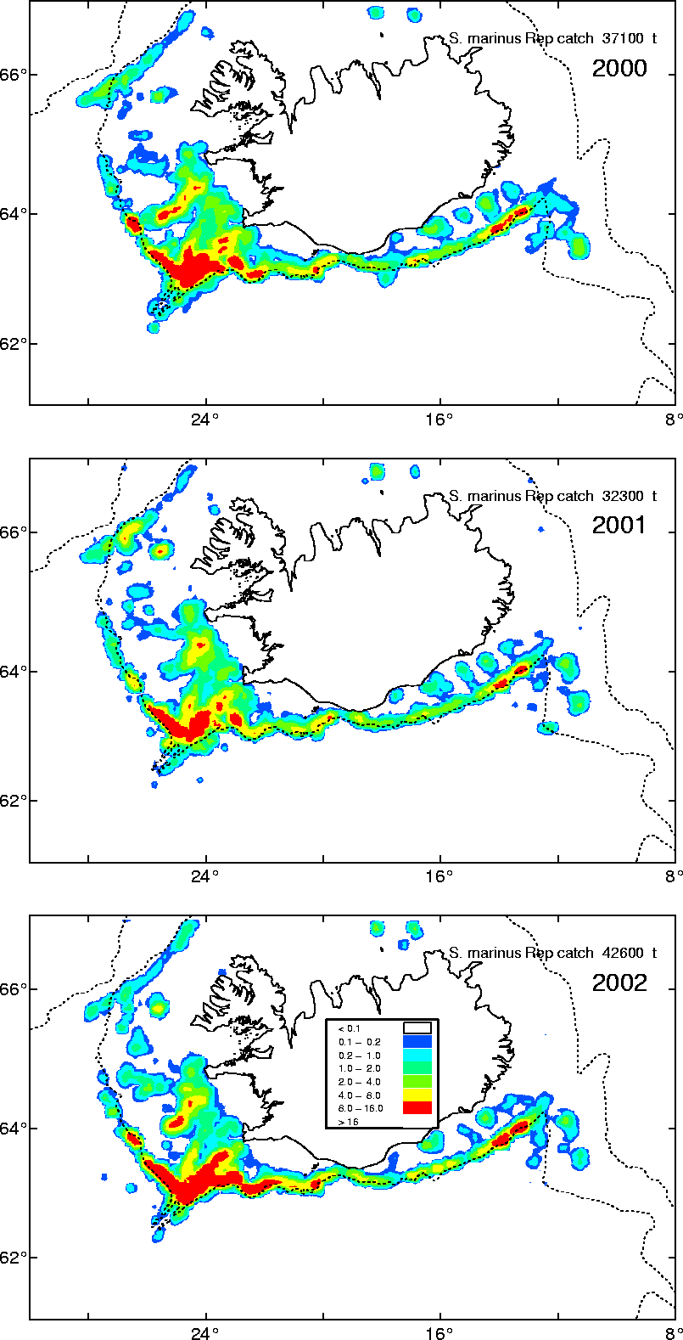

Split.catch
 | Afli | Prop mar | C mar | C. ment
Icelandic vessels | 66,444 | 73.1% | 48,543 | 17,902
UK and |  | 1.0% | - | -
Germany | 1,208 | 1.0% | 12 | 1,196
Norway |  |  | - | -
Faroes | 76 | 50.0% | 38 | 38
SAMTALS | 67,728 | 72% | 48,592 | 19,136

Results from previous years:

Year | S.marinus
1991
1992 | 54%
1993 | 47%
1994 | 40%
1995 | 46%
1996 | 49%
1997 | 49%
1998 | 53%
1999 | 60%
2000 | 60%
2001 | 67%
2002 | 73%

CPUE - unstandardized 10% and 50%

Standardized CPUE
CPUE in S. marinus from Icelandic trawlers, both based on results from GLIM model 1985-2000 (A) with 95% CV) of hauls where S. marinus catch compose 50% or more of the total catch in each haul (B).

CPUE in S. marinus from Icelandic trawlers, both based on results from GLIM model 1985-2000 with 95% CV) of hauls where S. marinus catch compose 10% and 70% or more of the total catch in each haul (B).

Length distribution

From catch
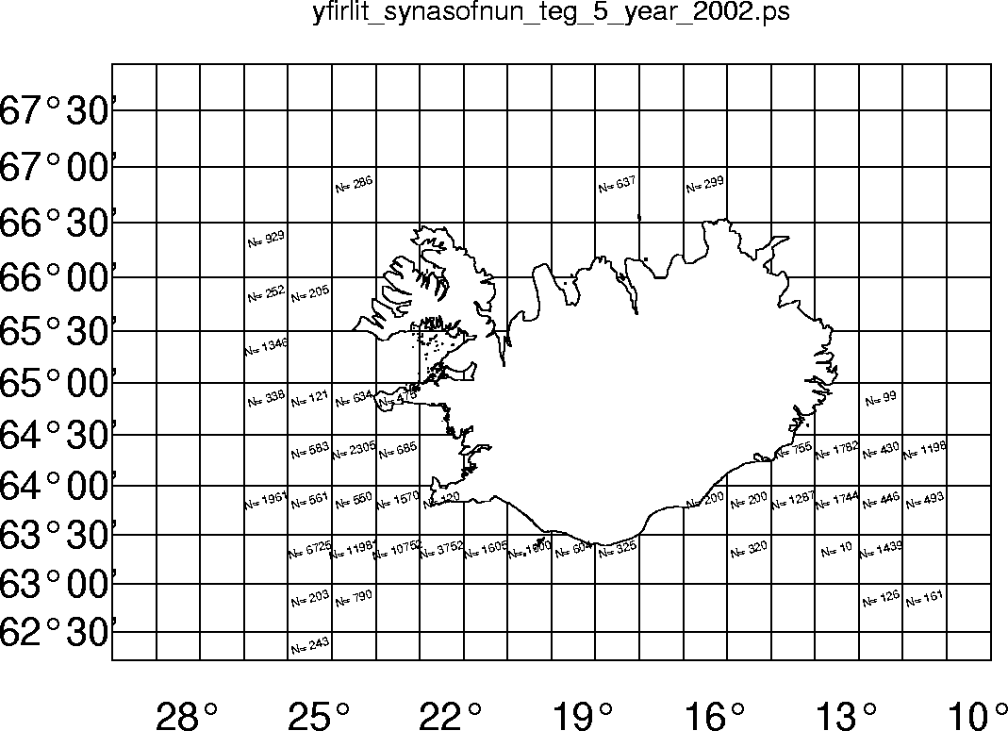
Overviw of sampling in 2002 by statistical squaere.
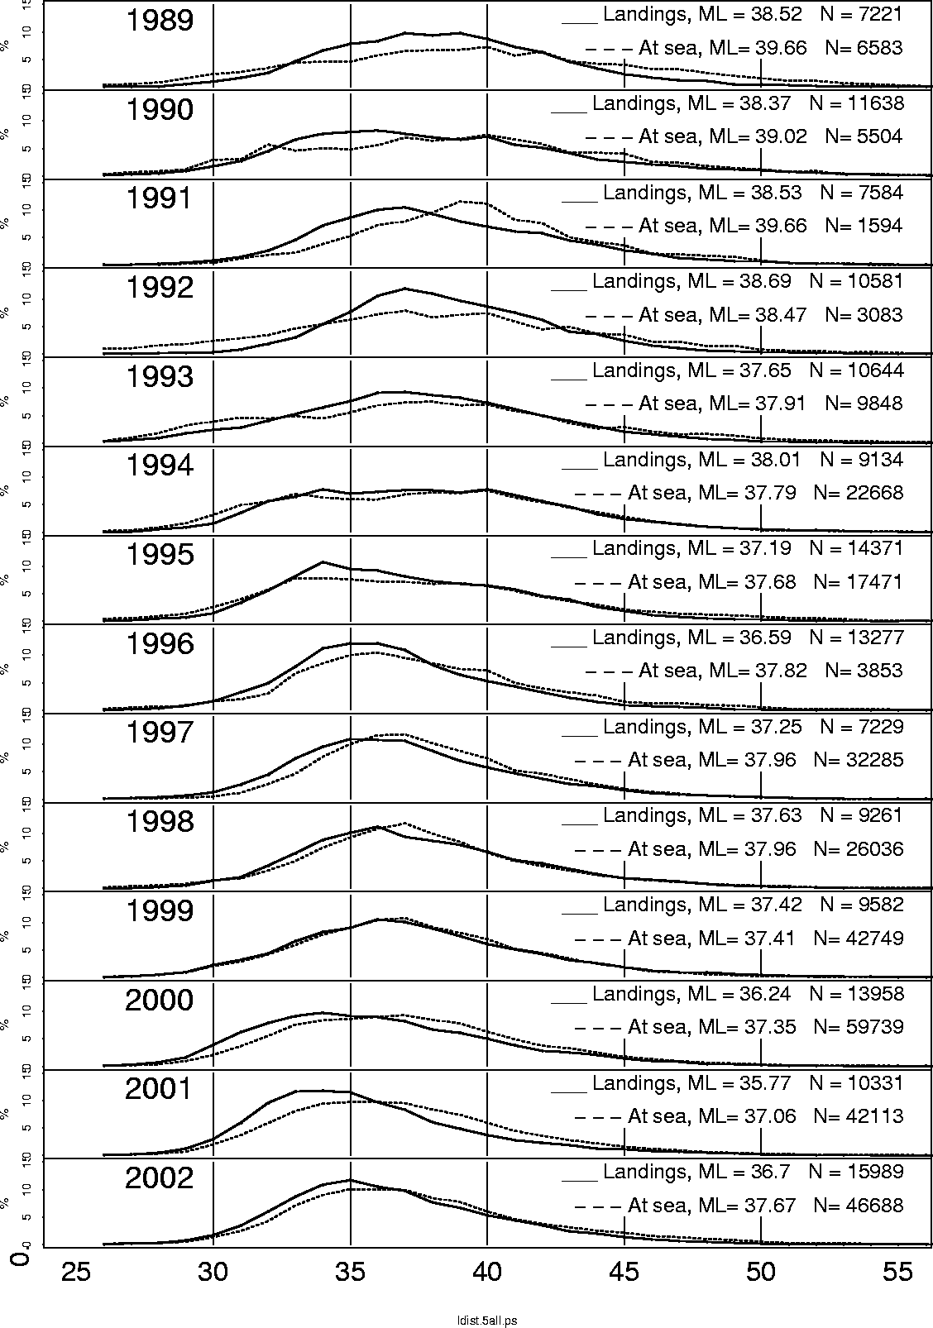
Length distribution from Icelandic landings and from samples taken at sea from the trawler fleet.

from groundfish survey in March

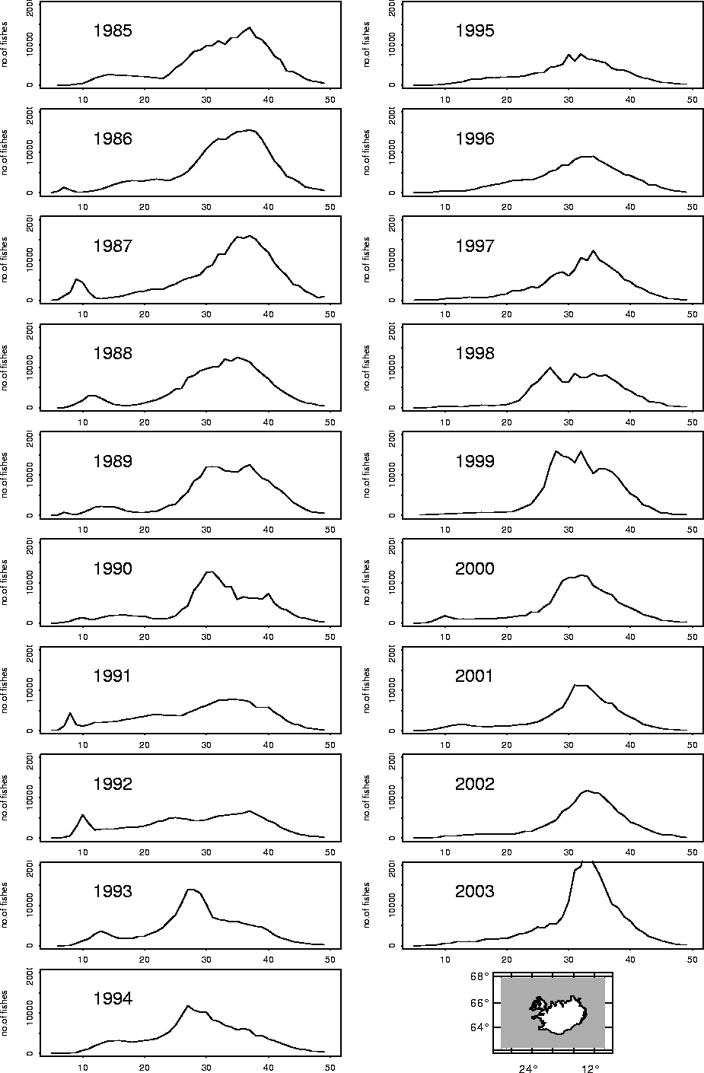

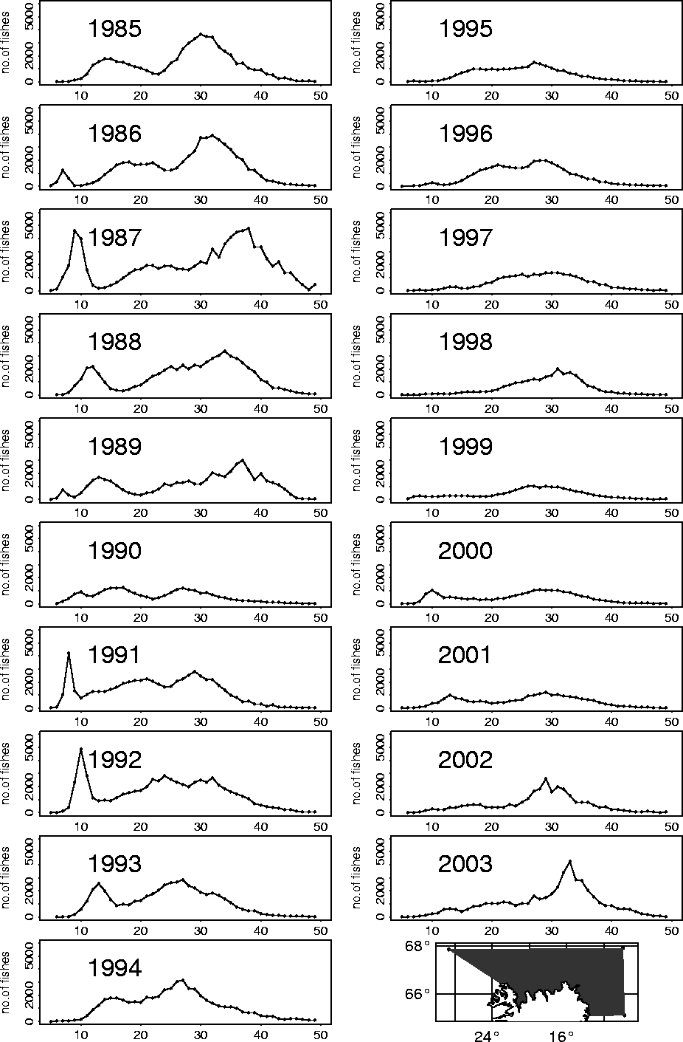

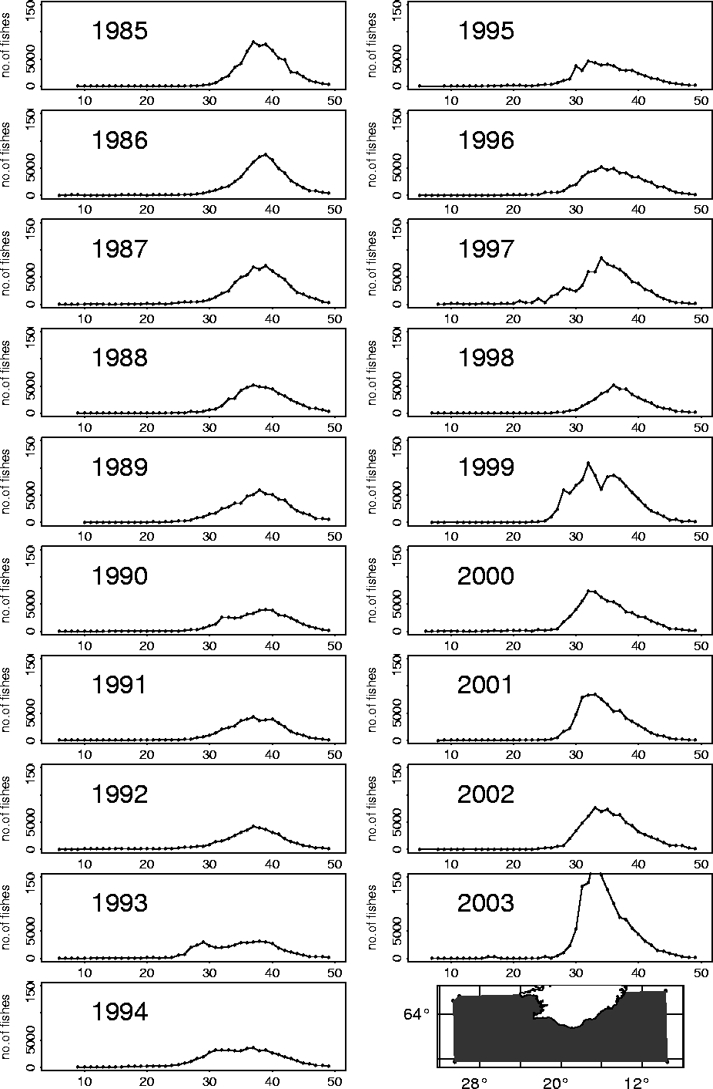

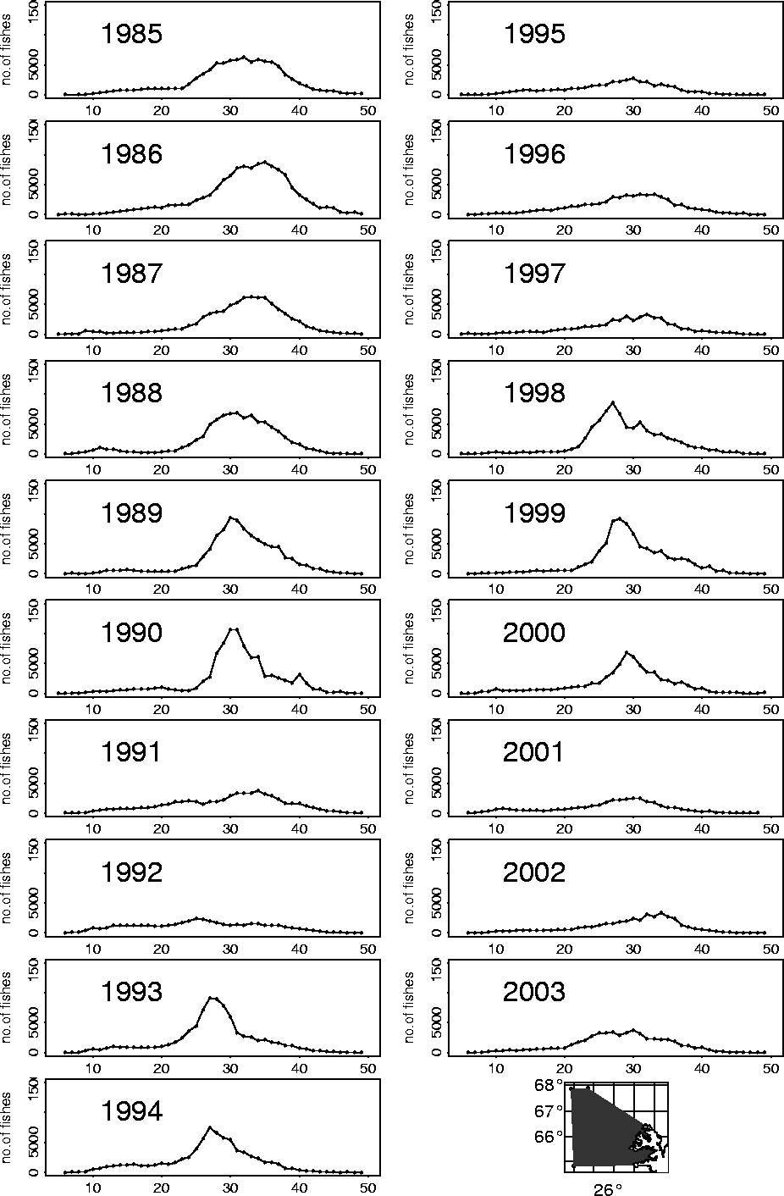

Groundfish suvey index
March survey
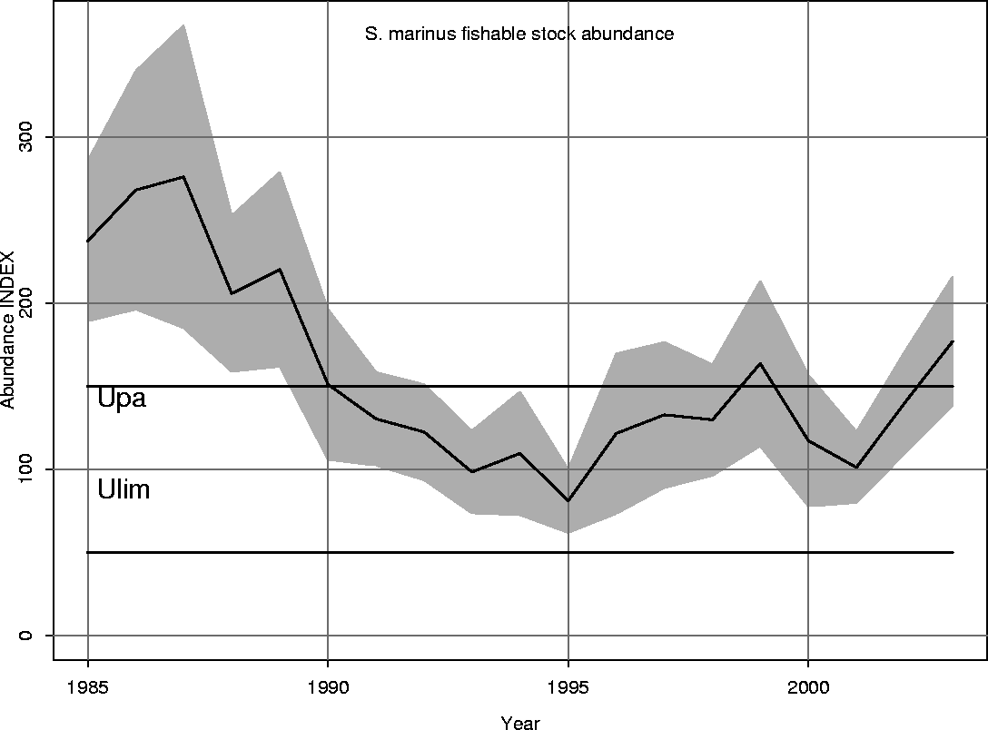
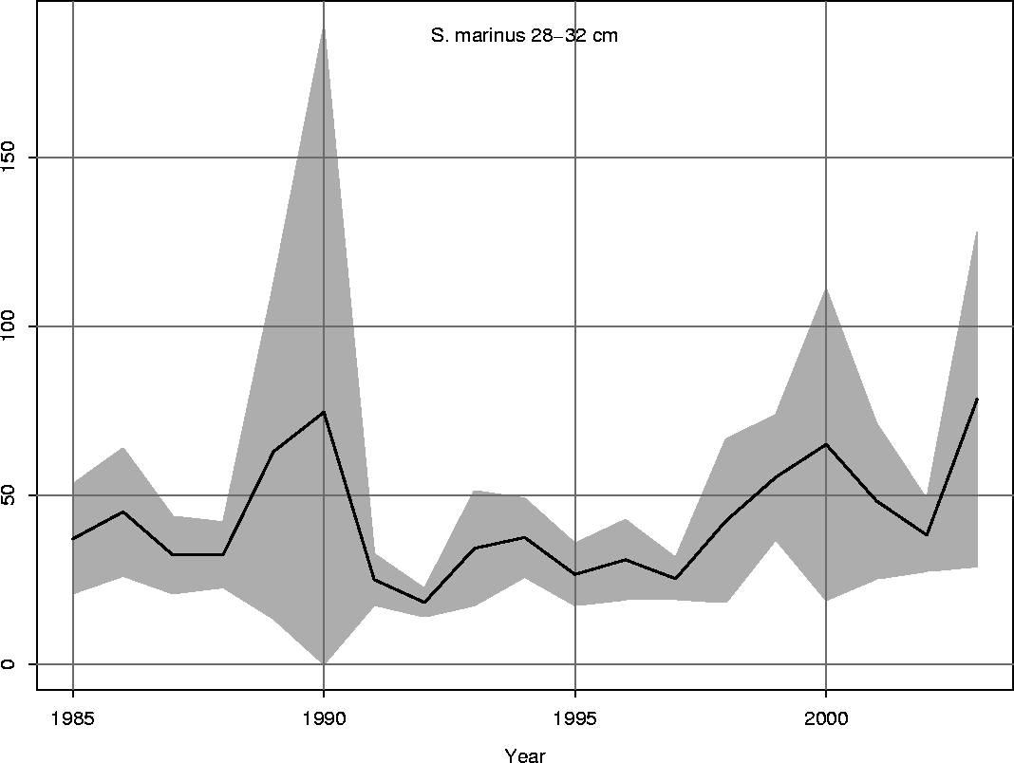

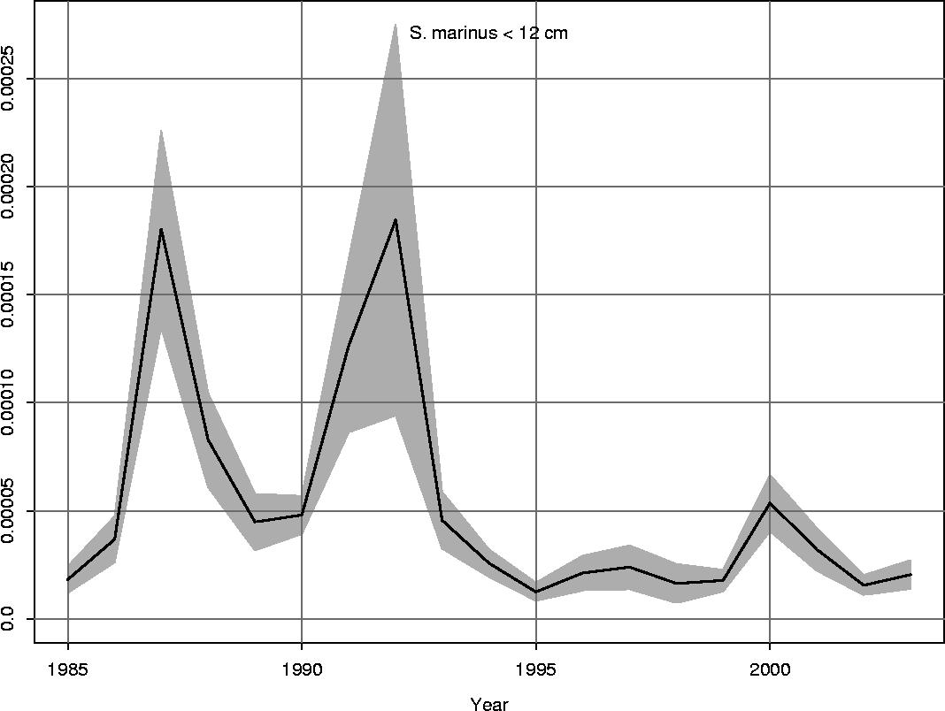

Groundfish survey in October

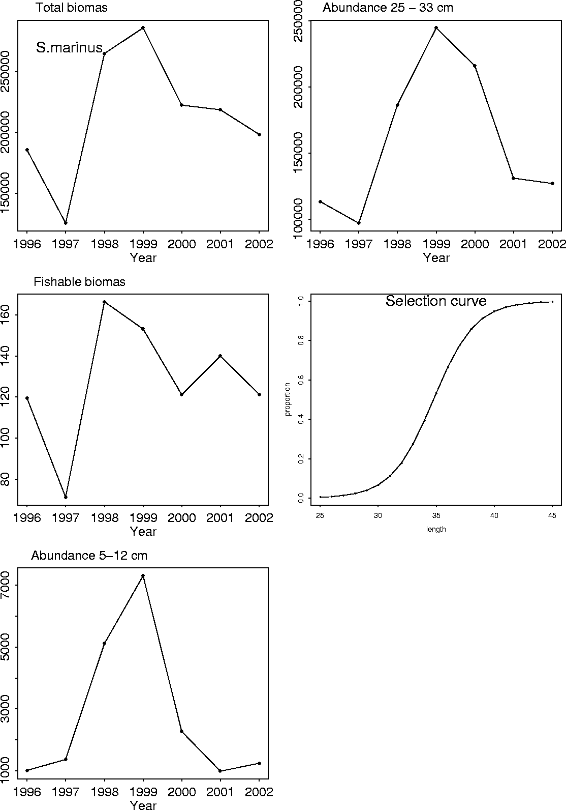

CaNo

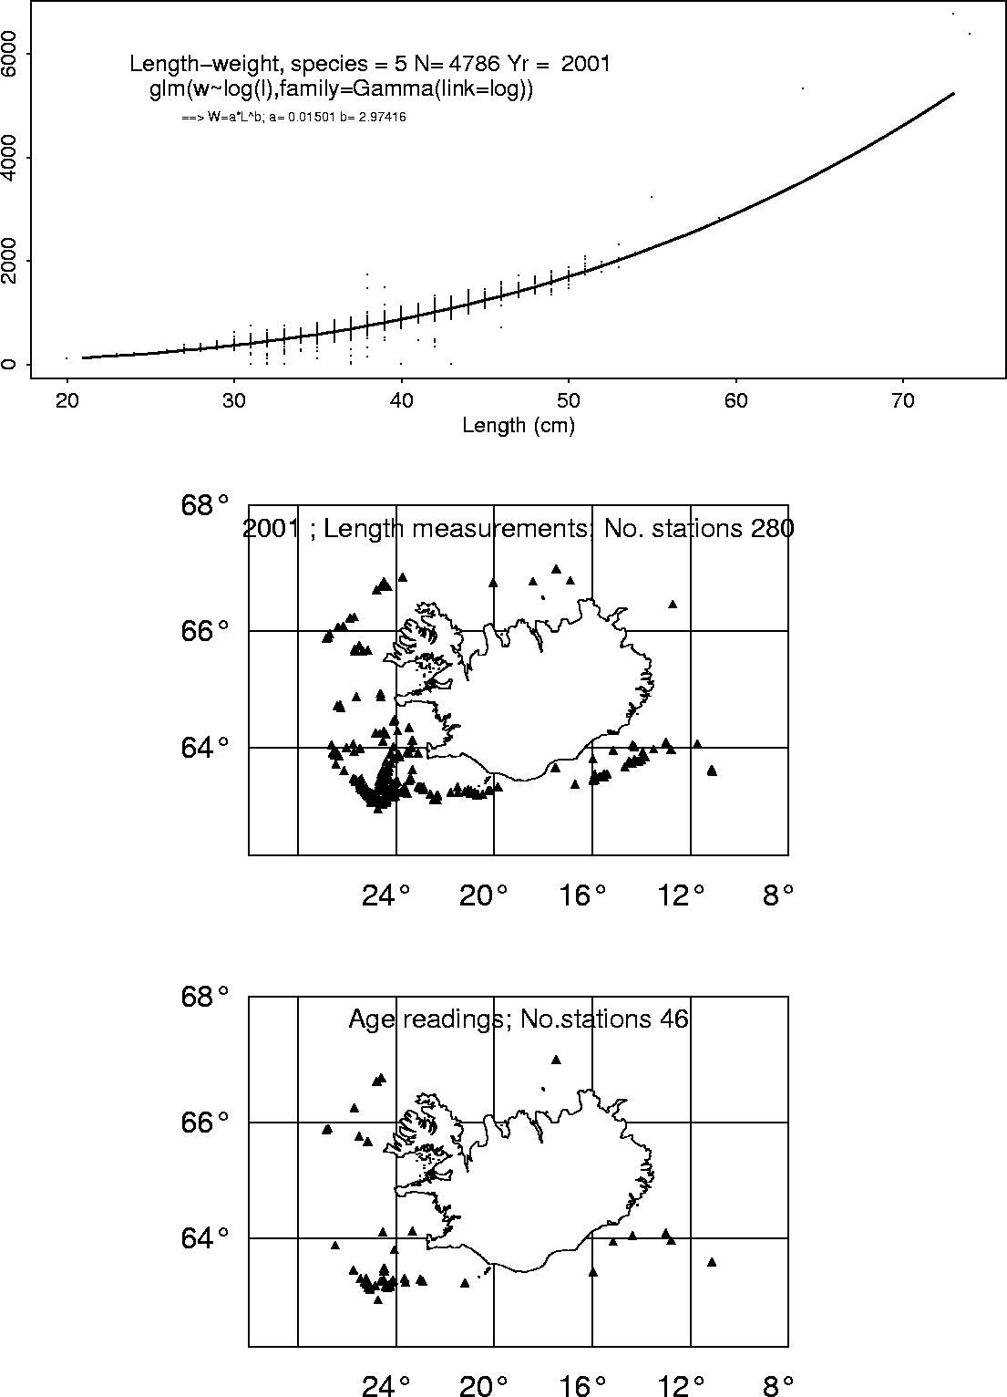

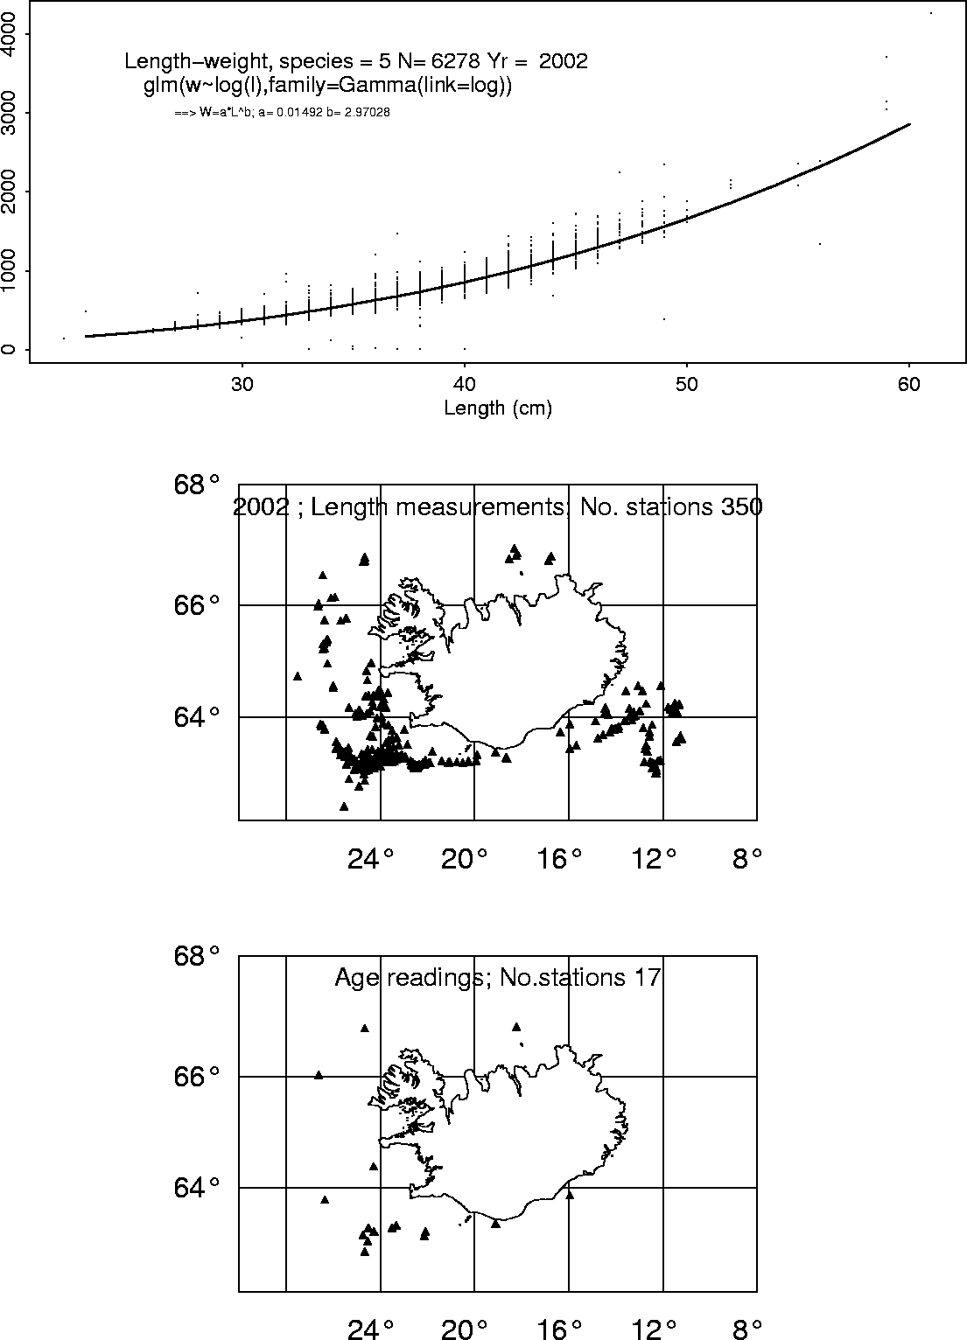

Ca_wt | 7 | 8 | 9 | 10 | 11 | 12 | 13 | 14 | 15 | 16 | 17 | 18 | 19 | 20 | 21 | 22 | 23 | 24 | 25 | 26 | 27 | 28 | 29 | 30
1995 | 59 | 366 | 1572 | 9312 | 2698 | 1314 | 3548 | 5684 | 6000 | 1743 | 859 | 371 | 1148 | 1158 | 511 | 684 | 1447 | 673 | 773 | 370 | 354 | 736 | 0 | 134
1996 | 0 | 354 | 808 | 3622 | 8943 | 2072 | 1300 | 1459 | 4398 | 5641 | 921 | 388 | 268 | 337 | 1210 | 1033 | 803 | 0 | 0 | 0 | 0 | 0 | 0 | 0
1997 | 33 | 229 | 483 | 1039 | 2704 | 11563 | 2820 | 1366 | 3123 | 3621 | 3024 | 896 | 644 | 960 | 448 | 544 | 691 | 595 | 753 | 271 | 140 | 208 | 155 | 31
1998 | 24 | 285 | 598 | 1213 | 1134 | 3257 | 12548 | 2086 | 2039 | 2411 | 3410 | 2048 | 1015 | 726 | 521 | 390 | 425 | 662 | 516 | 400 | 425 | 359 | 54 | 226
1999 | 0 | 367 | 1492 | 1244 | 1820 | 2651 | 2330 | 15703 | 1171 | 1235 | 1884 | 2769 | 2317 | 1219 | 487 | 231 | 347 | 226 | 948 | 281 | 587 | 175 | 107 | 234
2000 | 0 | 118 | 595 | 3977 | 1894 | 2524 | 1610 | 2292 | 14272 | 1778 | 1234 | 1843 | 2379 | 2201 | 571 | 619 | 226 | 124 | 585 | 503 | 248 | 493 | 471 | 451
2001 | 125 | 140 | 396 | 1625 | 7757 | 1804 | 1978 | 1249 | 836 | 11649 | 521 | 784 | 1064 | 1794 | 966 | 418 | 435 | 168 | 130 | 125 | 291 | 204 | 153 | 373
2002 | 0 | 631 | 653 | 484 | 2661 | 12744 | 2188 | 2160 | 1524 | 2379 | 14412 | 1646 | 1325 | 835 | 972 | 833 | 675 | 88 | 541 | 88 | 222 | 616 | 553 | 350
Ca_No | 7 | 8 | 9 | 10 | 11 | 12 | 13 | 14 | 15 | 16 | 17 | 18 | 19 | 20 | 21 | 22 | 23 | 24 | 25 | 26 | 27 | 28 | 29 | 30
1995 | 195 | 852 | 3136 | 17691 | 4589 | 1970 | 4240 | 7070 | 6989 | 1855 | 886 | 407 | 1001 | 1015 | 379 | 599 | 1055 | 521 | 509 | 250 | 285 | 500 | 0 | 93
1996 | 0 | 759 | 1559 | 6276 | 15193 | 3207 | 1887 | 2121 | 5403 | 6388 | 1297 | 421 | 271 | 429 | 1176 | 879 | 850 | 0 | 0 | 0 | 0 | 0 | 0 | 0
1997 | 61 | 522 | 824 | 1782 | 4534 | 17506 | 3979 | 1769 | 3665 | 3839 | 3292 | 883 | 577 | 788 | 427 | 489 | 587 | 479 | 636 | 234 | 107 | 134 | 110 | 18
1998 | 73 | 691 | 1233 | 2322 | 2005 | 5190 | 18663 | 2753 | 2426 | 2547 | 3412 | 2011 | 915 | 647 | 453 | 340 | 315 | 602 | 383 | 298 | 348 | 322 | 43 | 143
1999 | 0 | 907 | 3392 | 2224 | 3311 | 4147 | 3317 | 21933 | 1543 | 1434 | 1948 | 2781 | 2346 | 1120 | 430 | 219 | 298 | 244 | 655 | 227 | 444 | 166 | 88 | 186
2000 | 0 | 376 | 1401 | 8348 | 3570 | 4018 | 2484 | 3113 | 18936 | 2095 | 1444 | 1838 | 2387 | 2117 | 562 | 627 | 192 | 117 | 499 | 358 | 127 | 395 | 381 | 335
2001 | 326 | 357 | 856 | 3288 | 14242 | 2975 | 3078 | 1838 | 1099 | 14406 | 621 | 882 | 1112 | 1643 | 945 | 406 | 387 | 104 | 106 | 91 | 221 | 158 | 144 | 259
2002 | 0 | 1500 | 1458 | 968 | 4831 | 21502 | 3440 | 3178 | 2149 | 2972 | 17100 | 1937 | 1590 | 898 | 1052 | 834 | 649 | 89 | 529 | 89 | 209 | 507 | 400 | 308
% weight | 7 | 8 | 9 | 10 | 11 | 12 | 13 | 14 | 15 | 16 | 17 | 18 | 19 | 20 | 21 | 22 | 23 | 24 | 25 | 26 | 27 | 28 | 29 | 30
1995 | 0.3 | 1.5 | 5.6 | 31.5 | 8.2 | 3.5 | 7.6 | 12.6 | 12.5 | 3.3 | 1.6 | 0.7 | 1.8 | 1.8 | 0.7 | 1.1 | 1.9 | 0.9 | 0.9 | 0.4 | 0.5 | 0.9 | 0.0 | 0.2
1996 | 0.0 | 1.6 | 3.2 | 13.0 | 31.6 | 6.7 | 3.9 | 4.4 | 11.2 | 13.3 | 2.7 | 0.9 | 0.6 | 0.9 | 2.4 | 1.8 | 1.8 | 0.0 | 0.0 | 0.0 | 0.0 | 0.0 | 0.0 | 0.0
1997 | 0.1 | 1.1 | 1.7 | 3.8 | 9.6 | 37.1 | 8.4 | 3.7 | 7.8 | 8.1 | 7.0 | 1.9 | 1.2 | 1.7 | 0.9 | 1.0 | 1.2 | 1.0 | 1.3 | 0.5 | 0.2 | 0.3 | 0.2 | 0.0
1998 | 0.2 | 1.4 | 2.6 | 4.8 | 4.2 | 10.8 | 38.8 | 5.7 | 5.0 | 5.3 | 7.1 | 4.2 | 1.9 | 1.3 | 0.9 | 0.7 | 0.7 | 1.3 | 0.8 | 0.6 | 0.7 | 0.7 | 0.1 | 0.3
1999 | 0.0 | 1.7 | 6.4 | 4.2 | 6.2 | 7.8 | 6.2 | 41.1 | 2.9 | 2.7 | 3.7 | 5.2 | 4.4 | 2.1 | 0.8 | 0.4 | 0.6 | 0.5 | 1.2 | 0.4 | 0.8 | 0.3 | 0.2 | 0.3
2000 | 0.0 | 0.7 | 2.5 | 15.0 | 6.4 | 7.2 | 4.5 | 5.6 | 34.0 | 3.8 | 2.6 | 3.3 | 4.3 | 3.8 | 1.0 | 1.1 | 0.3 | 0.2 | 0.9 | 0.6 | 0.2 | 0.7 | 0.7 | 0.6
2001 | 0.7 | 0.7 | 1.7 | 6.6 | 28.7 | 6.0 | 6.2 | 3.7 | 2.2 | 29.1 | 1.3 | 1.8 | 2.2 | 3.3 | 1.9 | 0.8 | 0.8 | 0.2 | 0.2 | 0.2 | 0.4 | 0.3 | 0.3 | 0.5
2002 | 0.0 | 2.2 | 2.1 | 1.4 | 7.1 | 31.5 | 5.0 | 4.7 | 3.2 | 4.4 | 25.1 | 2.8 | 2.3 | 1.3 | 1.5 | 1.2 | 1.0 | 0.1 | 0.8 | 0.1 | 0.3 | 0.7 | 0.6 | 0.5
M weigh | 7 | 8 | 9 | 10 | 11 | 12 | 13 | 14 | 15 | 16 | 17 | 18 | 19 | 20 | 21 | 22 | 23 | 24 | 25 | 26 | 27 | 28 | 29 | 30
1995 | 303 | 430 | 501 | 526 | 588 | 667 | 837 | 804 | 858 | 940 | 970 | 912 | 1147 | 1141 | 1348 | 1142 | 1372 | 1292 | 1519 | 1480 | 1242 | 1472 |  | 1441
1996 |  | 466 | 518 | 577 | 589 | 646 | 689 | 688 | 814 | 883 | 710 | 922 | 989 | 786 | 1029 | 1175 | 945
199 | 541 | 439 | 586 | 583 | 596 | 661 | 709 | 772 | 852 | 943 | 919 | 1015 | 1116 | 1218 | 1049 | 1112 | 1177 | 1242 | 1184 | 1158 | 1308 | 1552 | 1409 | 1722
1998 | 329 | 412 | 485 | 522 | 566 | 628 | 672 | 758 | 840 | 947 | 999 | 1018 | 1109 | 1122 | 1150 | 1147 | 1349 | 1100 | 1347 | 1342 | 1221 | 1115 | 1256 | 1580
1999 |  | 405 | 440 | 559 | 550 | 639 | 702 | 716 | 759 | 861 | 967 | 996 | 988 | 1088 | 1133 | 1055 | 1164 | 926 | 1447 | 1238 | 1322 | 1054 | 1216 | 1258
2000 |  | 314 | 425 | 476 | 531 | 628 | 648 | 736 | 754 | 849 | 855 | 1003 | 997 | 1040 | 1016 | 987 | 1177 | 1060 | 1172 | 1405 |  | 1248 | 1236 | 1346
2001 | 383 | 392 | 463 | 494 | 545 | 606 | 643 | 680 | 761 | 809 | 839 | 889 | 957 | 1092 | 1022 | 1030 | 1124 | 1615 | 1226 | 1374 | 1317 | 1291 | 1063 | 1440
2002 |  | 421 | 448 | 500 | 551 | 593 | 636 | 680 | 709 | 800 | 843 | 850 | 833 | 930 | 924 | 999 | 1040 | 989 | 1023 | 989 | 1062 | 1215 | 1383 | 1136

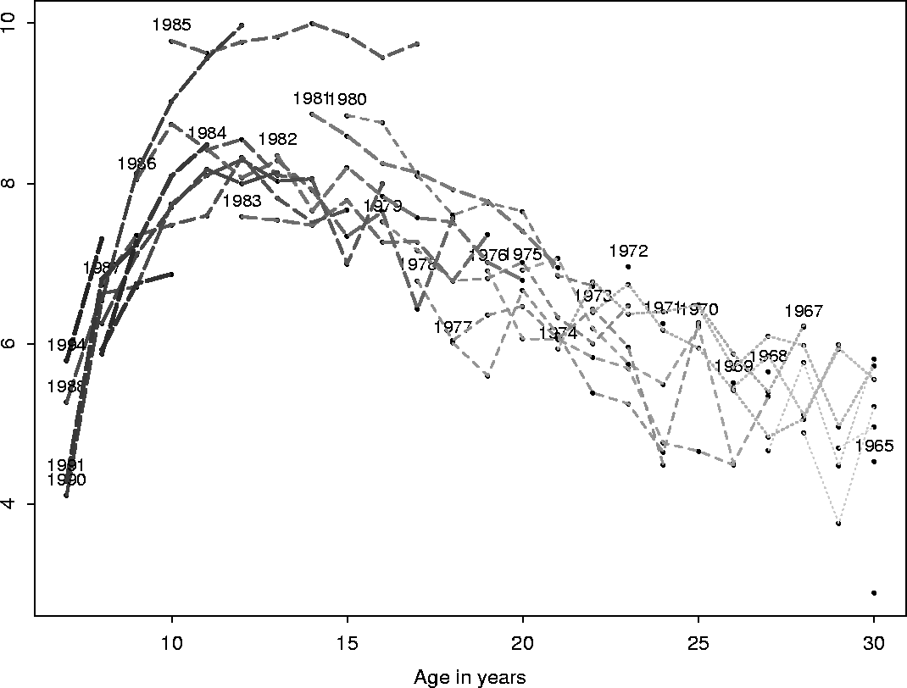
fit <- glm(no~factor(yearclass) + age1,data=karfaaldur[karfaaldur$age > 11 &karfaaldur$age < 26 ,],family = poisson)

Estimation of total mortality based on CaNo
Aldur | Z 2003 | Z 2002
20+ |  | -0.2120842
15+ | -0.204573820 | -0.238403
15-25 | -0.2135692 | -0.246719
12-25 | -0.1448467 | -0.1677752
13+ | 0.1709167
14+ | 0.1930709

Tech. min 2002

Sebastes marinus The SG accepted the BORMICON as exploratory, and this work is appreciated. However, Absolutely no information was provided by which the assessment could be evaluated. The WG should consider Biological reference points based directly on the analytic assessment, but the existing values were retained at present.In plenary, it was decided to recommend a 25% reduction in effort. Accordingly, the 2001 effort was used as a reference, and applied to the 1999-2001 CPUE.

The following text table gives the running mean of the IGS index given in Table 8.2.3.
 |  |  |  |  |  | Year
3 year | 1987 | 1988 | 1989 | 1990 | 1991 | 1992 | 1993 | 1994 | 1995 | 1996 | 1997 | 1998 | 1999 | 2000 | 2001 | 2002 | 2003
run.average | 1097 | 1053 | 986 | 810 | 704 | 567 | 493 | 464 | 406 | 438 | 471 | 539 | 598 | 577 | 536 | 503 | 583

Table 8.2.1 Index on fishable stock of S. marinus in the Icelandic groundfish survey by depth.
 | Depth interv
Year | < 100m | 100-200m | 200-400m | 400-500m | Total 0 - 400m |  | Total
1985 | 7 | 91 | 140 | 24 | 237 |  | 261
1986 | 2 | 86 | 180 | 12 | 268 |  | 280
1987 | 2 | 124 | 150 | 10 | 276 |  | 286
1988 | 1 | 95 | 110 | 4 | 206 |  | 210
1989 | 1 | 101 | 118 | 11 | 220 |  | 231
1990 | 2 | 68 | 81 | 22 | 151 |  | 173
1991 | 2 | 76 | 53 | 8 | 130 |  | 139
1992 | 1 | 62 | 59 | 9 | 122 |  | 132
1993 | 1 | 48 | 50 | 17 | 98 |  | 115
1994 | 1 | 58 | 51 | 1 | 110 |  | 111
1995 | 0 | 36 | 45 | 11 | 81 |  | 92
1996 | 1 | 44 | 76 | 21 | 122 |  | 143
1997 | 1 | 60 | 71 | 34 | 133 |  | 166
1998 | 2 | 57 | 71 | 3 | 130 |  | 132
1999 | 1 | 56 | 107 | 44 | 164 |  | 208
2000 | 2 | 47 | 69 | 8 | 117 |  | 125
2001 | 2 | 33 | 67 | 6 | 101 |  | 107
2002 | 2 | 64 | 74 | 11 | 140 |  | 151
2003 | 9 | 60 | 107 | 29 | 176 |  | 205

BORMICON run

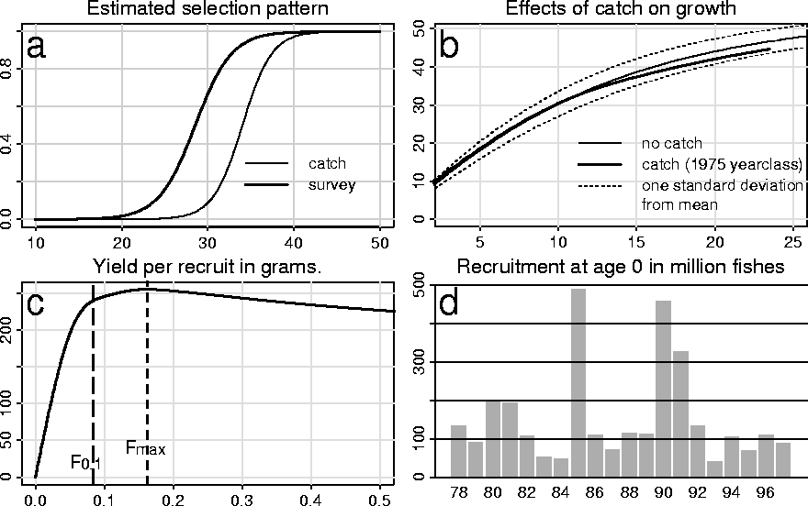

Figure 1. Summary results from the base case

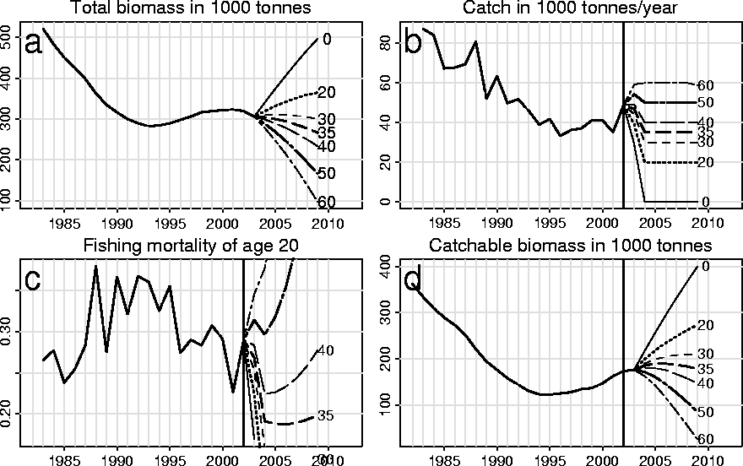
Figure 2. Comparison of results from the base case using fixed annuyal catch after 2002.

Figure 3.
