Practical exercises on growth

Part A – Fitting the von Bertalanffy growth curve using data where age is known

Data set: Icelandic cod sampled in the spring survey (bottom trawl gear with 40 mm mesh size)

i) Calculate the mean and standard deviation of the length for each age class. Plot the mean length against age.

ii) Use the mean length at age to estimate the L∞ and K parameters of the von Bertalanffy growth curve:

$$L_{t}=L_{∞}\left(1−e^{−K\left(t−t_{0}\right)}\right)+ε_{i}$$

where $ε_{i}=N(0,σ^{2})$
by minimizing
$$\text{SS}=ε_{i}=\sum_{t}{{\left(L_{t}−{\hat{L}}_{t}\right)}^{2}}=\sum_{t}{{\left(L_{t}−L_{∞}\left(1−e^{−K\left(t−t_{0}\right)}\right)\right)}^{2}}$$

Part B – Fitting the von Bertalanffy growth curve using length data where age is unknown

Dataset: Icelandic cod sampled in the spring survey (bottom trawl gear with 40 mm mesh size), file name: “Icelandic Cod 1985-2010 length.txt”

This file is extracted from a database, and the first step is to get a visual overview of the data to see if there are any indications of growth (modal progression), therefore

- Import the data in Excel
- ….
- Prepare for import in Pasgear 2 by adding a date using the Date function (=Date(<year>,3,15). This will give all records a the date 13/03/<year>

Installation of Pasgear

Download and install from http://www.imr.no/forskning/bistandsarbeid/data/pasgear_2/en
Choose the last version: Pasgear II Setup (ver 2.4 June 2010)
Prepare file for import of Icelandic Cod

- Open a new Project and give it a name
- Open the Data file and delete the following columns (right click in tree-view and press Delete.
- Right click on Data and choose Import -> Text

There are 4 steps in the import wizard:
Step 1:
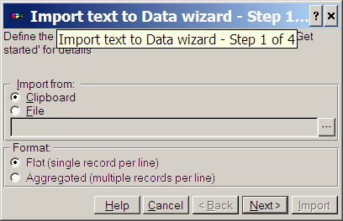
Step 2:
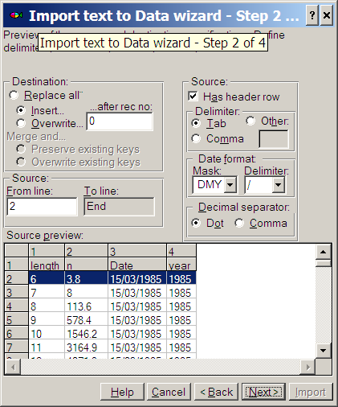
Step 3: Map the import columns to the excel file. The fields Station, Species, Gear and mesh will be given constant default values
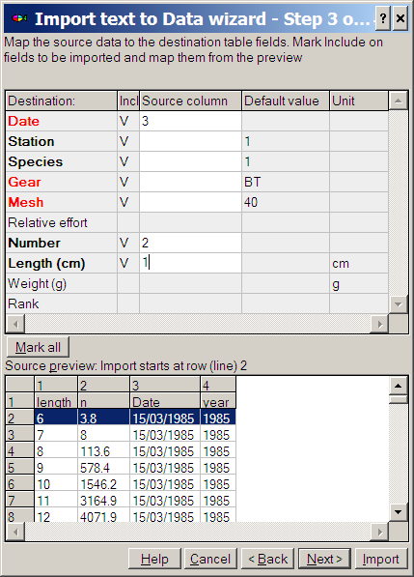

Step 4. Last check to see if all fields are filled in correctly, then press [Import]
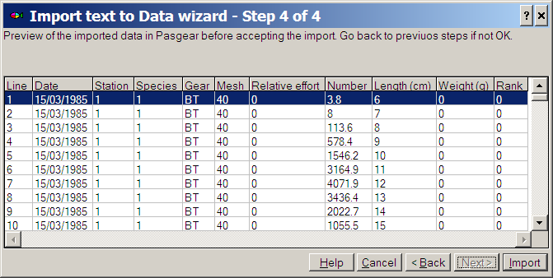

Finally: Close the import wizard by [Cancel].
The data are now imported

Make an Analysis
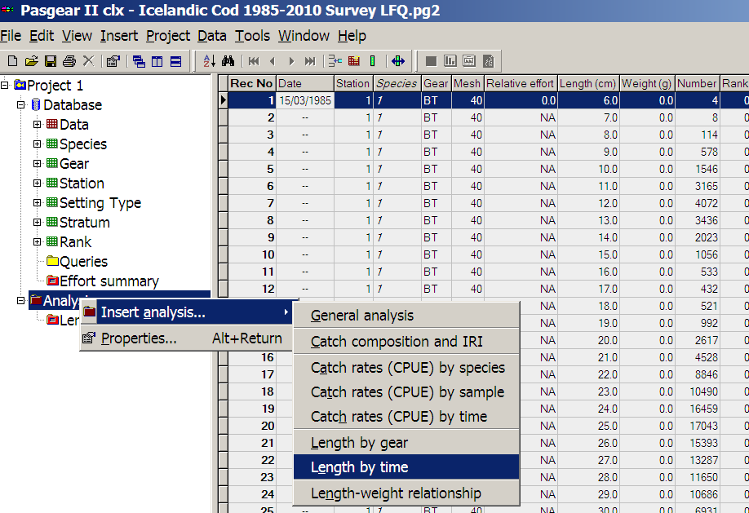

After pressing OK to the property page then double click on the Columns object (Month)
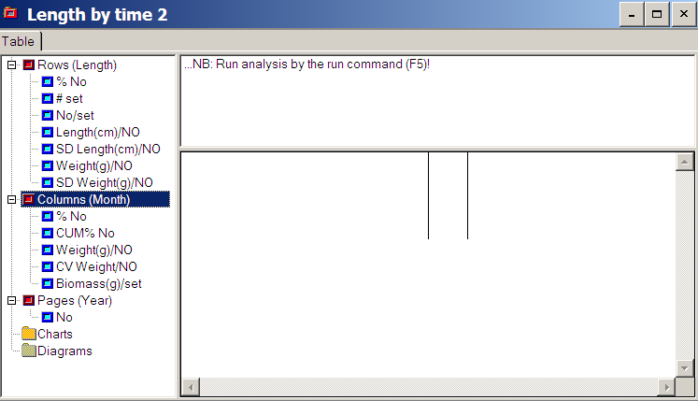
And choose Years instead
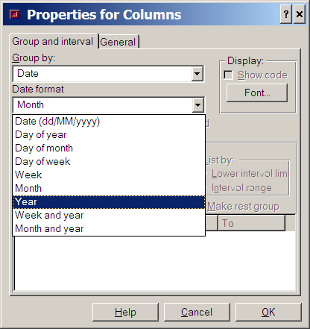

Double click on the Page object (Years), and choose NA (= no grouping)

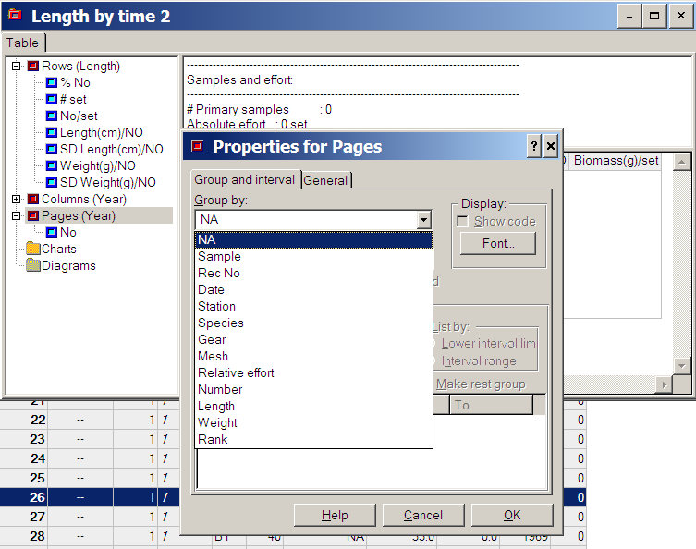

Everything is now ready so press F5 (= run or refresh), the table should look like this:
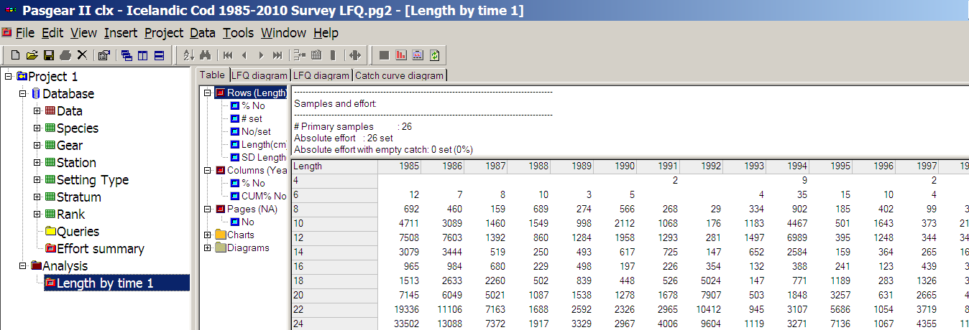

You can now open the LFQ Diagram and scrutinize the data. Hint, turn the plot 90 degrees by pressing the X-axis and choose ‘South’ for direction. Use then the Zoom function and the Axis length (Y-axis) to Zoom the plot. Scroll and find a period with clear growth.
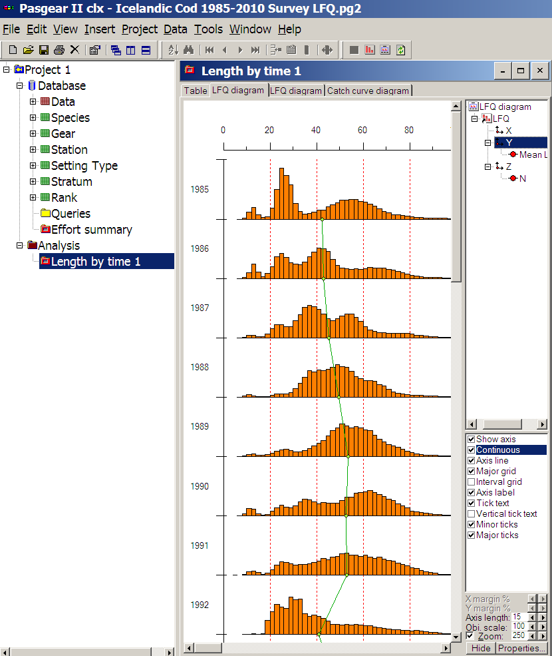

We shall choose the period from 1994 to 2001, so we make a Query to specify this period and connect to the Analysis:
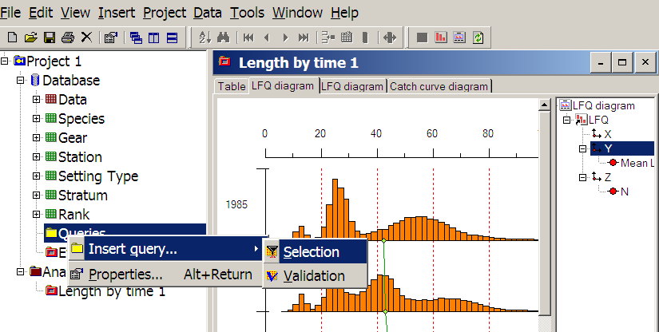

Query:
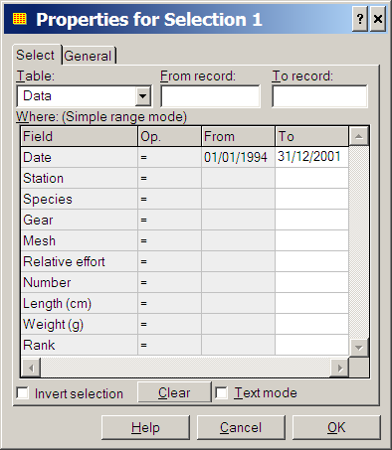
Connect Query to analysis and Refresh (F5)
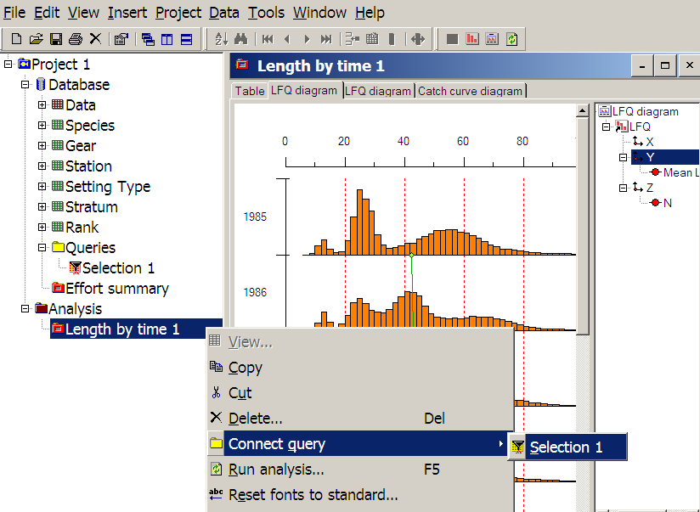

Right click in Table and Choose <Export to FiSAT>
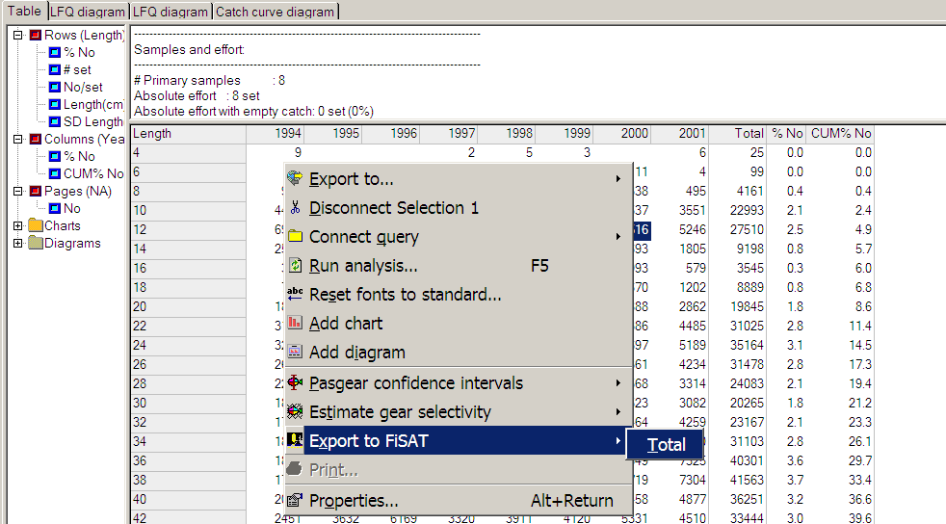

FiSAT II

Install from http://www.fao.org/fishery/topic/16072/en

To open the Pasgear file then first make a New Fisat File, then choose <Import OLD FiSAT L/F File>
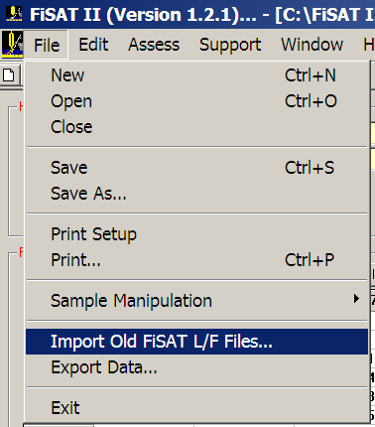

Your Source is the files exported from Pasgear. Your Destination is the New (empty) FiSAT II file:
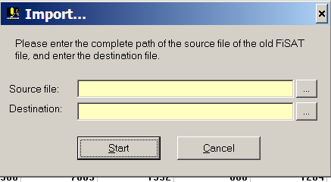

FiSAT will not recognize data after 2000 from Old files – these will be given the prefix 19xx, Therefore you must re-label the data from 2000 and 2001 (which will appear as 1900 and 1901). Use the [Edit Sample header] on these 2 columns:
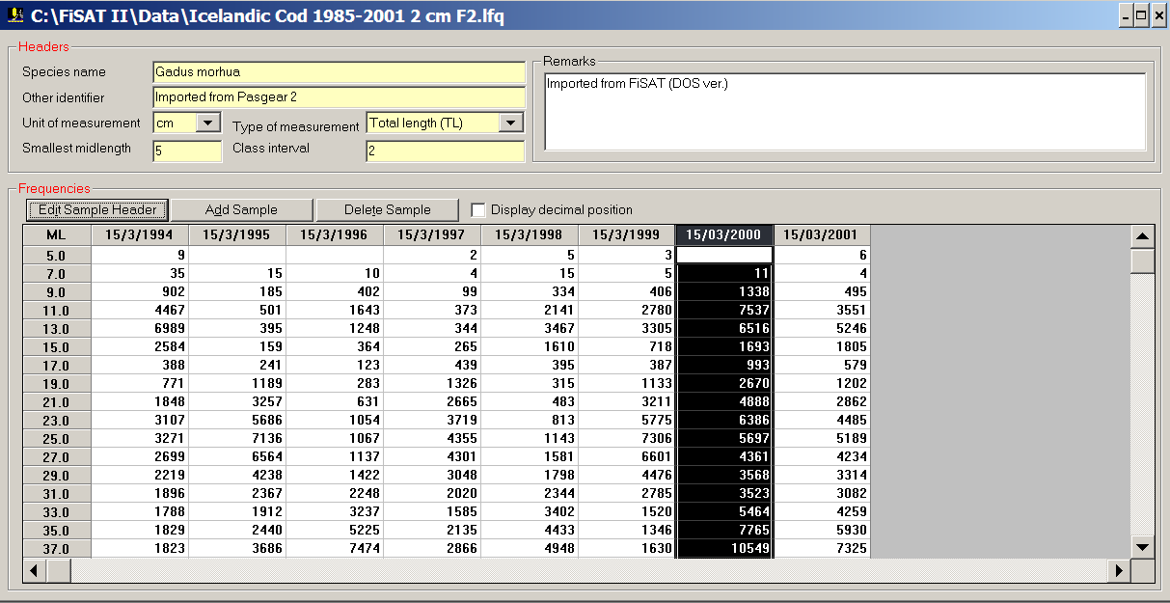
Analyzing data in Fisat:

Open the lfq file (Icelandic cod) cm’ and decompose the yearly (8 samples) length frequencies into normally distributed ’cohorts’ by choosing Assess/Modal progression analysis/ Bhattacharya’s method.

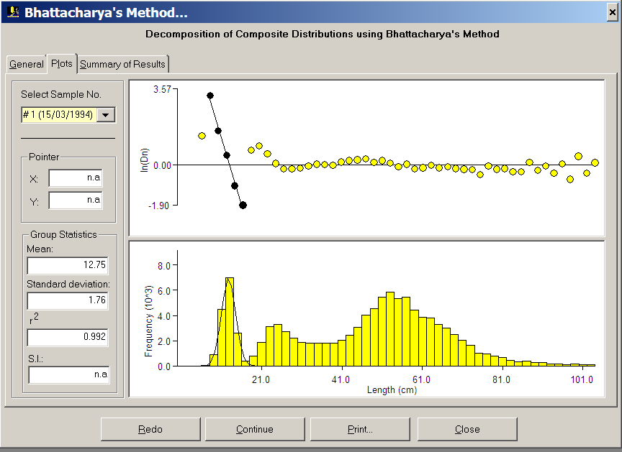

Save the results in a <name>.msd file (extension is automatic when saving). “Msd” extension stand for ’Mean and SD’.

Open the saved ’ <name>.msd’ file and connect the mean length of cohorts (= Modal progression analysis, MPA) by choosing Assess/Modal progression analysis/Linking of means

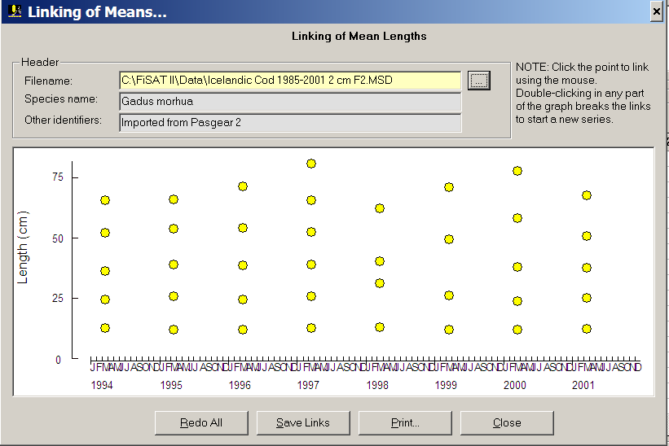

Save the result in a <name>.gin file (extension is automatic when saving). ‘Gin’ extension stands for ’growth increment data’.

Open the saved ’ <name>.gin’ file and estimate VBGF parameters K and Loo by choosing Assess/Analysis of growth increment data/Gulland & Holt method

You may have to fix the Loo and “de-select” some data points

3) Reopen the lfq file (Icelandic cod) and try to do a direct estimate of the growth parameters by choosing Assess/Direct fit of L/F data/ELEFAN I …Automatic search

You can use the K and Loo estimated from the MPA and Gulland & Holt as ‘seed’ input, or do a ‘K-scan’ or a ‘response surface’ analysis for sets of K and Loo. Set the step sizes as e.g. 0.1 for Loo and 0.05 for K.

Note that ELEFAN I is usually much faster in its automatic search when <constant starting point> is chosen identified by the coordinates SS (= starting sample) and SL (= starting length) that you chose visually and then enter the coordinates enter in the combo-box. What would be a reasonable constant starting point? Try with different starting points and note if there are any differences.

NB! Note that there appears to be a bug in the ELEFAN module of so that the iteration sometimes does not perform. If the yellow ‘optimum line’ is the first to appear, and there has been no changes in the parameters from the input seed values, then you have to close and start again.

4) Compare the various results and report these. Plot the length frequencies with estimated growth curves superimposed.

Give your best estimated set of VBGF for Icelandic Cod.

